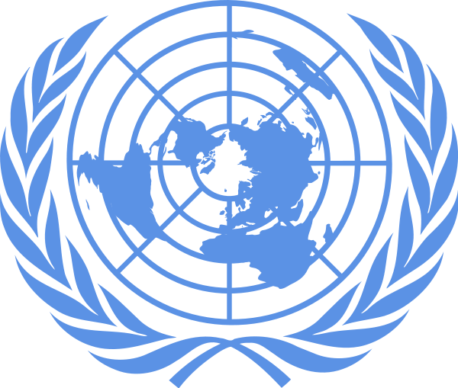

·
Kent Denver and Littleton High School
Model United Nations Conference
October 11, 2014
Background Guide
Intermediate World Health Organization
West Africa Ebola Outbreak:
Short-Term Management and Long-Term Prevention

Ciannah Gin
Chloe Hancock
Julia Jaschke
Jon Ort
History of the World Health Organization
April 7th is World Health Day, and on that same day in 1948 the World Health Organization’s Constitution was formed and put into action. Before the creation of the World Health Organization, there was a critical need for a global organization that could address health issues with all of the U.N. member nations in order to combat health issues on a global scale. The first attempt at international health cooperation began at the first International Sanitary Conference in Paris starting on July 23, 1851. The prerogative was to be harmonious and to reduce conflicting and expensive maritime quarantine requirements of a variety of European nations. Following the First World War, a major goal was to take steps in matters of international concern for the prevention and control of diseases. Once the Second World War started, international health work came almost to a standstill [1]. At the conference to set up the United Nations in San Francisco in April 1945, representatives from Brazil and China proposed that an international health organization be established, and a conference to frame its constitution convened. A Technical Preparatory Committee met in Paris in 1946 and drew up proposals for the Constitution, which were to be presented later in the year at the International Health Conference in New York City. After these proposals were presented, the conference drafted and adopted the Constitution of the World Health Organization, signed by fifty-one members of the UN and ten other nations in July 1946. Since then, the purpose of the World Health Organization has been to serve as a global leader in health issues and concerns. The World Health Organization currently includes 194 member states.
Today, WHO is the directing and coordinating authority for health within the United Nations. It "provides the world with leadership on global health matters, shapes the health research agenda, articulates evidence-based policy options, provides technical support to countries and monitors and assesses health trends." The work done by WHO includes sending response teams to regions of the world affected by outbreaks or suffering from disasters, and the organization strives to lead mass immunization campaigns to protect children of the world from the spread of deadly diseases and to maintain human health. WHO issues its annual World Health Report, a publication on health and a world health survey, to the nations of world. By providing knowledge and information on international health crises, WHO has become a valuable part of the UN in preventing and raising awareness for current-day health issues. WHO’s constitutional statement is “the attainment by all people of the highest possible level of health.”
The World Health Organization focuses on educating the public about and assisting with the most recent high-profile diseases, such as HIV/AIDS, tuberculosis, malaria, and particularly Ebola, where WHO plays a significant role. WHO also internationally supports healthy nutrition, food security, occupational health, and diminishing cases of substance abuse. In addition to these functions, WHO works to assign a global standard to the identification of drugs. Additional priorities for the WHO include promoting universal health coverage and increasing access to medical products [2]. WHO currently has around 200 programs ranging from Health and Human Rights to Rabies prevention.

Core Functions of WHO
The core functions of WHO include the following [3]:
- Providing leadership on matters critical to health and engaging in partnerships where joint action is needed;
- Shaping the research agenda and stimulating the generation, translation and dissemination of valuable knowledge;
- Setting norms and standards
- Promoting and monitoring their implementation;
- Articulating ethical and evidence-based policy options;
- Providing technical support, catalyzing change, and building sustainable institutional capacity; and
- Monitoring the health situation and assessing health trends.

Background on the Ebola virus
The Ebola virus is believed to have originated near the Ebola River in the Democratic Republic of Congo, and it is suspected that patient zero in outbreaks primarily gets infected by improper preparation, handling and consumption of live or wild bats or pigs. Ebola is a deadly disease composed of a group of viruses that cause a hemorrhagic fever and severe multisystem organ damage. Ebola is transmitted through sharing of bodily fluids like blood, saliva, and fecal matter through mucus membranes. Once Ebola has been introduced to the body in can take four to twenty-one days for symptoms to begin to appear, and the disease is not contagious until the infected person begins to show the deadly symptoms. The first signs of Ebola are sudden onset of a high fever, intense weakness, muscle pain, headache and sore throat; then as the virus progresses the infected person experience vomiting, diarrhea, rash and kidney/liver failure. Ebola impairs kidney and liver function, and with its up to 90% mortality rate, Ebola is one of the most deadly diseases on Earth. Unfortunately, an effective cure has yet to be discovered.
There are many ways to diagnose the Ebola virus such as antigen detection, serum neutralization test, reverse transcriptase polymerase chain reaction, electron microscopy, and virus isolation by cell culture. Treatment options, however, are very limited and the ones that exist either are case-by-case (such as the recent decision to bring infected American health workers back to the United States so that they could be treated and ultimately cured in facilities with better supportive care than in West Africa) or untested options that present a variety of ethical dilemmas. WHO has taken action against the recent outbreak of Ebola in West Africa, but lack of infrastructure and poverty tend to impede the attempt to eradicate the virus. They have created an aide-memoire on standard precautions that are meant and expected to reduce the transmission of Ebola in affected countries. This current Ebola crisis is expected to take months to end because the disease now has deeply penetrated West African countries and is expected to affect 20,000 people worldwide.
No pathologist today is entirely sure where the Ebola virus originated. Significant evidence from the first outbreak of the virus in 1976 in West Africa points to bats as the culprit of spreading the virus to humans [4]. However, how or where bats contract the virus, or even if they are the transmission vector, is not currently proven medical knowledge. Primates have also been known to acts as hosts of the virus. Mortality rates from Ebola within these species vary, although bats seem to be relatively unaffected by the disease, while non-human primates seem to have higher death rates. One fact is certain, however: Ebola virus is an example of zoonosis, a disease that spreads from animals to humans, and its ability to survive within different organisms – bats, monkeys, and humans, for example – indicate that the virus is not species dependent, or in other words, it can sustain itself within a variety of hosts [5].
As of today, there is no cure for Ebola virus. While treatment options in West Africa are available, they often do little to alleviate the symptoms of the disease, where health care workers have access to limited equipment and isolation capacities. According to an article published by the University of Connecticut, the first epidemic of Ebola virus in 1976 had an 88% mortality rate – in other words, 88% of patients infected with the disease succumbed to it [6]. In the 2014 outbreak, the mortality rate is considerably lower – as of early August, the death rate was slightly higher than 55% – but is still considerable [7]. Since Ebola first became present earlier this year, more than 2,300 individuals have died due to the disease [8].

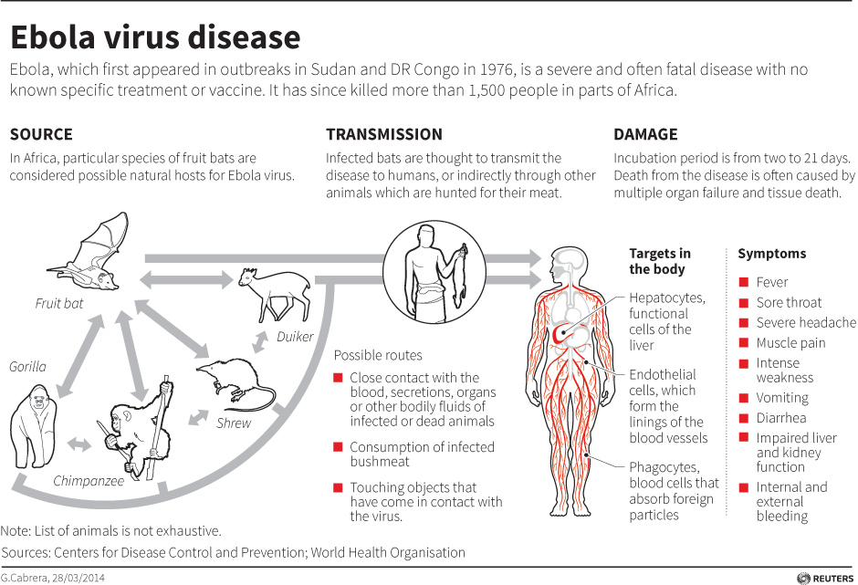
Image from: http://www.cbc.ca/news2/interactives/map-ebola
WHO and U.N. Response to Ebola
As of September 18, 2014, WHO has recorded more than 5,300 cases of Ebola in the West African countries of Liberia, Guinea, Sierra Leone, and Nigeria. The first reported cases of this Ebola outbreak were in December of 2013. This outbreak is considered to be the deadliest Ebola outbreak in history, with the death toll currently estimated to be more than 2,600 people. With an approximately 50% mortality rate, this is certainly not the most violent outbreak of the disease; other outbreaks in 2002-2003 have killed up to 90% of those infected. The World Health Organization is taking initiatives to reduce the number of people affected by this deadly disease.
The highest priority of WHO for this Ebola outbreak is to reduce and control the transmission of Ebola. WHO’s most effective way of reducing transmission is to implement specific education to those who are infected, maintain effective quarantines, track down people who have been in contact with confirmed Ebola cases, remove Ebola-infected bodies in a proper and timely fashion, and provide medical personnel with quality personal protective equipment (PPE). To help diminish the effects of Ebola, WHO seeks to utilize the existing medical workforce and also supply affected countries with additional doctors. The majority of volunteer doctors working under WHO come from first-world countries. Despite current efforts to prohibit transmission of the Ebola virus, these doctors put themselves at particular risk of contracting it. WHO recently reported that a U.S. doctor had contracted the Ebola virus and was admitted to Emory University Hospital on September 10, 2014. He was the fourth American doctor to be taken back to the United States after contracting Ebola.
Members of the World Health Organization are coming together to discuss possible ways to combat Ebola. Following a two-day conference in Geneva, the World Health Organization has begun discussing ongoing efforts by pharmaceutical companies to develop drugs for this virus, and steps that can be taken to support the development of these drugs. WHO has urged companies as well as authorities to collaborate and speed up their efforts to fight the deadly virus.
On September 18, 2014, the United Nations declared the Ebola outbreak in West Africa a threat to peace and security. Secretary-General Ban Ki-Moon announced that, “the United Nations will deploy a new emergency health mission to combat one of the most horrific diseases on the planet that has shattered the lives of millions.”[9] This new mission is called the United Nations Mission for Ebola Emergency Response (UNMEER) and has five priorities: stopping the outbreak, treating the infected, ensuring essential services, preserving stability, and preventing further outbreaks [10]. The UN hopes to raise $1 billion USD over the next six months. Ban Ki-Moon stated, “the penalty for inaction is high. We need to race ahead of the outbreak – and then turn and face it with all our energy and strength.”[11] With the cooperation of all the world’s nations, there certainly must be a way to reduce the transmission and death toll of Ebola.

Global Case Studies
Introduction
Appearing most recently in West Africa, Ebola has sickened more than 5,300 people and killed more than 2,600 people since December, 2013, as well as grabbed the attention of the international community, and struck fear into the citizens of Guinea, Liberia, Sierra Leone, Nigeria, and the Democratic Republic of Congo. West Africa is the perfect host for Ebola because of its predominantly poorly equipped health-care facilities, which makes it challenging for hospitals to maintain the highest level of sanitation and order, thus allowing Ebola to spread easily to patients, doctors, and family members. The cultural practices of these West African nations, such as the foods they consume and their burial traditions, have led to a losing battle in the race against the spread of Ebola. Consumption of bushmeat that has been infected with the virus through bites from bats is believed to be one method of transmission of Ebola to humans. Unlike some viruses that cannot be passed on once a person has died, Ebola remains in the system of the deceased and can be transmitted to others through bodily fluids. Because West Africans practice a tradition of keeping the bodies of the dead weeks after they have died, Ebola has quickly spread to families of the deceased. Culture, mixed with the limited access to the necessary facilities, has allowed for the rapid spread and major outbreak of Ebola in many countries throughout West Africa.

Map of Areas Affected by the Ebola Virus in Guinea, Sierra Leone, and Liberia

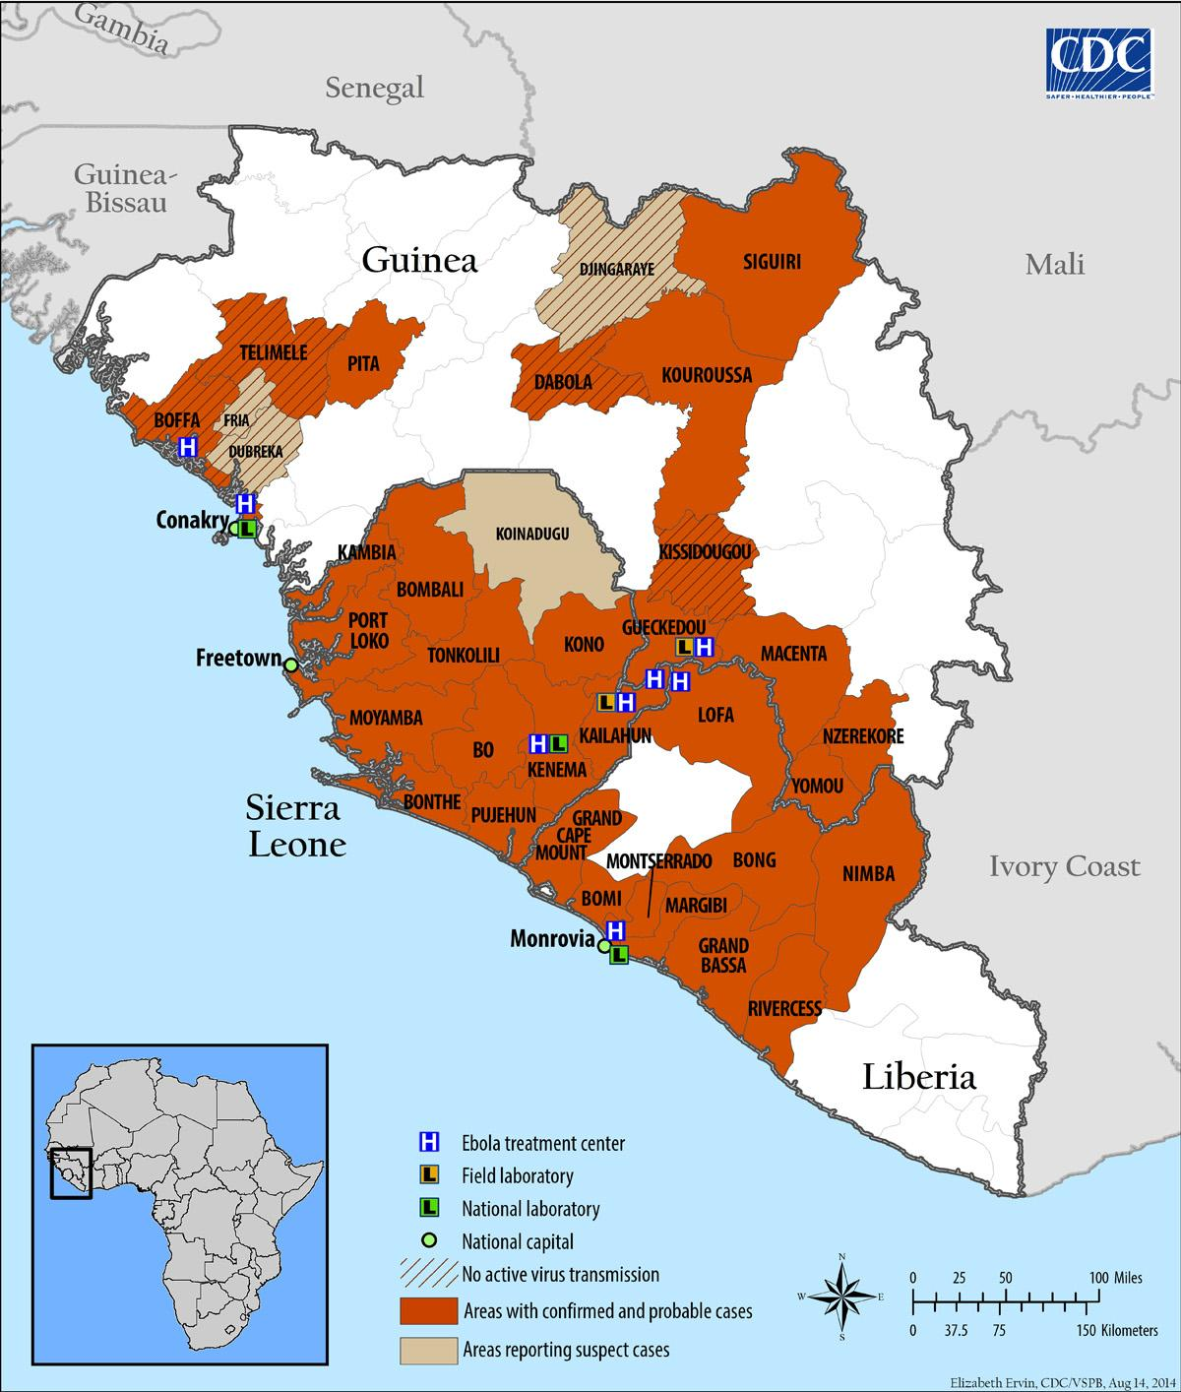

Guinea
Although believed to have had its first case of Ebola in December, 2013, Guinea did not officially confirm this case until 2014 when Ebola had already spread to neighboring countries Liberia and Sierra Leone. Since these first reports in Guinea, 638 cases have been confirmed along with 410 confirmed deaths. In a desperate effort to stop the spread of Ebola and save even more citizens from contracting the virus, Guinea declared Ebola a Health Emergency. The government in Guinea is working to tighten the borders to prevent the outbreak from spreading, and is requiring all people who come in contact with the disease to stay in their homes for the three-week incubation period of the virus, or face penalty by law. Schools have been closed until the disease has been sufficiently reduced. Although Guinea has four treatment centers, officials have struggled to get the victims of the disease to go to the centers for treatment. Instead of going to the centers, many sick people hide in fear in their own homes, which has only helped Ebola continue to spread by putting entire families and even communities in contact with the disease. The Red Cross Society in Guinea has been forced to end some of its operations after receiving death threats, because many people in Guinea believe that doctors cause the disease. This shows the limited education some Guineans have regarding the transmission and general knowledge of Ebola. Guinea’s first mistake - not properly acknowledging the outbreak of Ebola when it first occurred - has led it and its neighboring countries on a downward spiral. With limited resources and increasing resistance to treatment, Guinea must quickly take steps to educate the population, help them to separate the disease from their cultural beliefs, and to take control of the situation before it slips even further out of Guinea’s grasp.

Liberia
The President of the Republic of Liberia, while declaring a State of Emergency in Liberia on August 6 said, "the scope and scale of the epidemic, the virulence and deadliness of the virus now exceed the capacity and statutory responsibility of any one government agency or ministry. The Ebola virus disease, the ramifications and consequences thereof, now constitute an unrest affecting the existence, security, and well-being of the Republic amounting to a clear and present danger.” With only 314 available treatment beds, Liberia is struggling to keep up with the virus, reporting 1,698 confirmed cases and 871 deaths. Liberia is struggling due to the country’s resistance to treatment. Cases of Liberians escaping from hospitals and isolation have become a huge issue, giving one reason why Liberia has been hit the hardest out of West Africa. WHO has reported that efforts to control the outbreak in Liberia have not been sufficient. Hospital workers are being forced to work without proper protective materials and therefore many have contracted the virus. Due to the terrible working conditions, many hospital workers have gone on strike. The virus in Liberia has affected much more than just public health. The Ebola outbreak can also be linked to food shortages. Without adequate supplies and due to the resistance of the community, Liberia may continue to weaken and, as is already occurring, Ebola may wreak havoc on more than just national health.

Sierra Leone
After the outbreak of Ebola in Guinea, Sierra Leone had its first outbreak in May of 2014 on the border of Guinea. Since the outbreak in May, there have been 1,261 suspected cases and 476 deaths. In efforts to try to control the spread of the disease, the government in Sierra Leone has instituted stricter regulations for travel in and out of Sierra Leone, required quarantine for those affected or possibly affected (punishable by the police), and increased restrictions on mass gatherings. Similar to other countries struggling to control the spread of Ebola, these actions have provoked public resentment and protests against doctors and the required quarantine. The fear of being kicked out of villages or houses has led to a large number of hidden cases (people too afraid to seek help after contracting the disease). In an attempt to control to spread of the disease, the government of Sierra Leone has declared a three-day lockdown beginning September 19, 2014. During the three day lockdown, people will be banned from leaving their houses and volunteers will go door-to-door as part of a social campaign to help educate the community. Although the lockdown will prevent the spread of Ebola through human contact for those three days, the overall impact is questionable given the virus's one- to three-week incubation period. With a lack of medical resources, common throughout all of West Africa, Sierra Leone is struggling to control its frightened citizens and is unsure how successful its attempts will be.

Nigeria
Nigeria's first case of Ebola occurred when a man traveled from Liberia to Nigeria after his sister died from Ebola. The man had been in contact with her body and had contracted the virus. Arriving in Nigeria on July 20 and dying on July 25, the man exposed others in Nigeria to the disease, including health officials who subsequently fell ill. Since this exposure, Nigeria has experienced 21 cases and 7 deaths. The Nigerian government has been praised for its ability to maintain a relative level of calm among its citizens. By working with local media, the government has been able to educate communities and thus to prevent many of the “hidden cases” that have occurred in neighboring countries. The Nigerian government has not yet imposed any quarantines or travel restrictions, which has been credited for the maintained trust between the government and citizens. Although no quarantines have been imposed on the citizens, school has been suspended while the government attempts to control the virus. Surveillance teams are on high alert monitoring the people who have come in contact with those infected. The level of attention and trust in Nigeria, along with the outbreak taking place in a relatively isolated part of Nigeria, is unique compared to the other countries struggling to control the virus and can hopefully help set a precedent for controlling Ebola in West Africa.

The Democratic Republic of Congo
Ebola is not new to the Democratic Republic of Congo--it is the site of the first outbreak in 1976. The DRC had not experienced the virus since 2012, until on August 26, 2014 the Ministry of Health informed the World Health Organization of the first suspected case of Ebola in the Democratic Republic of Congo. The first victim of the deadly disease was a pregnant women thought to have received the disease through the preparation of bush meat. Following the death of the woman, 52 suspected cases and 25 deaths have been reported, none of whom had come in contact with people from infected regions of West Africa. WHO released this confirmation of the report, stating, “results from the virus characterization, together with findings from the epidemiological investigation, are definitive: the outbreak in DRC is a distinct and independent event, with no relationship to the outbreak in West Africa."[12] As unfortunate as the situation is, the Democratic Republic of Congo (DRC) is fortunate because of the location of the outbreak. The outbreak is currently occurring in a remote part of the DRC, preventing more deaths than would have occurred if it were in the capital, Kinshasa. The people in the infected region of the DRC are not known to travel, and the area is not a tourist hot spot. The minimal movement in and out of the affected area helps to reduce the concern that Ebola could spread from this region to other countries and continents, including Europe. The Public Health Agency of Canada has set up a response network in the DRC and an educational system to teach the people of the DRC about the spread and risk of Ebola. Along with The Public Health Agency, the Ministry of Health has also established a phone number dedicated to educating the public about Ebola and the current cases in their region. The Ebola outbreak in the DRC highlights the impact of location on the death toll and the importance of education in the hopes to prevent future outbreaks.

Long-Term Solutions
This section will present basic information regarding possible long-term responses to the Ebola virus, especially in the form of non-governmental organization (NGO) and government involvement, medical advancements, other relevant technologies, public education, and societal considerations. These topics will constitute approximately one half of the model World Health Organization’s discussion during the conference. The World Health Organization has warned that the international response to the Ebola virus outbreak has been weak, underestimated, and insufficient, and in early September, it warned that the infection rate of the disease could “rise exponentially” [13].

Non-Governmental Organization Involvement
In the current Ebola outbreak, a significant portion of international aid that goes to the countries hit by the virus comes from non-governmental organizations, or groups without government affiliation that seek to fulfill a specific mission statement/common purpose. Many of these organizations are medical charities, such as Medecins Sans Frontieres (Doctors Without Borders) and the American Red Cross. These organizations send employees and volunteers, along with medical supplies, to affected areas in order to attempt to stop the disease. Many of the countries affected by Ebola lack the fiscal and physical resources to provide adequate healthcare to their population. Take Nigeria, for example. Over the summer, hundreds of civilians, the majority of them young girls, have been murdered or kidnapped by the terrorist group Boko Haram. As the Nigerian government attempts to resolve this and other domestic issues, its ability to respond to Ebola virus is diminished.
While NGOs provide a committed response to the Ebola virus, their involvement is neither entirely sufficient nor can it be permanent, for a variety of reasons. Foreign healthcare workers cannot stay in Africa forever, and upon arrival, they face the risk of contracting the virus. Mobile treatment centers sponsored by charities lack the ability to treat patients like a hospital or permanent medical facility can, and workers are often distrusted by native communities.
In addition to NGOs, there are two options for international involvement in the crisis. First, individual, affluent countries like the United States or the United Kingdom could intervene by supplying medical materials on behalf of their respective governments. The second option is a coordinated international response, where an organization such as WHO would intervene and take on all the responsibilities of stopping the spread of the virus. While WHO is involved in the crisis and is closely following the spread of the disease, its involvement could grow significantly. Ultimately, however, the ideal situation would be to bring African governments to a capacity where they can independently handle and stop an Ebola outbreak. Consider which response would be most adequate and in the best interests of your country.

Current Treatments
The key to halting the spread of Ebola virus is isolation. An infected patient may go as long as 21 days past the infection date without symptoms [14]. This period of time is known as the incubation period, when the Ebola virus multiplies in its host’s body. As soon as a patient begins showing symptoms of the disease, he or she is severely infected and must immediately be quarantined, because the virus is now highly contagious. In West Africa, patients with symptoms may not report their condition to the authorities, and the ability to quarantine individuals is limited. Medical treatment centers are not permanent structures, and therefore the lack of these centers makes it harder to completely isolate an individual. In order to protect themselves from the virus, workers dress in protective clothing (see image below).
Medicines and treatment plans can alleviate some of the symptoms and dangers of Ebola. Injecting an intravenous drip feed can combat dehydration and over-the-counter prescriptions can reduce headache pain, but without a drug or treatment to completely eradicate the virus within an individual, the majority of patients (>50%) die.
Synthesizing a drug that could cure patients with Ebola has been a focus of scientists. Two American health workers that were infected with the disease were treated with an experimental serum, ZMapp. At the time of this experiment, ZMapp had never been administered to humans, which raised an ethical dilemma: should the drug, with potentially unknown consequences, be administered? Both patients made a full recovery after receiving the serum, although it cannot be proven that ZMapp was the deciding factor in their survival. Both Americans were also treated at U.S. facilities where they were able to benefit from constant supportive care, which contributes significantly to recovery. The serum, when injected, releases antibodies produced by non-human organisms, such as bacteria. Antibodies are essentially tags that attach to potentially harmful cells in the human body. These antibodies bind to Ebola-infected cells and subsequently send out a signal that alerts the body to destroy those cells [15]. Private companies like Mapp Biopharmaceutical Inc., the manufacturer of ZMapp, will no doubt continue to invest in and develop new and innovative treatments for the Ebola virus, but will also continue to face ethical barriers and the high possibility of failure.

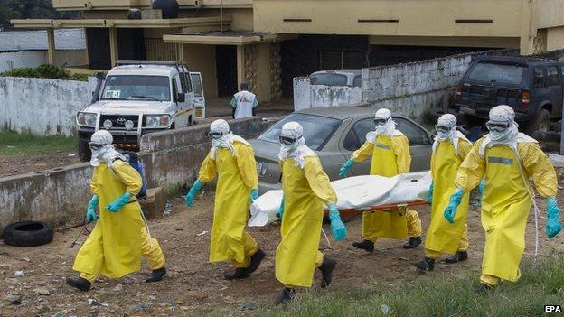
Health care workers remove the corpse of an Ebola virus disease victim in Western Africa while wearing protective clothing. The 2014 outbreak of Ebola virus is the deadliest yet (Source: BBC).

Other Technologies
In the Ebola crisis, new milestone advancements reached by companies, research teams, or NGOs are a vital part of combating the disease. For example, when a person infected with Ebola enters a public space, all those in contact with the disease must be immediately contacted and monitored for symptoms of the virus. The effort to reach out to so many individuals is massive, and the actual records of mass communication are often recorded on paper. This presents logistical problems on a number of levels. The number of records must be staggering, and analyzing thousands of pages of data is a nearly impossible feat. This is where the NGO Magpi enters the scene. Magpi has created a computer program that has the ability to track and analyze thousands of pieces of data, which has many applications in the real world [16]. The NGO founder believes that his product could also be very beneficial to control Ebola, as the huge numbers of data that are collected can be effectively analyzed within the program. While Magpi is only one example, such innovations and ideas are important aspects of combating Ebola virus.

Implications for Society
Education is one of the most powerful tools to curb the spread of Ebola. Part of the reason why the outbreak has been so terrible this year is due to the public misconception and distrust of Western medical practices in Africa. Many residents of West Africa are wary of foreign medical workers and may refrain from recommended treatment options and instead consult a local doctor, who might be prone to follow traditional herbal or spiritual treatments instead of WHO-recommended modern ministrations. It is important for someone, be it NGOs, WHO, or governments, to teach local doctors about the importance of referring Ebola cases to more trained professionals and the authorities. Local doctors have often built up significant trust with their patients and can make a considerable impact on an individual’s decisions.
Simple reinforcement of education is an important way to prevent unreported cases of Ebola. While many an educational campaign about the virus has been launched in West Africa, few seem to genuinely change locals’ opinions about foreign medical treatments. Local leaders and doctors have the potential to convince their communities to place trust in foreign medical aid, so it is in these individuals that real educational change can occur. Finally, it is crucial for individuals to be familiar with the symptoms of Ebola, and to report to an Ebola clinic if they present the signs of the disease. In addition, it is residents’ responsibility to take sick friends or family to a clinic. Consider what the effects of the establishment of a long-term education program in West Africa would be.
Violence has also been perpetrated against healthcare workers in Africa. Some workers have been threatened with knives and other weapons, while an Ebola clinic in a Liberian slum was looted by distressed locals. The looters stole potentially infected materials from the clinic, such as sheets and blankets, which could contain patient vomit or excrement [17] [18]. The looting of the clinic symbolizes both the poor communication between medical personnel and locals and the poignant irony of an Ebola eradication center contributing to the spread of the disease. In September 2014, eight individuals attempting to educate Guinean locals about Ebola virus were found dead – three with slit throats – implying that paranoid villagers carried out the murders [19].
All of the confrontations between locals and medical workers that are described above lead to one important consideration: the 2014 Ebola virus outbreak is not only a virulent virus manifesting itself within West African communities, but also a social crisis. The miscommunications, stereotypes, and assumptions between Western and local medical and aid personnel and residents of West Africa evince the need for understanding between the two groups. The 2014 Ebola outbreak also demonstrates that paranoia, distrust, and panic manifest themselves within a population when a deadly disease strikes. All of these social concerns and considerations fall under the jurisdiction of WHO to solve.
While education is a solution that can help to stop this outbreak and future ones, the key to prevent Ebola virus outbreaks for the future is to respond to societal beliefs and practices in West Africa that contribute to the spread of the virus. For example, the Ebola virus can spread by traditional West African funerary rites, where the deceased are embalmed in a very involved process. If an individual dies as a result of Ebola virus or dies infected with the virus, the family members that participate in the funerary rites have the potential to become infected from that person’s fluids. Similarly, handling, preparing, and eating meat that comes from the African wilderness (bush meat) is also one of the ways Ebola has spilled over into humans.
At this point, it is important to make a distinction: traditional West African practices are not “wrong” for contributing to the spread of Ebola. The way the culture interacts with the virus is no different than an outbreak of a virulent virus in more developed nations. The motivations behind practicing these potentially dangerous actions must also be considered. Formal ceremonies for the deceased are found in ideologies of all cultures, and the West African tradition of embalming the body is no different. In addition, when West Africans eat bushmeat, they are sustaining themselves. Without bushmeat, many people would become protein deficient [20]. One cannot simply force these people to stop their traditional culture. This would only lead to more miscommunication and distrust between West Africans and foreign medicine workers, and would potentially destroy a valuable culture. Therefore, educating people about Ebola is not enough to stop the virus, but neither is eliminating cultural practices. Moderate adaptation of lifestyle is the key.
As a delegate representative to the World Health Organization, you must consider how to change the mentality of entire West African societies. Does the solution lie in NGO-funded projects to create Ebola-free, domesticated animals to serve as food in West Africa, or instituting the practice of having the dead embalmed by individuals wearing protective suits? The possibilities for solutions are endless, but developing one that will work effectively is both difficult and requires the cooperation of an entire population. Local doctors and leaders may again be important to helping with reform campaigns: they can begin to institute new policies within their communities. In any case, the potential implications of such a program, if successful, could be the most important step in eliminating all future Ebola outbreaks.

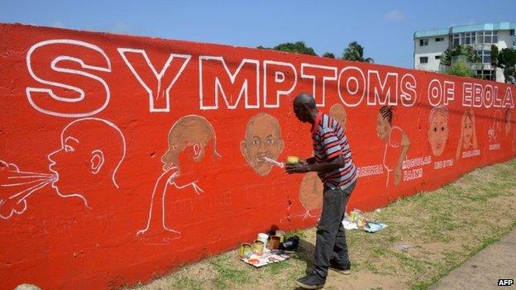
This artist depicts the symptoms of Ebola virus disease on a mural in a public space in West Africa. Educating the public about the symptoms of Ebola is a helpful tool in gaining control over an outbreak of the virus (Source: BBC).

Questions to Consider
The questions below are designed to be thought-provoking and relevant to the Ebola virus crisis. Allow the questions to guide your research for a position paper, and come to the conference with ideas and answers to each one.

- What responsibilities do individual countries have in regards to responding to the Ebola crisis? What about the World Health Organization?
- Should developed countries be more concerned about eradicating Ebola in Africa or preventing its presence within their own borders?
- Is it unethical for a powerful nation to remain neutral in this situation? Can the Ebola crisis be considered a humanitarian concern?
- How can the WHO help West African nations develop the resources to combat an Ebola outbreak on their own (to a reasonable degree; at some point, international involvement is important)?
- What are the ethical implications of administering a drug with unknown consequences to an Ebola patient? Who should give consent for this individual to be treated with such a medicine?
- Out of the major long-term solutions presented above (NGO/ government involvement, medical advancements, other technology, and education/ social mentality changes) which are the most plausible and which are the most inefficient solutions?
- In your opinion, what is the best way to go about convincing West Africans to modify their lifestyles to prevent the spread of Ebola virus? Does it lie in foreign aid or local leaders/ government?
- What course of action, in terms of developing long-term solutions, is in the best interests of your country?

Works Cited
[1] "The Role of WHO in Public Health." WHO. Accessed September 20, 2014.
[2] "Ebola Death Toll Rises to at Least 2,296, WHO Says." Fox News. September 10, 2014. Accessed September 20, 2014.
[3] "Leadership Priorities." WHO. Accessed September 20, 2014.
[4] "UN Announces Mission to Combat Ebola, Declares Outbreak 'threat to Peace and Security'" UN News Center. September 18, 2014. Accessed September 20, 2014.
[5] "UN Announces Mission to Combat Ebola, Declares Outbreak 'threat to Peace and Security'"
[6,7] "UN Announces Mission to Combat Ebola, Declares Outbreak 'threat to Peace and Security'"
[8]“Could Bats Be Ebola’s Natural Host/ Reservoir?” Stanford University. August 28, 2014. http://virus.stanford.edu/filo/bats.html.
[9] “Ebola Virus.” University of Connecticut. August 28, 2014. http://web.uconn.edu/mcbstaff/graf/Student%20presentations/Ebola/Ebola.html.
[10]”Ebola Virus.”
[11] Ebola mortality rate expected to rise as outbreaks runs its deadly course.” Fox News. September 9, 2014. http://www.foxnews.com/health/2014/08/06/ebola-mortality-rate-expected-to-rise-as-outbreak-runs-its-deadly-course/.
[12] “Ebola kills 2,300, nearly half of deaths in past 21 days: WHO.” Yahoo! News. September 9, 2014. http://news.yahoo.com/ebola-killed-2-288-nearly-half-past-21-155230568.html?pt=Array.
[13] “Ebola spread is exponential in Liberia: WHO.” SABC. September 9, 2014. http://www.sabc.co.za/news/a/fae368804567bb32ba08bfc7c599c9eb/ebola-spread-is-exponential-in-liberia:-who-20140909.
[14] “Ebola Hemorrhagic Fever: Transmission.” Center for Disease Control and Prevention. September 9, 2014. http://www.cdc.gov/vhf/ebola/transmission/index.html.
[15] “9 questions about this new Ebola drug.” Cable News Network. September 9, 2014. http://www.cnn.com/2014/08/04/health/ebola-drug-questions/index.html.
[16] “Magpi Helps Collect NGO Data--One Part Of Helping Deal With The Ebola Crisis.” Forbes. September 4, 2014. http://www.forbes.com/sites/benkepes/2014/08/25/magpi-helps-collect-ngo-data-one-part-of-helping-deal-with-the-ebola-crisis/.
[17] “Mob Attacks, Violence from Villagers Threaten Ebola Aid Workers in Africa.” Breitbart. September 9, 2014. http://www.breitbart.com/Big-Peace/2014/07/29/Mob-Attacks-Violence-from-Villagers-Threatening-Ebola-Aid-Workers-in-Africa.
[18] “Slum Residents Loot Ebola Clinic in Liberia.” NBC News. September 9, 2014. http://www.nbcnews.com/storyline/ebola-virus-outbreak/slum-residents-loot-ebola-clinic-liberia-n182681.
[19] “Eight Killed in Attack on Ebola Team in Guinea.” NBC News. September 18, 2014. http://www.nbcnews.com/storyline/ebola-virus-outbreak/eight-killed-attack-ebola-team-guinea-n206726.
[20] “Why West Africans keep eating bush meat, which could be Ebola’s bridge from animals to humans.” The Sydney Morning Herald. August 6, 2014. http://www.smh.com.au/world/why-west-africans-keep-eating-bush-meat-which-could-be-ebolas-bridge-from-animals-to-humans-20140806-100u73.html.

References
"2014 Ebola Outbreak in Democratic Republic of the Congo." Centers for Disease Control and Prevention. September 05, 2014. Accessed September 10, 2014. http://www.cdc.gov/vhf/ebola/outbreaks/drc/2014-august.html.
Carter, Chelsea J., Journalist Umaru Fofana Reported from Freetown, Chelsea J. Carter Reported, and Wrote from Atlanta. Claudia Dominguez. "Sierra Leone Plans Nationwide Lockdown to Stop Spread of Ebola." CNN. January 01, 1970. Accessed September 10, 2014. http://www.cnn.com/2014/09/06/world/africa/sierra-leone-ebola-lockdown/.
Cumming-Bruce, Nick, and Alan Cowell. "Ebola Could Strike 20,000, World Health Agency Says." The New York Times. August 28, 2014. Accessed September 10, 2014. http://www.nytimes.com/2014/08/29/world/africa/ebola-outbreak.html?_r=0.
"Ebola." Ebola. Accessed September 10, 2014. https://www.internationalsos.com/ebola/index.cfm?content_id=395&language_id=ENG.
"Ebola Death Toll Rises to at Least 2,296, WHO Says." Fox News. September 10, 2014. Accessed September 20, 2014. http://www.foxnews.com/health/2014/09/10/ebola-death-toll-rises-to-at-least-226-who-says/.
"Ebola in Sierra Leone." - Warning. Accessed September 10, 2014. http://wwwnc.cdc.gov/travel/notices/warning/ebola-sierra-leone.
"Ebola: 'plague' Threatens Liberia's Existence." The Week UK. Accessed September 10, 2014. http://www.theweek.co.uk/world-news/ebola/57952/ebola-plague-threatens-liberias-existence.
"Ebola 'threat to Liberia Existence'" BBC News. Accessed September 10, 2014. http://www.bbc.com/news/world-africa-29136594.
"Guinea Declares Ebola Emergency." BBC News. Accessed September 10, 2014. http://www.bbc.com/news/world-africa-28787025.
"Leadership Priorities." WHO. Accessed September 20, 2014. http://www.who.int/about/agenda/en/.
"New Ebola Cases Unrelated To West African Outbreak." Forbes. Accessed September 09, 2014. http://www.forbes.com/sites/davidkroll/2014/09/02/ebola-outbreaks-unrelated-in-west-africa-and-democratic-republic-of-congo/.
"Origin and Development of Health Cooperation." WHO. Accessed September 20, 2014. http://www.who.int/global_health_histories/background/en/.
"Sierra Leone Declares Ebola Lockdown." BBC News. Accessed September 10, 2014. http://www.bbc.com/news/world-africa-29093048.
"The Role of WHO in Public Health." WHO. Accessed September 20, 2014. http://www.who.int/about/role/en/.
"UN Announces Mission to Combat Ebola, Declares Outbreak 'threat to Peace and Security'" UN News Center. September 18, 2014. Accessed September 20, 2014. http://www.un.org/apps/news/story.asp?NewsID=48746#.VB0Ehi5dWRM.
"Update on the Ebola Outbreak in DR Congo | HealthMap." Update on the Ebola Outbreak in DR Congo | HealthMap. Accessed September 10, 2014. http://healthmap.org/site/diseasedaily/article/update-ebola-outbreak-dr-congo-11112.

