Humanitarian Response to Natural Disasters
AFTERSHOCK Simulation and
U.N. Disaster Assessment and Coordination Council

2015 Boulder-Fairview Model U.N. Conference
Zipporah Abraham Paiss

Haiti Case Study

At 4:53 PM on January 12, 2010, an earthquake shook Haiti 15 miles southwest of the Haitian capital of Port-au-Prince. The initial shock registered a magnitude of 7.0 and was shortly followed by two aftershocks with magnitudes 5.9 and 5.5. Haiti had not been struck by an earthquake of such magnitude prior to the eighteenth century, the nearest in power being a 1984 earthquake of 6.9. The broken down structures characterizing the scene of the hazardous situation came as an outcome of Haiti's absence of construction regulations. Without satisfactory fortification, the structures deteriorated under the power of the tremor, executing or trapping their tenants.

In Port-au-Prince the cathedral and the National Palace were both extensively damaged, just like the United Nations headquarters, national penitentiary, and parliament building. The city, as of now plagued by a strained and deficient base and as yet recouping from the two tropical storms and two hurricanes of August–September 2008, was not well prepared to manage such a fiasco. Other influenced territories of the nation—confronted with tantamount shortcomings—were comparatively ill-equipped.

In the fallout of the shudder, endeavors by citizens and international aid organizations to give medicinal help, sustenance, and water to survivors were hampered by the failure of the electric force framework, loss of correspondence lines, and streets filled with garbage. A week after, little help had been given past Port-au-Prince; after one more week, supplies were being circulated sporadically and only to other urban areas. It was assessed that three million people were influenced by the earthquake—almost 33% of the nation's aggregate populace. Of these, more than one million were left destitute in the prompt fallout.
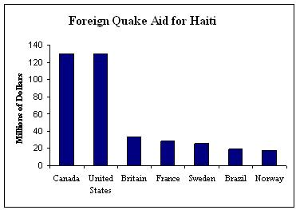
The United Nations said that altogether $13.34 billion was reserved for the crisis and expected to last through 2020, however two years after the shudder, less than half had really been discharged, that is according to U.N. documents. Listed in the USAID list of expenditures are: “emergency food for 4 million, temporary shelter for 1.5 million, 2.7 million cubic meters of rubble removed, 600 classrooms created, construction of a power plant for a new U.S.-brokered factory park, support for 160 health clinics, funding to arrest a cholera outbreak that killed nearly 9,000, better technology for farmers, and the creation of permanent housing.”

The lodging project can scarcely be marked a win, however. An administration review in 2013 observed that USAID didn’t plan for the amount that would be required for settlements, expanded the monetary allowance from $59 million to $97 million while cutting its objective from 15,000 houses to 2,649. It's only set up 900 so far.

Meanwhile, there are still 810,000 individuals in relocation camps — a large portion of which did not have latrines, as indicated by a UN report. Improvement plans for Port-au-Prince implied some downtown leaseholders were removed and their structures decimated. Where has all this aid gone and who is responsible for giving aid to those in need?
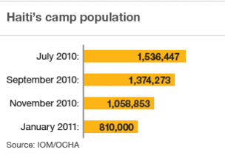
"I'm worse off than after the earthquake," said Jean-Louis Wilner, 32, who spent two years in a tent camp before being lucky enough to get a rental apartment that had been taken down to make way for a government center.
The voices of local people were overlooked by foreigners, undermining responsibility and maintainable development. As the Center for Global Development reported for this present month, just 0.6% of the cash spent by joint and multilateral givers was given to Haitian foundations and organizations. In the mean time an unexpected 40% continued supporting every one of the outsiders apportioning aid, with their expensive lodging recompenses, vehicles and drivers.

Natural Disasters

Natural disasters are classed as "great" if the capacity of the locale to help itself is unmistakably strained, making additional help necessary. This is normally the situation when a large number of individuals are killed, several thousands are made destitute, or when a nation endures significant financial misfortunes (contingent upon the monetary circumstances in that nation).

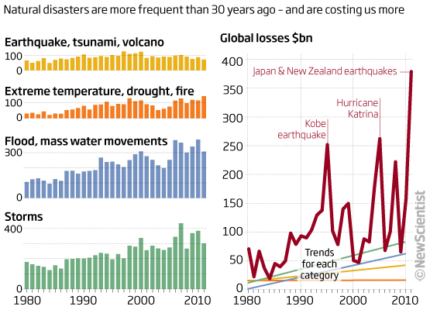

In the last one thousand years more than 15 million individuals have likely died in 100,000 periodical natural disasters. This figure does exclude fiascos like dry seasons and starvations which are hard to survey in numerical terms and can be responsible for the loss of millions more. Whilst there has been a precarious increment in the quantity of regular calamities and the guaranteed misfortunes they create due to the higher centralization of individuals and qualities, the quantity of casualties, in connection to the developing populace of the world, is by all accounts slowly declining on account of enhanced early cautioning frameworks and insurance strategies.

$380 billion. That is how much natural catastrophes cost the worldwide economy in 2011, making it the costliest year on record. The quantity of quakes has stayed stable subsequent to 1980 yet their financial expense is rising. Conversely, the quantity of climate related occasions surges and dry spells are rising. Evidence recommends this is connected to environmental change, especially on account of increased temperatures and precipitation.

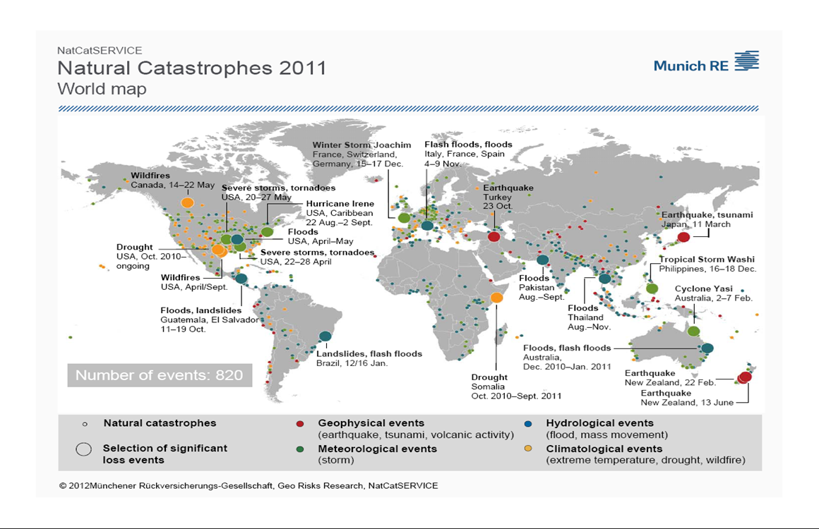

“Thankfully, a sequence of severe natural catastrophes like last year's is a very rare occurrence. We had to contend with events with return periods of once every 1,000 years or even higher at the locations concerned. But we are prepared for such extreme situations. It is the insurance industry's task to cover extreme losses as well, to help society cope with such events and to learn from them in order to protect mankind better from these natural perils,” said Torsten Jeworrek, Munich re board member responsible for global reinsurance business.
But are natural disasters a rare occurrence?
While some may suggest that 2011 was certainly unlikely year for many, more convincing evidence suggests that natural catastrophes are a regular occurrence and not only is the frequency of the catastrophes increasing, the magnitude of the disasters is increasing as well. In 2009 the world was similarly hit by natural disasters and this pattern continues as far back as history has been recorded. Yet, take a look at how natural disasters have become more frequent.
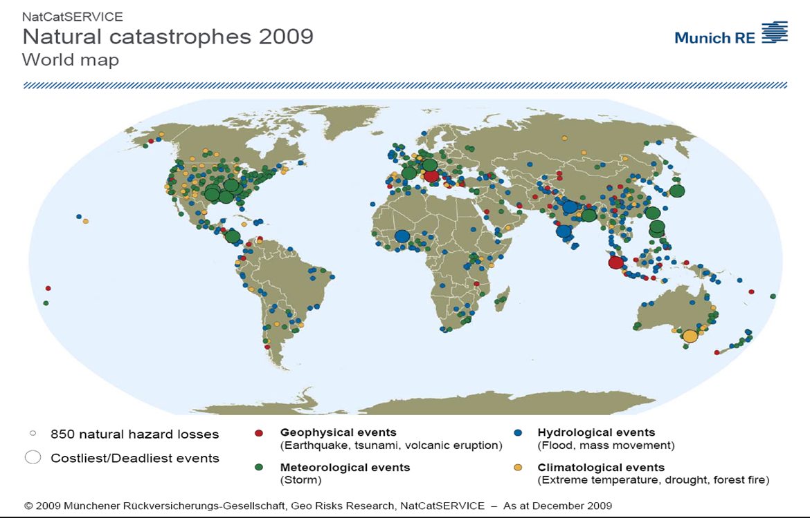

With around 820 disasters ending in suffering, the figures for 2011 were in accordance with the last ten years. 90% of the recorded natural disasters were climate related – then again, almost 66% of financial misfortunes originated from geophysical sources, basically from the substantial seismic quakes. Ordinarily, it is the climate related natural disasters that are the prevailing causes. All things considered in the course of the most recent three decades, geophysical events represented just shy of 10% of protected losses. The dissemination of territorial misfortunes in 2011 was likewise abnormal. Around 70% of monetary misfortunes in 2011 took place in Asia.
Around 27,000 individuals succumbed to natural disasters in 2011. This figure does exclude the innumerable individuals who kicked the bucket as an aftereffect of the starvation due to drought on the Horn of Africa, which was the worst humanitarian disaster of the year. Civil war and political unsteadiness made it extremely hard to give effective aid to those affected.
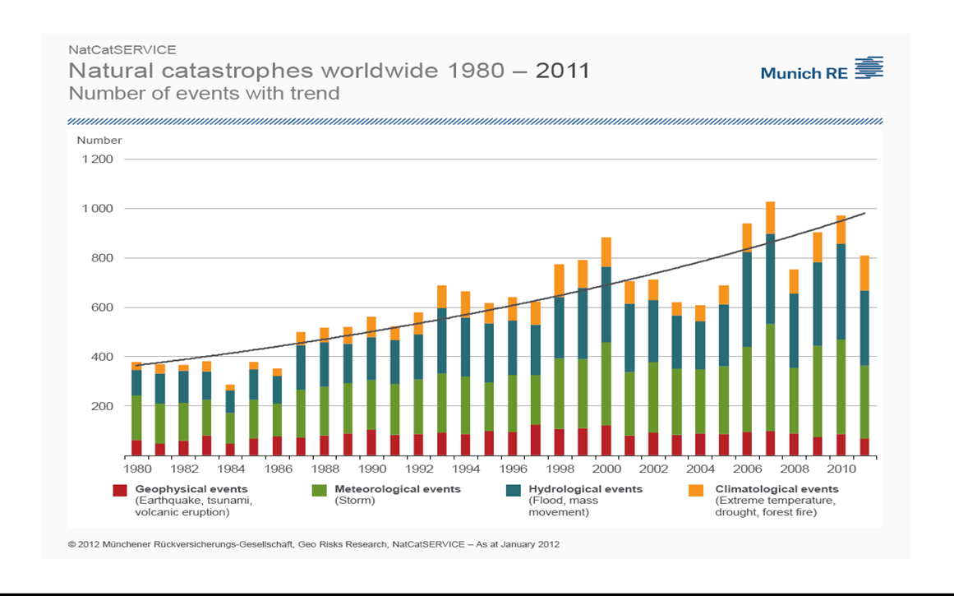
Worst Natural Disasters

Natural disasters are merely a part of an ever-changing planet. Vast improvements in technology have allowed for earlier and more precise warning systems for natural disasters, but the disasters themselves continue to occur just as they did in the past. In fact the ten worst recorded natural disasters span between the 1300s and the 21st century.

1. Spanish Influenza (1918): Death of 20 million to 40 million people, though other estimates range from 40 million to 100 million people.

2. The Black Death (1348): Killed an estimated 25 to 60% of Europe’s population, though some estimates were higher which would mean somewhere between 75 million to 200 million people.

3. Gujarat Earthquake (2001): Had a magnitude between 7.6 and 7.7 and resulted in a death toll of 20,000 people, injured 167,000 and destroyed 400,000 homes.

4. The Great White Plaque (1600s): This tuberculosis epidemic lasted for nearly 200 years. It was the leading cause of death in 1650.

5. North American Smallpox Epidemic (1775): Caused by a contagious virus known as “Variola major,” the initial signs of smallpox came 12 days later after exposure, where early symptoms included backache, fever, headache, vomiting, and general malaise.

6. Mozambique Flood (2000): Occurring between the months of February and March; it resulted in homelessness as it affected 1,400 sq km of arable land, killing 800 people and 20,000 cattle.

7. Yangtze River Floods (1931): When torrential rains hit southern China in August 1931, it caused the Yangtze River to flood killing nearly 3.7 million people.

8. European Heat Wave (2003): The hottest since 1540, at least 14,802 casualties recorded in France alone with victims coming from old people in nursing homes, or single family homes with no air-conditioning systems.

9. North Korean Famine (1994): estimated death toll of between 240,000 and 3,500,000 caused by starvation and hunger-related illnesses. Out of its 24 million people, 5 million are malnourished including 800,000 children with 80,000 on the brink of starvation.

10. East Africa Drought (2011): the Horn of Africa experienced a severe drought since mid-July of 2011 with an estimated 12.4 million people in need of food. It resulted in a food crisis across Kenya, Somalia, Ethiopia, and Djibouti, threatened the livelihood of more than 9.5 million people, and caused widespread death and famine.
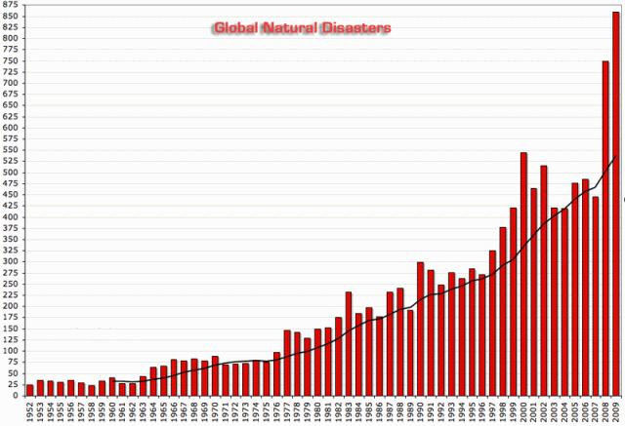
Who aids in the instance of a natural disaster?

Currently, there are a number of organizations that work to provide international relief when disaster strikes. Each organization has varying missions, resources, and capabilities that allow these organizations to provide assistance on a very broad scale. There are hundreds of relief organizations worldwide. Humanitarian Relief Organizations direct volunteers and donors to organizations that provide assistance during humanitarian crises. Every organization has a different mission varying from quick response to natural disasters to long-term solutions to rebuild and prevent further disasters. These organizations provide a multitude of support after natural disasters:
World Vision
World Vision focuses on international aid, specifically developing countries where poverty and lack of resources exacerbate the suffering. World Vision works in many of these countries, preparing for disasters before they happen, and responding quickly when they do.Within the first couple of hours after a disaster, World Vision staff members closest to the disaster respond with reports on the level of severity and need. World Vision provides extended support after a natural disaster working to help families stabilize by providing assistance with temporary shelter, water, sanitation and hygiene, child protection activities, healthcare, and economic opportunities. World Vision has one of the most comprehensive emergency relief operations in the world and has responded to a new emergency somewhere in the world on average every four days.

International Federation of Red Cross and Red Crescent Societies (IFRC)
The International Red Cross and Red Crescent Movement is the largest humanitarian network in the world. Their mission is to alleviate human suffering, protect life and health, and uphold human dignity especially during armed conflicts and other emergencies. It is present in every country and supported by millions of volunteers. IFRC is not a single organization, but is instead composed of the International Committee of the Red Cross (ICRC), the International Federation of Red Cross and Red Crescent Societies and the 189 individual National Societies. The IFRC deploys disaster experts to assess the humanitarian needs, organizes relief distributions and provides emergency shelter in natural disasters. Additionally, they mobilize relief supplies, ranging from tarps and blankets to cooking items and hygiene supplies; contribute financial assistance to support the local purchase and delivery of relief supplies, and other essential services such as emergency shelter, health care, clean water and emotional support; and they work to reconnect families that are separated across borders by war or disaster.

US Agency for International Development (USAID)
U.S. foreign assistance has always had the twofold purpose of furthering America's interests while improving lives in the developing world. USAID carries out U.S. foreign policy by promoting broad-scale human progress at the same time it expands stable, free societies,and creates markets and trade partners for the United States. The USAID has worked extensively in South Sudan and Syria and remains committed to responding to crises around the world, to help the people and places most in need. With a focus on disaster prevention, response, recovery and transition, the USAID works to Strengthen resilience by helping states and communities prepare for and mitigate the impacts of disasters to help people withstand crises rather than have to seek emergency assistance; Provide life-saving humanitarian assistance to save lives and alleviate suffering; Provide emergency food assistance while also sowing the seeds for recovery and resilience; Accelerate a rapid and durable recovery by supporting livelihoods, markets and the sustainable provision of basic services;
United Nations Office for the Coordination of Human Affairs (OCHA)
OCHA is the body responsible for coordinating relief efforts in natural disaster.Humanitarian coordination seeks to improve the effectiveness of humanitarian response by ensuring greater predictability, accountability and partnership. OCHA is the part of the United Nations Secretariat responsible for bringing together humanitarian actors to ensure a coherent response to emergencies. OCHA also ensures there is a framework within which each actor can contribute to the overall response effort. They play a key role in natural disaster response because of their ability to organize resources and people from agencies and organizations within and separate of the UN to ensure a cohesive strategy.

UN Refugee Agency (UNHCR)
The UNHCR is mandated to lead and coordinate international action to protect refugees and resolve refugee problems worldwide. Its primary purpose is to safeguard the rights and well-being of refugees. They recognize the growing number of people displaced internationally by natural disasters and climate change. “The process of climate change – and the multiple natural disasters it will engender – will in all certainty add to the scale and complexity of human mobility and displacement.”

