OAS: Human Trafficking
Background

Introduction
Human trafficking is the involuntary abduction and transportation of humans for the purpose of exploitation of those humans. The means and methods vary immensely, as do the nature of the exploitation that occurs. Human trafficking is a global phenomenon, and takes place in almost all countries in the Western Hemisphere. It is an age old institution, although it is often historically referred to as slave trade.
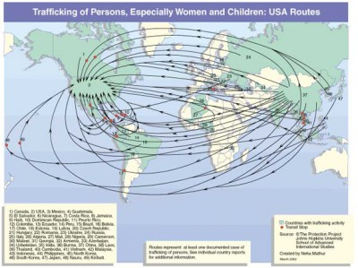
Human trafficking is often referred to as modern day slavery. It is difficult to know exact numbers with regard to human trafficking, since it is incredibly illegal and performed not only by vast criminal networks working on an international level but by many small, individual networks working on a local scale as well. However, it is estimated that there are at least 2.4 million people that are victims of human trafficking at any one time. Of those 2.4 million, nearly 2 million (80%) are forced into working as sexual slaves. 17 percent are forced into labor, often in sweat shops, houses, or other horrific conditions. Additionally, two thirds of the victims of human trafficking are women, and over a third are children.The industry as a whole is worth over $32 billion dollars every year, and it is “one of the fastest growing and lucrative crimes”, according to Michelle Bartlet, head of UN Women.
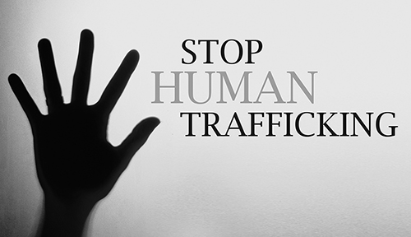
The Organization of American States has a division known as the “Anti-Trafficking in Persons Section” that is devoted to fighting against trafficking in persons (TIP). This group works to take steps against TIP on a scale that is impossible to achieve for local governments. The focus of this division and of the OAS as a whole with regard to this issue is to broaden awareness of TIP, identify policies to reduce TIP, and working to implement said policies. Recently, more and more countries in the OAS have passed harsh legislation to try and curb the spread of TIP, but despite this success in harsher legislation, there have been few actual convictions of human trafficking charges. Only one country had more than 50 convictions of human trafficking charges between 2010 and 2012, and the average rate of convictions of all cases was around 10 percent. This is despite the large increase in human trafficking that occurred during this time. It is evident that there is a problem in the OAS member states with regard to human trafficking, and it is the responsibility of this council to try and create more effective methods of curbing TIP in the Latin American region.

Human Trafficking
Human trafficking is formally defined by the United Nations Protocol to Prevent, Suppress and Punish Trafficking in Persons, Especially Women and Children, Supplementing the United Nations Convention Against Transnational Organized Crime as:
...recruitment, transportation, transfer, harbouring or receipt of persons, by means of the threat or use of force or other forms of coercion, of abduction, of fraud, of deception, of the abuse of power or of a position of vulnerability or of the giving or receiving of payments or benefits to achieve the consent of a person having control over another person, for the purpose of exploitation. Exploitation shall include, at a minimum, the exploitation of the prostitution of others or other forms of sexual exploitation, forced labour or services, slavery or practices similar to slavery, servitude or the removal of organs.

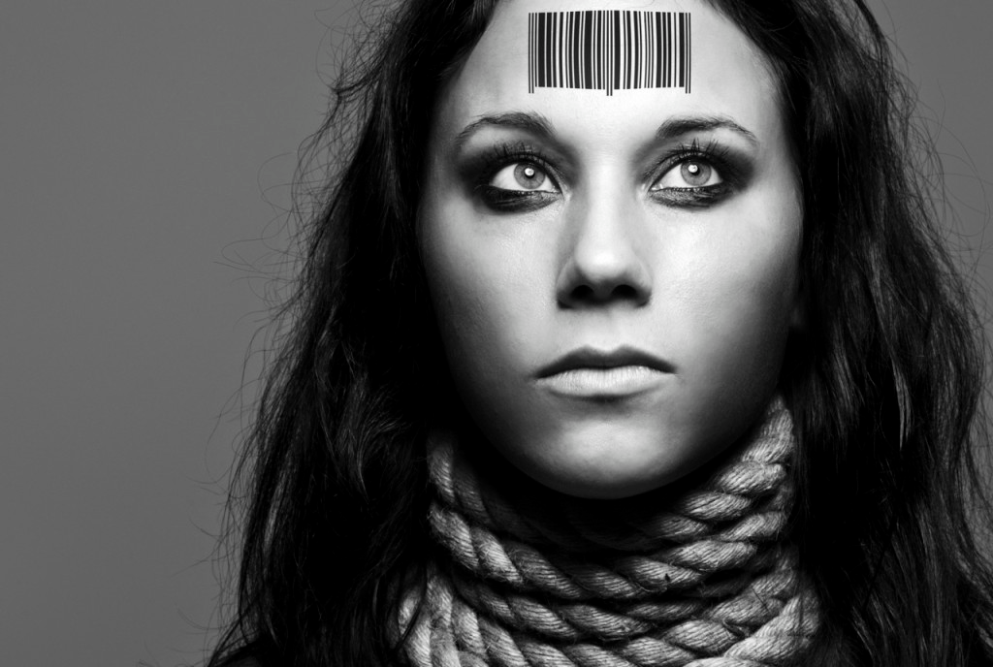
As is evident by the definition, the term ‘human trafficking’ or ‘trafficking in persons’ can refer to a wide variety of forced activities. These include bonded labor, forced labor, sexual labor, and organ harvesting. The methods of trafficking are varied as well, and include force or the threat thereof, fraud, deception, abduction, and coercion. A large focus has, in recent years, been placed on sexual exploitation, in large part because of the large percentage of TIP victims forced to engage in either pornography, prostitution, and/or stripping.
Because TIP is a crime whose victims are multitudes of poor individuals, and the methods of TIP are so varied, it is very difficult to stop the spread of trafficking. Additionally, the power dynamic that occurs between the trafficked victim and the trafficker is very difficult to overcome, and often results in reluctance to speak out on the part of the victim. This can, once again, take many forms, including creating intense fear, giving the trafficked victim a sense of purpose, or convincing the victim that they lack self-worth or skills in their new situation. All these serve to keep the victim in a state of helplessness and in what amounts to slavery.
The graphic below shows some statistics relating to the trafficking of persons into North America. It is worth noting once more that this is a growing criminal industry, and is only surpassed by drug trade. Millions are consumed by the industry each year, and millions more will continue to be devastated by this horrific institution unless stricter measures are taken to prevent its occurence.
It is important to distinguish human trafficking from human smuggling. Trafficking occurs when someone is transported to another location and forced into labor. It is a terrible crime, and has victims that suffer greatly. Human smuggling generally occurs when the person wishing to be smuggled across a border or region pays the smuggler to bring them across, and does not have an obvious victim. However, at the same time, note that TIP is often disguised as human smuggling.

Trafficking in Latin America
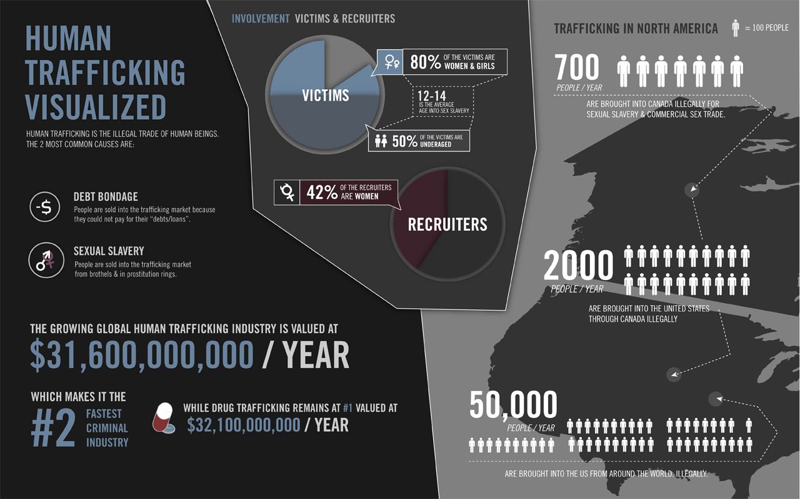
Human trafficking is a worsening problem in Latin America. The primary destinations of trafficked victims out of these nations are the United States and Canada, although some South American nations serve as destinations as well. United States State Department officials have estimated that over 100,000 people are trafficked in the region every year, with 10,000 of those consisting of women being brought into Northern Mexico for sexual exploitation.
44 percent of the victims of TIP in Latin America are trafficked for the purpose of labor. A recent report by the ILO stated the number of victims of forced labor in Latin America as 1.8 million, many of whom were TIP victims. Most of the victims of forced labor driven TIP remain in the Latin American or South American region, but some also join the large number of illegal migrants that immigrate to the United States, where a lack of legal protection and harsh working conditions in combination with the large demand for cheap labor have created an easy market for TIP.
Children are also often victims of trafficking, especially street children or orphan children. Some of this trafficking is for the purpose of sexual exploitation, while others are trafficked to serve as domestic servants, with some estimates placing as many as a million children currently in domestic servitude in Latin America, many of whom are subjected to physical, verbal, and sexual abuse. Others have been trafficked for the purpose of employment in criminal organizations, fighting as child soldiers, and illegal adoptions.
TIP is especially prevalent in Latin America for a number of reasons. Poverty, unemployment, illiteracy, and drug use have been highlighted as risk factors for TIP, and are often prevalent in Latin America. Additionally, high global demand for domestic servants, country wide crises, machismo and sexism, the existence of already established TIP organizations and networks, public corruption, harsh immigration requirements in destination countries, and limited economic employment are all factors that result in a prevalence of trafficking in the region.
Past Actions
Both the UN and the OAS have already taken actions to fight against human trafficking. The OAS adopted Resolution 1948 in 2003, “Fighting the Crime of Trafficking in Persons, especially Women, Adolescents, and Children”. The OAS also works to train regional law enforcement officials to prevent and fight TIP on a local level. In 2010, the OAS supported the Committee of Hemispheric Security’s Work Plan Against the Trafficking of Humans in the Western Hemisphere, a plan that serves as a reference to guide OAS member states in preventing TIP.
Those interested in the UN’s attempts to stop TIP, especially through its protocols of prevention of trafficking, prosecution of trafficking offenders, and protection of the victims, should visit the UNODC’s website, at www.unodc.org. In general, however, the UNODC has worked to fight against trafficking by researching and raising awareness regarding the issue, promoting its protocols designed to fight TIP, and strengthening international and interregional partnerships.

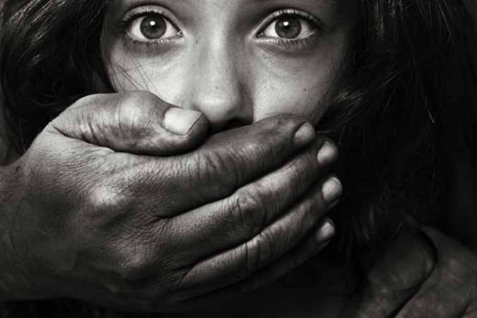

"2.4 Million Human Trafficking Victims." HumanTrafficking.org. N.p., 3 Apr. 2012. Web. 23 Aug. 2015.
"Anti-Trafficking in Persons Section." Organization of American States. N.p., n.d. Web. 23 Aug. 2015.
"Latin America's Success (and Struggles) in Fighting Human Trafficking." InsightCrime.org. N.p., 02 Dec. 2014. Web. 23 Aug. 2015.
"United Nations: Protocol to Prevent, Suppress and Punish Trafficking in Persons, Especially Women and Children, Supplementing the United Nations Convention Against Transnational Organized Crime." International Legal Materials 28.2 (1989): 493-526. Web. 23 Aug. 2015.
"Fighting Human Trafficking in the Americas." OAS. N.p., 2015. Web. 23 Aug. 2015.
"Trafficking in Persons in Latin America and the Caribbean." Congressional Research Service 14.2-3 (2015): 4-7. 29 July 2015. Web. 23 Aug. 2015.
"What Is Human Trafficking?" United Nations Office on Drugs and Crime. United Nations, 2015. Web. 23 Aug. 2015.

