Cherokee Trail High School Model United Nations

INTERMEDIATE
SECURITY
COUNCIL

Background Guide

Introduction to the United Nations Security Council
It is the job of the United Nations Security Council to peacefully settle acts of aggression and threats to global peace. The Security Council also has the authority to impose sanctions, deploy Peacekeeping Operations, formulate plans to regulate armaments, call on Members to impose economic sanctions, and in some situations authorize the use of force to maintain international peace and security. The overall agenda of this Security Council is to resolve the matters at hand and maintain peace and security.

Topic 1: Invasions and Resource Claims Prior to the Persian Gulf War
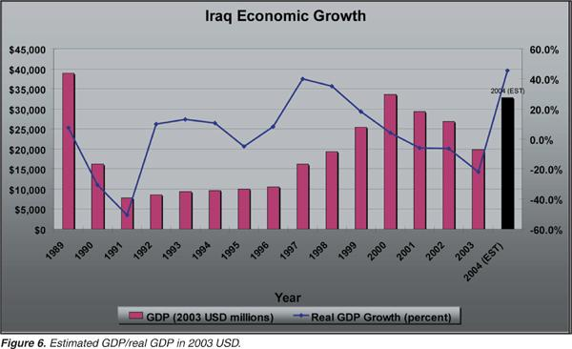
Past Relations in the Region
Kuwait was granted independence in 1961 by Britain; however, Iraq did not recognize the country as independent until 1963 as it had previously been governed by the Ottoman province in southern Iraq. Even after Iraq’s recognition of the nation, the two neighboring countries occasionally fought along their joining border.
During the Iran-Iraq War from 1980-1988 tensions between the two countries diminished. Kuwait assisted Iraq financially, loaning between 14 and 24 billion dollars to the struggling nation. After the war ended in 1988 Iraq initiated a costly reconstruction program to repair some of the damage, and fell into a deeper debt. The United Nations Compensation Commission calculated that Iraq was nearly 50 billion dollars in debt and owed a large portion of that money to Kuwait.

Tensions Over Oil Claims in the Region
Iraq attempted to repay the debt by increasing oil prices through OPEC oil production cuts. Kuwait on the other hand, had increased oil production and sales and was able to lower prices. This surge in sales for Kuwait caused oil prices to go down on a wide scale and Iraq was not profiting as much as they used to. 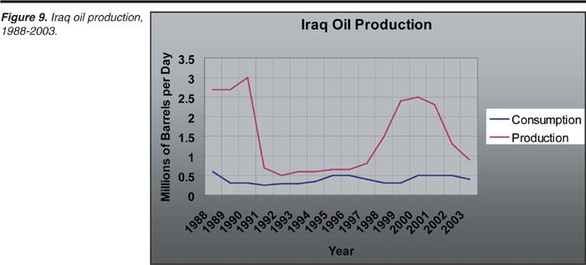

Iraqi leader at the time, Saddam Hussein, eventually discovered that Kuwait had been drilling on the shared border and accused the nation of siphoning crude oil from a common border. Hussein then exhorted that Kuwait and Saudi Arabia cancel out the combined owed debts of 30 billion dollars. At the same time, Iraq began to build up troops on Kuwait’s borders. This action prompted President Hosni Mubarak of Egypt to initiate negotiations between the squabbling countries in effort to keep the United States and other non-Gulf countries out of the matter. Hussein broke off all negotiations and invaded Kuwait on August 2nd, 1990, assuming that the majority of his fellow Arab states would ally with Iraq. This invasion caused the Persian Gulf War, also known as Operation Desert Shield

Summary of Topic
Relations between Iraq and Kuwait have changed numerous times since Kuwait became independent in 1961. Kuwait aided Iraq during the Iraq-Iran War (1980-1988) and loaned billions of dollars to the struggling nation. The Arabian Peninsula is abundant in oil and both countries attempted to make money through oil sales in order to make up for their loss after 1988; however, Iraqi leader Saddam Hussein suspected that Kuwait was illegally drilling in Iraq. Though some negotiations were being discussed with the help of Egypt, Hussein called them off and invaded Kuwait in 1990 which caused the Persian Gulf War. Now, in order to create long lasting peace and settle money and resource disputes among Iraq and Kuwait the Security Council must decide how to take action.

Sample Positions
- Iraq believes that Western powers should stay out of the matter and Hussein believes he should be able to invade and occupy Kuwait.
- The United States, and specifically (former) President George H.W. Bush condemned the invasion of Kuwait.
- Saudi Arabian King Fahd believes that the U.S. should provide military assistance.
- The United Arab Emirates was one of the first nations to propose combined milotary action to prevent Iraq from invading Kuwait.

Timeline
This link goes to a timeline that has events that took place leading up to the Persian Gulf War and contains important information that will help Members better understand why this conflict arose.
- https://www.timetoast.com/timelines/58136
Questions to Consider
- To what extent are the actions of Iraq the primary source of aggression and disruption of peace?
- How might the Arab states, whom Saddam Hussein assumed would join forces with him, support during this conflict?
- What gives a country, such as the United States, the right to intervene in these resource disputes?
- To what extent are Saddam Hussein’s claim that Kuwait was never a real country, but just a piece of land carved out of the Iraqi coasts by Western colonialists valid?
Resources
These resources contain useful information that will help delegates narrow down their country’s appropriate opinion on the crisis at hand.
- http://www.history.com/topics/persian-gulf-war
- http://www.cnn.com/2013/09/15/world/meast/gulf-war-fast-facts/index.html
- https://www.britannica.com/event/Persian-Gulf-War
- https://history.state.gov/milestones/1989-1992/gulf-war
- https://undertheradar.military.com/2015/09/21-facts-about-the-first-gulf-war/

Topic 2: Dealing With the Iranian Hostage Crisis
Past Relations
Iran and the United states were on good terms prior to the Iranian Hostage Crisis. Iran had just signed on to the Proliferation Treaty in 1968, and Former President Gerald R. Ford had even permitted the development of nuclear technologies in Iran that would fabricate fuel for the United States in 1975. In 1977 Former President Jimmy Carter visited the Iranian shah and can be quoted saying, “Iran, because of the great leadership of the shah [Mohammad Reza Pahlavi], is an island of stability”. However Iran’s stability was not long lived.

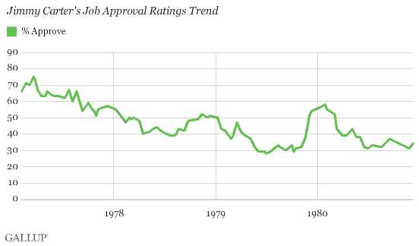

Iran’s Islamic Revolution
From 1978-1979 Iran was in a state of distress. In January of 1978 religious school youth began protesting in the streets after being outraged by slanderous remarks made against Ruhollah Khomeini, Former Supreme Leader of Iran. Iranian youth began to protest by the thousands and the shah, who at the time had cancer and was very ill, was shocked at the sudden outbursts of hostility against himself. As the government got involved the protesters were only fueled with more anger. If a protester was killed by someone in the government, the protesters would become enraged as it is a custom for the Shi'ite Muslims to mourn the dead for 40 days. Khomeini demanded the shah’s abdication, and in January of 1979, the shah and his family fled Iran. A month later, Khomeini returned to Iran
Deterioration of United States and Iranian Relations
When Khomeini returned he labeled the United States “The Great Satan” and this imprinted a hatred for the U.S. into the minds of the Iranian protesters. This hatred was only strengthened when Former President Carter allowed the deposed Shah to enter the country and receive cancer treatment. By November 1979 tensions were higher than ever and protesters began to crowd around the U.S. embassy. The protesters shouted anti-American slogans and on November 4, 1979 nearly 3,000 protesters climbed over the wall surrounding the embassy and took 66 people hostage. Those people were embassy workers, Marine guards and military officers and now it is up to the Security Council to resolve this issue.
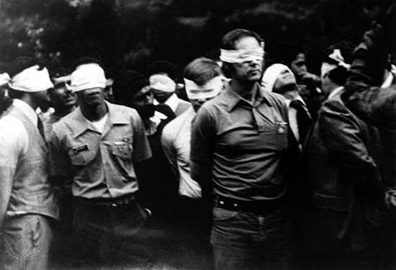

Sample Positions
- The United States believes that President Carter’s actions were humanitarian and not political, therefore, diplomatic relationships with Iran will be cut off and elite paramilitary units should be deployed.
- Iran is outraged by the United States’ actions and will not return the hostages unless the Shah is returned to Iran.
- The United Kingdom is a known ally of the United States and eventually voted in favor of Security Council Resolution 461 that condemned Iran for not releasing the hostages.
- Russia, at the time known as the Soviet Union, cancelled treaties with Iran due to this crisis such as the Soviet-Iranian Defense Treaty of 1921.

Questions to Consider
- How did the start of the Iran-Iraq War in 1980 push Iran to begin negotiating with the United States?
- How did this crisis, which is the longest known hostage situation on record, change diplomatic relations between Iran and the US?
- How did former President Carter and the 1980 Presidential Election affect the Iranian Hostage Crisis?

Timeline
January 16, 1979 - The Shah flees Iran and goes to Egypt.
February 1, 1979 - Ayatollah Ruhollah Khomeini returns to Iran, after 14 years in exile, to lead the country.
October 22, 1979 - The Shah is allowed to enter the United States to receive medical treatment for cancer.
November 4, 1979 - Iranian students demonstrating outside of the US embassy in Tehran storm the embassy and take 90 people hostage including 66 Americans. The students demand the extradition of the Shah from the United States. Ayatollah Khomeini issues a statement of support for the students' actions.
November 5, 1979 - The Iranian government cancels military treaties with the US and the Soviet Union, treaties that would permit US or Soviet military intervention.
November 6, 1979 - Premier Mehdi Bazargan and his government resign, leaving Ayatollah Khomeini and the Revolutionary Council in power.
November 7, 1979 - US President Jimmy Carter sends former Attorney General Ramsey Clark and Senate Intelligence Committee staff director William Miller to Iran to negotiate the release of the hostages. Ayatollah Khomeini refuses to meet with them.
November 14, 1979 - President Carter orders Iranian assets in US banks frozen.
November 17, 1979 - Khomeini orders the release of female and African-American hostages. They are released November 19 and 20, bringing the total number of US hostages to 53.
December 4, 1979 - The United Nations Security Council passes a resolution calling for Iran to release the hostages.
January 28, 1980 - Six American embassy employees, who avoided capture and hid in the homes of Canadian Embassy officers, flee Iran. In 1997 it is revealed that, along with the Canadian government, the CIA made the escape possible.
April 7, 1980 - President Carter cuts diplomatic ties with Iran, announcing further sanctions and ordering all Iranian diplomats to leave the United States.
April 25, 1980 - Eight US servicemen are killed when a helicopter and a transport plane collide during a failed attempt to rescue the hostages.
July 11, 1980 - Another hostage is released due to illness. The total number of US hostages is now 52.
July 27, 1980 - The Shah dies of cancer in Egypt.
September 12, 1980 - Ayatollah Khomeini sets new terms for the hostages' release, including the return of the late Shah's wealth and the unfreezing of Iranian assets.
January 19, 1981 - The United States and Iran sign an agreement to release the hostages and unfreeze Iranian assets.
January 20, 1981 - The remaining 52 US hostages are released and flown to Wiesbaden Air Base in Germany.

Resources
These resources contain useful information that will help delegates narrow down their country’s appropriate opinion on the crisis at hand.
- http://www.history.com/topics/iran-hostage-crisis
- https://www.britannica.com/event/Iran-hostage-crisis
- http://www.encyclopedia.com/history/united-states-and-canada/us-history/iran-hostage-crisis
- https://www.whitehousehistory.org/teacher-resources/jimmy-carter-and-the-iranian-hostage-crisis

