The Denver Center for International Studies and East High School
Model United Nations Conference
January 28, 2017

Background Guide
Beginner Security Council
Topic: Dakota Access Pipeline
Presiding Officer

Note to the Delegates
Greetings Delegates,
Welcome to this year’s Colorado High School Model United Nations Conference at East High School and hosted by the Denver Center for International Studies (DCIS) and Denver East High School! I hope you find this background guide useful as it serves to bring your attention to the United Nations Security Council’s decision making power and introduce the pressing matter of the usage of children in armed conflict. We fully hope that you will explore member states positions and policies further. This background guide will provide you with an abundance of starting points for your research, but you should not research using this background guide alone. Each delegation should prepare a written position statement and present it at the day of the conference. We can’t wait to host the conference this January and see what you all bring to the table on January 28, 2017.

Committee Specifics
The Senate Subcommittees will function in this council with normal MUN parliamentary procedure with a few exceptions. This is due to the fact that the Senate functions much like the UN in procedural matters with few minor differences most of which are names and speaking times. The most notable difference however is the role of the Committee Chair who has the ability to produce a "Chairman's mark" on any legislation the Committee considers, which can generally be used to render changes made to bills by Subcommittees pointless, as well as to remove and/or add provisions the Chairman does not or does like. Another difference in the function of this Committee shall be that draft resolutions shall be referred to as draft bills, working papers as bills, and resolutions as suggested legislature. Although customarily bills are drafted before debate in the Senate Subcommittees is held, this council will discuss and draft bills, and suggest legislature while in council and throughout debate, as is customary in normal MUN procedure.

History of the Committee
The Committee/s on Indian Affairs have been disjointed since the existence of both Senate and House Committees in the early 19th century. The aforementioned Committees also often ignored or promoted the Ignoring of Native American rights and did nothing to stop the grievances placed against the native americans throughout the 19th century and into the early 20th century. The Committees themselves were later reduced to Sub-Committees under the Committees for Insular and Interior Affairs. This reduction coincided with the beginning of the Termination era of the United States, in which Indian Affairs took a 20 year hiatus. By the end of this period in the early 1970’s a total of 10 Committees were responsible for Indian Affairs which led to a haphazard development of the Federal policy towards Native Americans. This fragmentation started to end with the establishment of the American Indian Policy Review Commission, whose task was to review all aspects of policy, law, and administration relating to affairs of the United States with American Indian tribes and people. In 1977 under the commission's recommendation a select Committee for Indian Affairs was formed. As the increasing large amount of problems and legislative issues regarding Indian Affairs were presented to the Senate is became clear that a permanent Committee was necessary. In 1983 the permanent Committee was established and its jurisdiction includes the study the unique problems of American Indian, Native Hawaiian, and Alaska Native peoples and to propose legislation to alleviate these difficulties. This Committee underwent several changes in regards to membership from an original 7 members up to 18 members, and down to 14 members. This final 14 member Committee is the current Committee under the U.S. Senate and the one in which debate will be held for this meet.

Overview of the Topic
The Dakota Access Pipeline, also known as the Bakken Oil Pipeline, is a 1,200 mile underground oil pipeline project in the United States spanning 4 states. It is under construction by Dakota Access, LLC, a subsidiary of Energy Transfer Partners, L.P. The pipeline is currently 87% complete and construction started in January 2016. The pipeline construction was unhindered up until the Standing Rock Sioux tribe sued the Army Corps of Engineers, (ACE), on July 27th in order to halt construction of the Pipeline. The suit came after a petition for the ACE to stop construction, and the suit’s hope was for the court to strike down the ACE’s permit. The protests started after the Sioux Tribe Sued, and opponents of the pipeline camped near the construction site. The situation escalated with alleged destruction of burial grounds by construction crews, and the first episode of violence occurred when protesters attempted to confront and stop the workers. In september of 2016 a U.S. District Court Judge ruled in favor of ACE, stating that, “the Tribe has not demonstrated an injunction was warranted here,”. Tensions continued to grow as protesters claimed police held them in dog kennels after they were arrested and peaked in November 2016 with police spraying protesters with water hose in freezing weather. Tensions diffused almost entirely with after months of protest the ACE denied Dakota Access the easement required to construct under lake Oahe, until a full environmental review of the pipeline was complete.

Specific Information Regarding the Pipeline
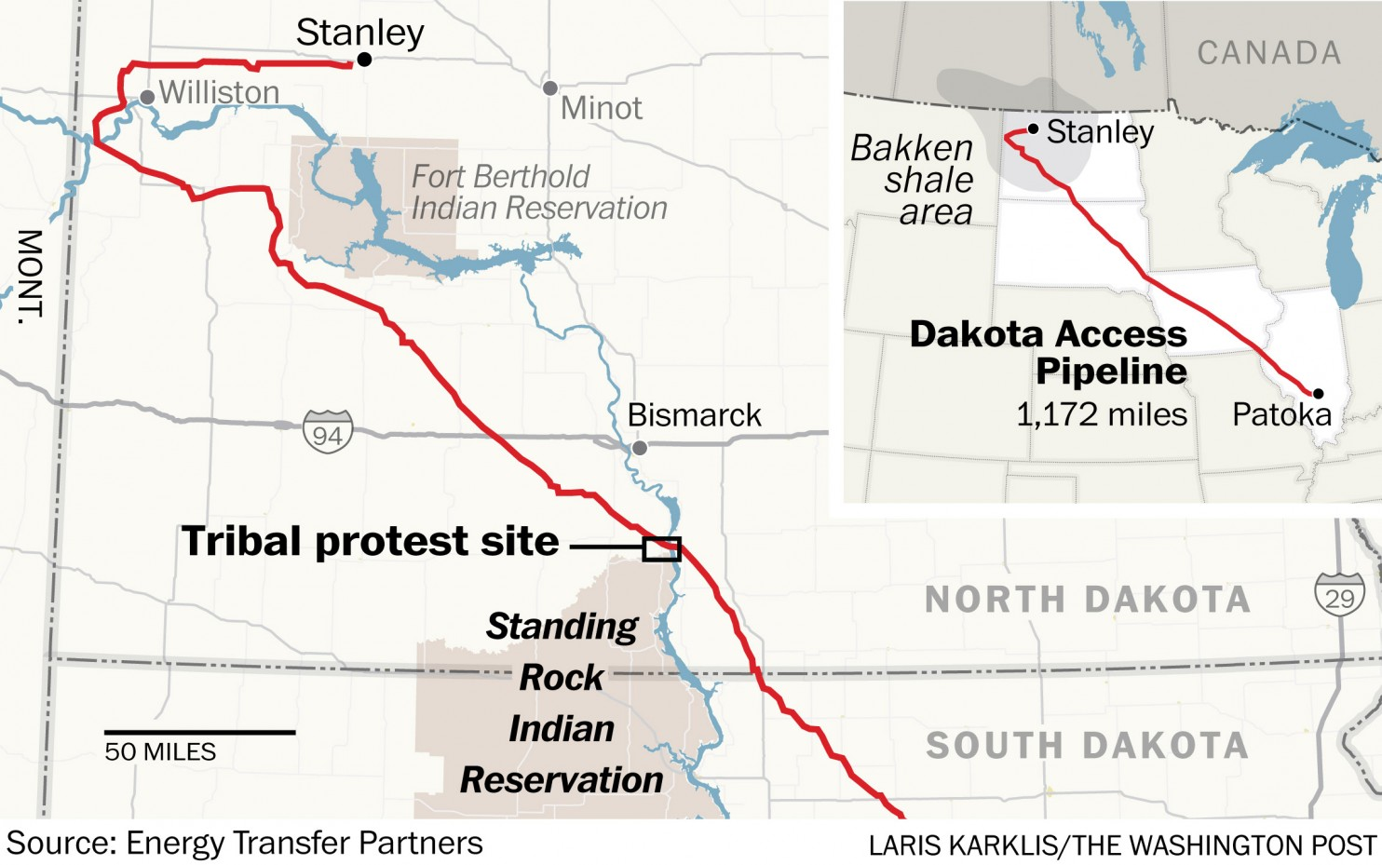
The pipeline route runs from the northwestern North Dakota Bakken and Three Forks sites. It starts in Stanley, North Dakota, and travels in a southeastward direction to end at the oil tank farm near Patoka, Illinois. It crosses 50 counties in four states.Dakota Access estimated the pipeline would cost $3.78 billion, of which $1.4 billion would be invested in the North Dakota portion, $820 million in the South Dakota portion, $1.04 billion in the Iowa portion, and $516 million in the Illinois portion.

Arguments Against the Pipeline
The Dakota Access Pipeline has sparked a controversy across the United States, originally purely environmental arguments have been made but since the issue was brought forth by the Sioux Tribe many more possible impacts have been clear. The primary argument against the pipeline is possible environmental contamination on Lake Oahe, one of the primary sources of water for Standing Rock Indian Reservation. The main concern here is the possibility of a spill contaminating the water of the tribe which could be seen as a use of Native Americans as a first warning system. This falls in line with the narrative of the United States government continually ignoring Native rights in the past, the very thing this Committee was put forth to examine. However water contamination is not the only argument against the pipeline, already construction and protests have blocked many people from accessing the tribal burial grounds around the Standing Rock Indian Reservation. This complaint originally came from protesters when construction crews allegedly destroyed burial sites on the Tribe’s private land. This could definitely be seen as a violation of Native American rights and should be a key issue in regarding what this committee plans to suggest to the senate.

Arguments For the Pipeline
The Dakota Access Pipeline has fell under consistent scrutiny for its possible environmental impacts, when in fact proponents of the pipeline argue that it would lessen the environmental impact of transporting crude oil. This is due to the fact that over 418,000 barrels of oil a day are being moved by train from the Bakken oil region. It is estimated that this is 4.5 times more dangerous as a vehicle for transportation than the oil pipeline would be. If the pipeline is not built continued use of the rail will be necessary and spills may happen for frequently across the area. The pipeline itself is also a total of 95 feet under lake Oahe at the lowest point, this indicates that even if a spill were to occur the damage although still large, would be mitigated. Additionally there are a total of 8 other pipelines in close proximity with the lake, and one that runs underneath the lake that have been operating since 1982. This indicates how rare a pipeline spill is, and shows that the lake is already at risk for a spill, so stopping the construction of a much needed pipeline in order to safely transport oil is an unnecessary toil. The pipeline itself never crosses Standing Rock Sioux Reservation land, and crosses almost entirely private land, of which the owners have all agreed to allow for the construction. All of these indicate that although grievances against the natives seem to be prevalent, they are mis-founded, and that protests just don’t have a base for the risks they retort when taking into account the surrounding pipelines and general safety of pipelines as a whole.

Timeline of the Event
January 2016:
Dakota access LLC. greenlights construction of the Dakota Access pipeline.
April 2016:
Petition is started by the Standing Rock Sioux tribe to immediately halt construction, and for the Army Corps of Engineers to reevaluate permit requests. The petition itself got more than 430,000 signatures.
July 2016:
The Army Corps of Engineers gave approval to the pipeline. The Standing Rock Sioux Tribe filed an injunction to halt the pipeline's construction, and decide to sue the Army Corps of Engineers to get the permit struck down.
August 2016:
Protests start at standing rock with a growing total of around 3,000 people around the Sacred Stones camp at Standing Rock. The U.N. released a statement in support of the protests.
September 2016:
Violence first breaks out when construction workers allegedly violate burial grounds, and protesters attempt to stop them. A U.S. District Court Judge allows for construction to continue dismissing the case made against the pipeline, and the Army Corps of Engineers.
October 2016:
Tensions increase drastically, as police militarize around the protest zone and arrests start to occur. Additionally protests grow even larger, now involving not just the Sioux Tribe, and other Native Tribes, but non indigenous peoples as well. As arrests occur protesters claim police held them in dog kennels.
November 2016:
President Obama released a statement saying that the federal government could possibly intervene to reroute the pipeline. Protests gain full blown national attention with celebrities, politicians, and others publicly taking a stance on the issue. Tensions reach a maximum with the spraying of protesters with water in below freezing temperatures. Both the governor and Army Corps of Engineers made attempts to relocate protests, so construction could continue.
December 2016:
The Army Corps of Engineers did not grant easement to allow building of the pipeline to continue and mandated a full environmental review before the pipeline could continue construction.
Goals for Council
- To determine whether the claims of the Sioux tribe is justified, and if legislation needs to be put in place to prevent future events from happening.
- Decide if the way the pipeline permit and easement process was handled grants full rights to native americans.
- Determine any future grievances that may occur from the Dakota Access pipeline, and suggest legislation to fix these.
Possible Grievances Against Natives
- Possible contamination of a water source used by Native Americans.
- Possible, if unintentional, use of Natives as a first warning system.
- Alleged disturbance, destruction, and blockage of burial sites.
- Unnecessary force used against protesters.

Bibliography
- Javier, Carla. "A timeline of the year of resistance at Standing Rock." Fusion. N.p., n.d. Web. 16 Jan. 2017.
- Contributor, Quora. " Is the Dakota Access Pipeline safe?" Newsweek. N.p., 17 Nov. 2016. Web. 16 Jan. 2017.
- "Dakota Access Pipeline." NPR. NPR, n.d. Web. 16 Jan. 2017.
- "Dakota Access Pipeline Facts." Dakota Access Pipeline Facts. N.p., n.d. Web. 16 Jan. 2017.
- "Dakota Access Pipeline: What's at stake?" CNN. Cable News Network, n.d. Web. 16 Jan. 2017.
- "FAQ: Standing Rock Litigation." Earthjustice. N.p., 09 Jan. 2017. Web. 16 Jan. 2017.
- "Joint Statement from the Department of Justice, the Department of the Army and the Department of the Interior Regarding Standing Rock Sioux Tribe v. U.S. Army Corps of Engineers." Joint Statement from the Department of Justice, the Department of the Army and the Department of the Interior Regarding Standing Rock Sioux Tribe v. U.S. Army Corps of Engineers | OPA | Department of Justice. N.p., n.d. Web. 16 Jan. 2017.
- Sidder, Aaron. "Understanding the Controversy Behind the Dakota Access Pipeline." Smithsonian.com. Smithsonian Institution, n.d. Web. 16 Jan. 2017.

