Committee History

The Commission on the Status of Women (referred to as CSW from here on out) is a functional committee of the Economic and Social Council (ECOSOC), which is one the six principal organs of the UN. ECOSOC is responsible for issues concerning economic, social and environmental challenges. CSW is the fourth functional committee of ECOSOC, the others are the Statistical Commision, Commission on Population and Development, Commission for Social Development, Commission on Narcotic Drugs, Commission on Crime Prevention and Criminal Justice, Commission on Science and Technology for Development, Commission on Sustainable Development, and the United Nations Forum on Forests. The CSW was established in 1946 by ECOSOC resolution 11(II). The function of the commission is to assemble recommendations and reports on economic, social, political, educational and civil development of rights of women to the ECOSOC council. Every July ECOSOC convenes to set guidelines for the commissions to concentrate on the following year. CSW explores the agenda issues set by ECOSOC and then sends back a report to them, they who bring it to the General Assembly as a recommendations to be considered.
The CWS is responsible for topics related to the advancement of women with an emphasis on economic empowerment. Its original goals consisted of ensuring equality and promoting women’s rights. Their first measures involved getting rid of discriminatory laws, fostering awareness of women’s issues and increasing female political participation- which was especially poignant since only 25 of the initial 51 UN Member states gave women equal voting rights. Over the years the committee has evolved beyond these bounds and now addresses a range of different women’s issues.
As the times have changed so have the priorities of the CSW. In fifties the commission focused on discrimination in marriage laws, concentrating on divorce, minimum age of consent in marriage and registration of marriages. The Commission also touched on women’s literacy and practices harmful to women (though they couldn’t discuss female genital mutilation due to the stigma present in that era).
During the sixties and up to the mid seventies the CWS had a demographic, and thus agenda, change. Membership in the UN began to expand dramatically as new nations emerged and joined the organization. Similarly the focus of the CWS shifted to include the needs of women in developing nations, promoting women to become beneficiaries and agents of change within their areas. This also extended to an expansion of women’s economic participation as evidence accumulated that poverty disproportionately affected females. They touched on addressing community and rural development, agricultural work, family planning and the impact of scientific and technological advances, especially in those less developed nations.
From 1976-85 the UN declared a “Women’s Decade” and the CWS drafted the Convention on the Elimination of All Forms of Discrimination against Women (CEDAW) during this time period. The decade gave more legitimacy to the CWS itself and called for the elimination of discrimination against women, and gave comprehensive procedures to do so.
In the late and 80’s and early 90’s the council’s attention turned toward to violence against women and exposing it as a public issue. Before then violence against women was a private issue, and not discussed, so the Commission gathered data on it and made declarations, effectively bringing it into the international forefront.
The modern agenda of the CWS is predominantly based off of the goals set at the Beijing World Conference in 1995. They made a Platform for Action at this conference that consolidated the last five couple decades of legal advanced aimed at elevating women’s rights. The CSW is still striving to achieve it’s goals of equality set at this conference today.
Non-government Organizations work closely with CSW to achieve it’s goals. They are especially influential because they are allowed to participate in sessions of the CSW, attend caucuses and panels and organize their own parallel events through the NGO Committee on the Status of Women, NY. It is also important for contested area’s such as Taiwan who do not have official nation status but can participate on the NGO level and have their voices heard. CSW also works closely with the other UN entities, such as the United Nations Development Fund for Women (UNIFEM) and the United Nations International Research and Training Institute for the Advancement of Women (UN-INSTRAW).
Throughout the last sixty years of existence CSW has striven diligently to promote equality of the sexes. The forms of disadvantages change over the years but the reality of sexism and disproportionate burdens on women persists. The combination of these realities with the CSW’s ability to spotlight issues and rally Governments, UN entities, NGOs, and other international and regional organizations to address the issue of women’s rights continues to cement the relevance of this Commission into the modern age.

I. Fostering Unmarried Female Empowerment

-Are United Nations programs providing the same opportunities for unmarried women as married women?
-What groups of unmarried women are being overlooked in current United Nations programs?
-How can the UN work with cultural or societal barriers to accomplish unmarried female empowerment?

Women are vital to the stability of the world’s economy. They make up 66% of the world’s workforce, produce 50% of the world’s food, and invest up to 90% of their income into their households. Along with other forms of misogyny, hate of women or girls, and patriarchal structures, women have to work within these societies under a number of demands. First, women have the expectation of marriage in their future. Marriage is tied to the idea of heterosexual reproduction, for the purpose of keeping a certain identity or group in existence. Women’s role as mother’s can be limiting in academic, economic, and political realms. Many women are married at a young age due to arranged marriages and financial necessity. The United Nations General Assembly has adopted Resolution 66/170 as October 11th being International Day of the Girl Child, which promotes “revisions of school curricula to integrate positive messages on gender norms related to violence, child marriage, sexual and reproductive health, and male and female family roles.”
The United Nations has not addressed the issue of what is to come after women have been in the workforce and are trying to navigate within society. What is keeping women and supporting women through college, through succeeding in the workforce? There are rates of tertiary education for women as low as 15% in countries around the world. Programs are not in place to continue supporting women throughout the lifespan. There has been the CHAPTER XVI STATUS OF WOMEN 2. Convention on the Nationality of Married Women since 1957 and it is important to recognize the importance of unmarried women as well. Unmarried women are made from many different populations, with many different issues. There have been programs organized for the broad issues that unmarried women face, but by uniting under these issues, this committee hopes to empower, reestablish the agency, and support women throughout the lifespan, regardless of marital or relationship status.
One of the biggest issues that face unmarried women is the issue of contraception. The UNPFA report of 2012 says that access to contraception is a universal human right and this issue is especially important to unmarried women. Referring to earlier paragraphs, women are placed in the role of a mother by society. For unmarried women this role can be expressed in many different ways. First, there are women who are mothers that are single. Some of these women who are in the childbearing age of motherhood have lost their husbands or have been abandoned by there husbands, which can leave them in a place of shame, less agency, and in the worst cases, vulnerability to relatives and close community members. For them, having contraception is protection in knowing that they will be able to live their lives without the fear of not being able to support their other children and not have to give up their work to take care of the newborn. In the 2012 UN State of the World Population report, it says that, “Addressing the unmet need for family planning worldwide would avert 54 million unintended pregnancies and result in 26 million fewer abortions… research also shows that where family planning supplies, information and services are widely available, abortion rates are lower.” Another reason that unmarried women would have to worry about contraceptives is because they are sexually active with people they are not married to. By preventing a woman access to contraceptives because of her partner, this can lead to risk of STI’s, unsafe abortions, and financial burden on the woman. According to Michelle Bachelet, Executive Director of UN Women, complications arising from unsafe abortion, pregnancy and childbirth remain indeed a leading cause of death among young women aged 15 to 19. The UNFPA “estimates that contraception use may increase 30 percent over the next 15 years in order to fulfill current unmet needs.” It is also estimated that each dollar spent on family planning can save government $4 in spending on health, housing, water, sewage and other public services. Whether a woman is a unmarried mother or a sexually active unmarried single woman, contraception is something that the UN has recognized, validated, and can expand programs to meet these needs.
Another important issue that unmarried women face is ageing. More than half of the world’s population over 50 is women, increasing exponentially as population age increase. “At ages 65 and over, widows outnumber married women in most developing countries, often by a factor of two or more, while by age 75 and above, the female widowed-to married ratio rises beyond 5 to 1 in some countries. Because women typically marry men who are older than they are, and because of women’s higher life expectancy, old men often have younger wives to care for them. This is not true for old women, as husbands die earlier and also need care earlier. As a consequence, those most at risk of destitution in old age are older single (never married or divorced), widowed and childless women. In Kenya, for example, traditional norms require women to have at least two sons in order to be worthy of support. Those without children are even worse off, often being forced to leave their homes to avoid accusations of witchcraft.” When this leaves women in a vulnerable position, many questions have to be considered. To start, how are women going to create a social network of support in this stage in life? With children and other relatives being able to take advantage of them, many women are not only without a husband, but also without protection. Older persons who are married are less likely than those who are unmarried to show signs of depression and to feel lonely, and are more likely to report that they are satisfied with life. This can create a desperate situation for unmarried women who are older. With this stage, comes another important question: What are good ways to rebuild the agency that these women have possibly lost in marriage? Women in India who loose their husbands can be forced into destitution and prostitution to support themselves. Giving the same opportunities to these women as younger women, allows the world to reap the benefits of experience and fulfill Madrid 10+ Review recommendations of empowerment.
One of the best ways to give unmarried women a way to vocalize their needs is through political activism. While many women are still restricted in their involvement, grassroots and community activism can be the important and most impactful way for unmarried women to get what they need from their governments and their communities. Programs in the spirit of ‘Promoting Women’s Political Leadership and Governance in India and South Asia’ create connections between north and south countries and promote the empowerment of single women. Allowing single women to advocate for other single women and married women creates positive connections between women, bridging the gaps that have made this topic relevant.

Sources:

Achieving the Millennium Development Goals, May 2006
Chris Fortson, “Women’s Rights Vital for Developing World,” Yale News Daily 2003
http://unstats.un.org/unsd/demographic/products/indwm/
Kevin Kinsella and Wan He, An Aging World: 2008, U.S. Census Bureau, International Population Reports, P95/09-1 (Washington, D.C.: U.S. Government Printing Office, June 2009).
Women 2000 Report, UN
Achieving the Millennium Development Goals, May 2006
http://www.un.org/en/events/girlchild/
http://www.un.org/womenwatch/osagi/ianwge2012/Between-Gender-Ageing-Report-Executive-Summary-2012.pdf
http://www.unfpa.org/public/home/mothers/pid/4382
UNICEF: Gender Equality – The Big Picture, 2007
http://unstats.un.org/unsd/demographic/products/indwm/
http://www.unwomen.org/en/news/stories/2012/7/ensuring-equity-and-promoting-rights-including-those-of-young-people#sthash.o5TcwHYm.dpuf
http://www.un.org/womenwatch/daw/public/ageing-final.pdf
http://www.changemakersinpolitics.org/assets/Local-Governance-for-Gender-Equality-A-study-in-select-districts-of-India.pdf

Topic II: Empowerment of Women through the 3rd Millennium Development Goal
In 2000, the United Nations set a series of “Millennium Development Goals” to create clear targets for the world to achieve by 2015. The goals address major issues facing the world in the coming millennium, including poverty, HIV/AIDS, and the empowerment of women (“United Nations Millennium Development Goals”). The empowerment of women falls under the third Millennium Development Goal (MDG 3), and is outlined specifically as eliminating gender disparity or differences in education, with an additional specification of creating education equality in primary and secondary education by 2005 and equality in all levels of education by 2015 (“Goal”).

Education

Education is a very important aspect of female empowerment, as it is a predecessor to gainful employment. The gap between females and males enrolled in school is much smaller than the gap between female/male employment, and female/male government participation. However, there is still progress to be made in this area. Gender parity has been achieved in primary education around the world, but wide gaps remain in secondary and especially tertiary education. In sub-Saharan Africa, the proportion of women to men receiving a university-level education actually shrank since the MDG’s were created in 2000 (“Goal”).
Additional challenges to this subsection of the MDG include regional disparities around the world, with some regions seeing an increase in female education that others lack. There is also a gap between rural education and urban education. Oftentimes girls living in rural areas are more likely to be kept home to work, and face challenges such as transportation to schools that can be miles away.

Employment

Part of MDG 3 is increasing female employment outside of agriculture, a sector that has more traditionally been considered women’s work and lacks potential for advancement. Since the goal was set in 2000, the number of women working in non-agricultural positions climbed to 40%. However, the success was not evenly distributed: Southern Asia, Western Asia, and Northern Africa saw an increase of only 20% (“Goal”).
Moving forward, systems of quotas and other methods to include women in non-agricultural enterprise should be considered to help ease regional disparities in progress. Other considerations for female employment beyond the quantitative targets of the Millenium Development Goals is job security and income differences (“Millenium”).

Leadership/government
The presence of women in government is important not only as an indicator of gender equality, but also as a tool to continue the trend of gender equality. The target of MDG 3 with regards to women in government is parity with the number of men in government. At this point, the number of women in government continues to lag far behind the 50% goal of the United Nations; women in parliament stands at only 20% worldwide (“Goal”). The good news is that there has been a steady upward trend since the Millennium Development Goals were set; the downside is that progress had been slow and seems unlikely to approach 50% by 2015.
One reason for the progress made in women’s presence in government is the use of quota systems around the world. In 2012, 22 of the 48 countries holding elections had either voluntary or legislated requirements mandating the presence of women in the parliament. The results indicate that quota systems work: countries with quotas had women fill, on average, 23% of their parliament while countries without quotas achieved a dismal 12% female placement rate (“Goal”). However, regional differences in the distribution of women in government persist (see appendix for region specific female governance).

Closing thoughts

There are numerous factors that make women vulnerable and create the need for a separate millennium goal. This is not to say they are not affected by other issues; in fact, poverty is the main obstacle to development in the area of women’s empowerment (“Goal”). Women are made more vulnerable by factors like pregnancy and reproductive health, culturally entrenched disempowerment, and the general responsibility for child rearing. For these reasons, among others, it is important to consider women’s empowerment in education, employment, and government as a somewhat different and more challenging topic.

Bibliography

"The Gender Dimension of the Millennium Development Goals Report 2013." UN Women. United Nations Entity for Gender Equality and Empowerment of Women, 01 Jul. 2013. Web. 03 Oct. 2013. <http://www.unwomen.org/en/news/stories/2013/7/the-gender-dimension-of-the-millennium-development-goals-report-2013/>.
A summary of the role of women in all of the MDG’s, with a comprehensive section for the third goal specifically.

"Goal 3 Factsheet" un.org. United Nations, n.d. Web. <http://www.un.org/millenniumgoals/pdf/Goal_3_fs.pdf>
This is a link to a factsheet outlining the subgoals of MDG 3 and the progress that has been made since the goals were set in 2000

"MDG 3: Promote Gender Equality and Empower Women." Who.int. World Health Organization, n.d. Web. 03 Oct. 2013. <http://www.who.int/topics/millennium_development_goals/gender/en/>.
Report by the World Health Organization (a specialized agency associated with the United Nations) on the health and wellness aspects of achieving MDG3.

"Millennium Development Goals." Worldbank.org. The World Bank, n.d. Web. 03 Oct. 2013. <http://www.worldbank.org/mdgs/gender.html>.
Summary of MDG 3 from the World Bank, which is not UN affiliated but has worked closely with the UN since the founding of the two organizations.

"Proportion of Seats Held by Women in National Parliaments (%)." data.worldbank.org. The World Bank, n.d. Web. 03 Oct. 2013. <http://data.worldbank.org/indicator/SG.GEN.PARL.ZS>.
A great resource that has decades of data on women in parliament for individual countries, includes graphs, charts, and maps of the data.

"United Nations Millennium Development Goals." UN News Center. UN, n.d. Web. 03 Oct. 2013.

Appendix

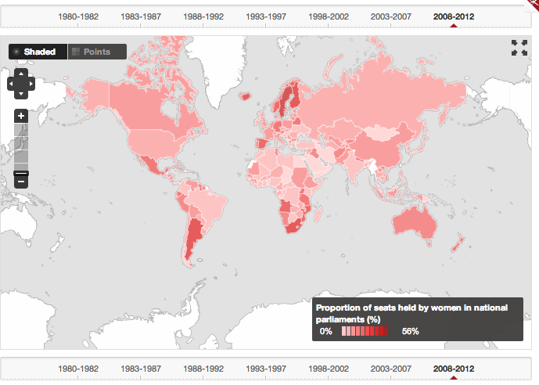

http://data.worldbank.org/indicator/SG.GEN.PARL.ZS/countries?order=wbapi_data_value_2012%20wbapi_data_value%20wbapi_data_value-last&sort=asc&display=map
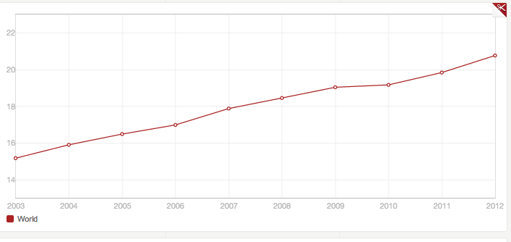
Percentage of Seats of Parliament Held By Women
http://data.worldbank.org/indicator/SG.GEN.PARL.ZS/countries?order=wbapi_data_value_2000%20wbapi_data_value&sort=asc&display=graph
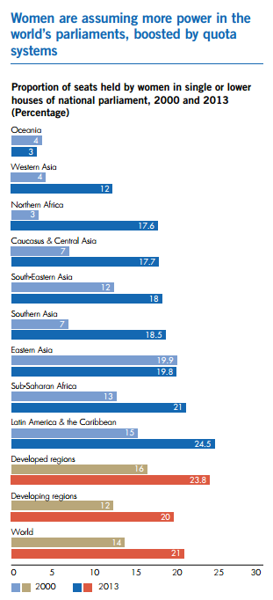
Source: The Millennium Development Goals Report 2013 p. 22

