Cherokee Trail High School
Model United Nations Meet
November 11, 2017

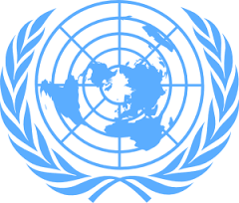

Beginner
SECURITY
COUNCIL

Terrorism
Background Guide

Table of Contents
Introduction…………………………………………………….. 3
The Birth of ISIS…………………………………………….... 3
ISIS and Their Many Name……....…………………………….4
Acts of Terrorism Committed by the Group………………....…4
Conflicts in Syria ……………………………………................4
Use of Chemical Weapons…………………………………....... 5
United Nations Actions Against ISIS…………………………..6
Timeline………………………………………………………...7
Refugee Crisis………..………………………………………....9
Map of ISIS Territory ………………………………...….…...11
Sample Positions…………………………………………….... 11
Questions to Consider……………………………………….... 11
Sources………………………………………………………...11

Introduction to the United Nations Security Council
It is the job of the United Nations Security Council to peacefully settle acts of aggression and threats to global peace. The Security Council also has the authority to impose sanctions, deploy Peacekeeping Operations, formulate plans to regulate armaments, call on Members to impose economic sanctions, and in some situations authorize the use of force to maintain international peace and security. The overall agenda of this Security Council is to resolve the matters at hand and maintain peace and security.

The background guides posted are meant to advise you and your partner on how to discuss the topics and what is expected. You will be expected to represent a United Nations member or an invited state in order to present solutions to: the terrorism crisis, specifically ISIS, and/or the territorial claims in the Arctic Circle.

You will be representing one of the following countries: Denmark, Norway, Canada, Russia, United States, China, France, United Kingdom, Italy, Japan Ukraine, Egypt and Sweden. (The People’s Republic of China, The French Republic, The Russian Federation The United States, and The United Kingdom, are all Permanent members, P-5s, so they have veto power. Note a 20 minute warning must be given if you intend to use veto power during a vote.) You may also be assigned one of the invited states: Syria, Iraq, Yemen, Afghanistan, and Iran. If you are one of these countries you are able to debate but you cannot vote on resolutions or amendments, so during role call be sure to say “present”, but not “present and voting”.

Your PO’s will be there to guide you through the process. There are pre-written resolutions posted and all should read those prior to the council. These are the resolutions you will be amending and eventually voting on throughout the day. If you are one of the countries who has written a resolution please prepare an authorship speech to be given at the beginning of your council.

The Birth of ISIS
After the United States invaded Iraq in 2003 there was much turmoil in the region. Many Sunni Muslims that were loyal to Saddam Hussein were left jobless and angry. Al Qaeda in Iraq (AQI) saw this anger and decided to capitalize on it. They began to be a dominate force in the region and enforced strong opposition against the US troops that were located in Iraq. While Saddam was secular many of his advisors found common ground with the leaders of AQI. At the time AQI was fighting with Iran backed Shiite troops and many AQI members were imprisoned in an American war camp called “camp bucca”. This gave the members a chance to get together and to radicalize. Then in 2007 the US was backing a Shiite government in Baghdad that they had installed. The new government in Baghdad was reaching out to Sunni people and was motivating them to not support AQI. At this point “peace in the Middle East” seemed achievable and AQI seemed to be on its last leg. Then in the Arab Spring happened and an uprising was held against the Syrian dictator Bashar al-Assad. Meanwhile, AQI was traveling back and forth between Iraq and Syria. Then when Assad began harming his own people AQI decided this was the perfect scenario for their comeback. They merged with their counterpart in Syria and renamed themselves the Islamic State of Iraq and Syria or ISIS for short. The head of Al Qaeda was displeased with the forming of ISIS as they had planned to form their own subsect in Syria and keep the two groups separate. After conflict between Al Qaeda and the subsect AQI, AQI separated and officially became the ISIS we hear about today.

ISIS and Their Many Names
ISIS is known as many different things: primarily ISIS, ISIL, Daesh, and IS. ISIS is their official name and stands for the Islamic State of Iraq and Syria. ISIL is the acronym that former President Obama referred to the group with. ISIL stands for Islamic State of Iraq and the Levant. IS stands for Islamic state. Daesh is used in the Arabic speaking world for acronyms and has been a name applied to the group, the group is called Daesh by primarily the French government and the government of the United Kingdom. The name Daesh does however irritate the group because of its negative connotation in the Arabic community. Most of the confusion over what the name is lies in the translation of the Arabic phrase “Al-Sham”.

Acts of Terrorism Committed by the Group
ISIS has committed some of the most notorious acts of terrorism in world history. For example, in 2013 there was a large wave of ISIS promotion videos that circled the internet. For many this was the first real exposure to the group and it was quite horrific seeing that many of the videos were of beheadings and things of such gruesome nature. Since then they have taken credit and/or committed many other terrorist attacks including: the Paris Terror Attacks of 2015, the suicide bombers at the Brussels airport, attacks at a celebration of France’s Independence day, bombs in New York, car bombs in Egypt, hostages being taken in Sydney and so many more horrific acts.

Conflict in Syria
Trouble in Syria has been brewing for quite a while but it all really began in 2011 in a Syrian city called Deraa. Some school kids were arrested and tortured for putting graffiti that had an anti-government message on the wall. Civilians began to protest for the kids to be released and while the protests began peaceful they did not stay that way for long. The civilians were not only protesting for the release of the kids they were also protesting for more freedom from the government. On March 18, 2011 the situation took a turn for the worse when the military began firing at the protestors; they killed four. The next day the military fired at mourners at the funerals held for victims and killed another person. People were shocked and horrified by the acts of the government and the military. Civil unrest began to spread throughout the country. The protests began with the people wanting democracy and greater freedoms than they already had. Once the president, Bashar al-Assad, began to fire and harm his own people the tide of the protests changed. People began to demand for Assad to resign. When Assad refused protesters were enraged. Then those who supported Assad began to fight those who were against Assad and a civil war had unofficially begun.

One layer to the issues regarding the conflict is that there is not one group of rebel fighters but many. Some say that there could be up to 1,000 different group in opposition of the government. The conflict has become about more than just those in opposition to Assad and those for Assad. Terrorist groups like ISIS have also begun to add to the chaos by taking advantage of the unrest in the country, taking land and power with them.

Many people native to Syria have had to relocate and have become part of the huge surge of refugees in the world. The UN states that over 5 million people have had to leave the country. This has also caused a problem with educating the Syrian children because there is often no place for them to go to school when they have to relocate. Many times the refugees are traveling to neighboring countries like: Lebanon, Turkey, Jordan and/or Iraq. In some cases the refugees make it all the way to Europe where they plan to start a new life.

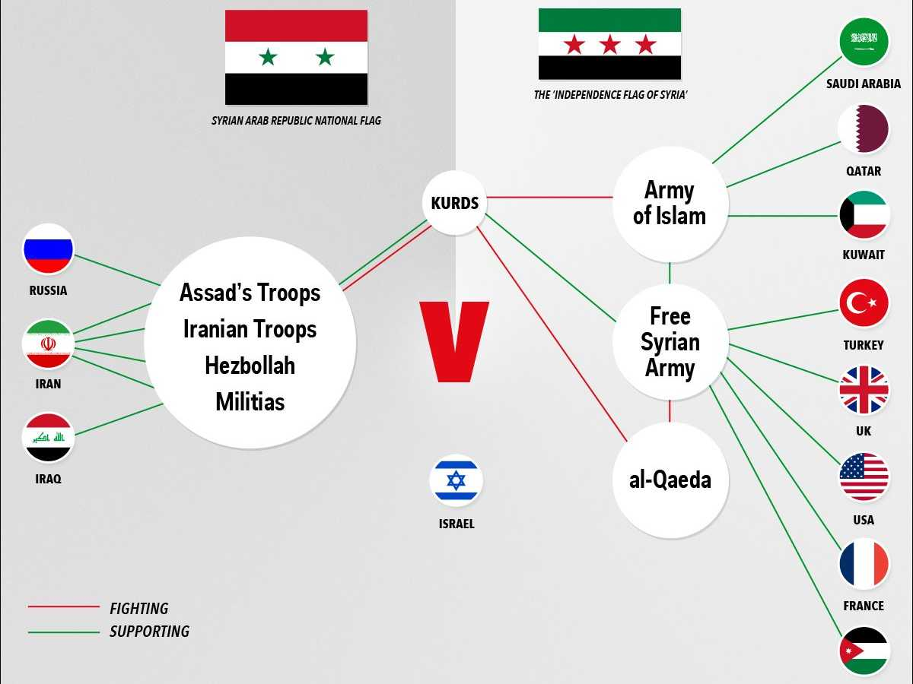
Chart detailing the various groups involved in the Syrian conflict.

Use of Chemical weapons
The initial chemical weapons attack happened on April 4, 2017. Chemical weapons are deemed illegal under international law because they are thought to be too harsh for an human to experience. The attack was done by the government of Syria. Assad’s regime has come out and said that the incident was a lie while the Russian government has come out and said that it was an airstrike that hit a rebel depot that contained chemical weapons. Witnesses state that there was a “yellow cloud” that went up into the sky like a cloud of fog. Many heard the sounds of explosions and then when they reached the scene they bore witness to victims choking in the street. There is no official confirmation how many victims there are. A health directorate in Idlib has stated that at least 89 died, including 51 women and children, and at least 541 people are injured from the attack. The Organisation for the Prevention of Chemical Weapons (OPCW) had examined samples collected from victims; they found that the victims had been exposed to sarin or a sarin like substance. French Intelligence Agencies released a report confirming that sarin, diisopropyl methylphosphonate (DIMP) and hexamine were present in the environment.

The Syrian government vehemently denies the use of chemical weapons against their people. Assad claims that it was a “fabrication” to cover up the US missile strike on Syria’s Shayrat airbase. Assad has stated the US and the terrorists are working together to bring down his regime and that the west, but mainly the US, is fabricating these stories to incriminate him and his regime.

United Nations Actions Against ISIS
At the UN, the security council unanimously called on all able states to join the fight against Isis in Syria and Iraq, and redouble their efforts to prevent any further attacks by the militant group.The 15 members of the council adopted a French-drafted resolution on Friday calling on UN members to take “all necessary measures” against a group it described as “a global and unprecedented threat to international peace and security”. Countries were urged to step up sanctions and improve efforts to cut off the flow of foreign fighters to Iraq and Syria. They created a Strategy to counter terrorism. This Strategy was based off four pillars.
- Addressing conditions conducive to the spread of terrorism;
- Preventing and combatting terrorism;
- Building Member States’ capacity to prevent and combat terrorism and to strengthen the role of the United Nations system in this regard;
- Ensuring the respect for human rights for all and the rule of law as the fundamental basis for countering terrorism
“The UN security council has unanimously backed action against this evil death cult in both Syria and Iraq as we can only say that UN needs to take desperate measures during desperate times.” The UN is trying to organize one front to fight terrorism, while maintaining human rights and keeping peace on a large scale.

Timeline Of ISIS

2013
21 August
Hundreds of people are killed when rockets filled with the nerve agent sarin are fired at several districts in the Ghouta agricultural belt around Damascus. The international community expresses outrage at the most significant confirmed use of chemical weapons against civilians since Halabja in 1988. Western powers say the attack could only have been carried out by Syria's government, but President Assad blames rebels.
14 September
When the United States suggests military intervention, President Assad agrees to the removal of Syria’s chemical weapons. This was a joint mission led by the UN and OPCW (Organisation for the Prohibition of Chemical Weapons) by 30 June 2014.
20 October
A suicide truck bomb kills more than thirty people. The attack is one of 27 suicide bombings that occurred in Syria during 2013, total leaving more than four hundred dead. The frequency increases with influence of extremist jihadist groups like al-Qaeda's affiliate in Syria, the al-Nusra Front, and the Islamic State in Iraq and the Levant (ISIS)
November
The Syrian government begins an air campaign against opposition-held parts of the northern city of Aleppo. Unguided barrel bombs are dropped indiscriminately from helicopters on densely populated areas. The attacks lead to hundreds of civilian deaths.
19 November
More than twenty people are killed in suicide bombing outside the Iranian embassy in the Lebanese capital. An al-Qaeda linked jihadist group claims responsibility and threatens to continue until iranian forces leave Syria. The Lebanese Shia Islamist group whose fighters have played a key role in helping turn the tide in President Assad's favour.
30 December
ISIS fighters and allied tribesmen capitalise on tensions between Iraq's Sunni Arab minority and its Shia Arab-led government by taking control of the city of Falluja and seizing parts of nearby Ramadi, the capital of the western province of Anbar. The move comes after Prime Minister Nouri Maliki, widely accused of pursuing sectarian and authoritarian policies during his two terms in office, orders security forces to break up anti-government protest camps. Hundreds of thousands of Iraqis are displaced by the violence.
2014
January
Syrian rebels from the Islamic Front, an alliance of hardline Islamist groups, al-Nusra and the pro-Western Free Syrian Army launched a joint offensive against Isis fighters, angered by their attacks on fellow rebels and abuse of civilians. Thousands of people are killed in the rebel infighting, which allows government forces to consolidate their control of southern and central Syria. Isis is pushed out of much of Aleppo province, but is able to hold on to its stronghold of Raqqa province.

29 April
The Organisation for the Prohibition of Chemical Weapons (OPCW) begins to investigate the use of chlorine gas in attacks. In every case, barrel bombs were allegedly dropped from helicopters. After they exploded, casualties reportedly began displaying symptoms typical of chlorine poisoning. In June, the inspectors say they believe toxic chemicals such as chlorine are being used in a "systematic manner" in the Syrian conflict.
8 May
Hundreds of rebels are evacuated from their last stronghold in the central Syrian city of Homs. The withdrawal from the Old City marks the end of three years of resistance in the city, once dubbed "the capital of the revolution". Much of Homs fell to the opposition in 2011, but over the next two years government forces gradually regained control by subjecting areas to continuous siege and bombardment.
10 June
Six months after seizing Falluja, Isis militants launch a major offensive in northern Iraq. They overrun the country's second largest city, Mosul, in only two days as 30,000 soldiers drop their weapons and flee. Emboldened, the jihadists advance southwards with the support of Sunni Arab tribesmen and other militant groups, seizing a series of towns, military bases and oil refineries before being stopped not far from the capital, Baghdad. Nouri Maliki rejects calls from Sunni Arabs, Kurds and fellow Shia Arabs to step aside as prime minister.
23 June
The joint OPCW and UN mission announces that the removal of Syria's chemical weapons material is complete. It also says Syria has destroyed all declared production, mixing and filling equipment and munitions. In August, the US says all of the most hazardous chemical agents have been destroyed on board a cargo vessel, the MV Cape Ray. The remaining chemicals will be destroyed at Finnish and British facilities.
29 June
Isis declares it has established a "caliphate" in the territory it controls, stretching from Aleppo in north-western Syria to the eastern Iraqi province of Diyala. The group says its leader, Abu Bakr al-Baghdadi, will be known as Caliph Ibrahim and it will be renamed the Islamic State (IS).
1 August
A deadly battle erupts between the Lebanese army and jihadist militants from Syria after they seize the Lebanese border town of Arsal in response to the arrest of one of their commanders. Dozens of people are killed before a ceasefire is negotiated and the militants withdraw. Arsal is home to tens of thousands of the 1.1 million Syrian refugees in Lebanon.
2 August
ISIS fighters push further into northern Iraq, overwhelming lightly-armed Kurdish Peshmerga forces that had moved into areas abandoned by the Iraqi army. The town of Sinjar is overrun and the strategically important Mosul Dam, which supplies water and electricity to much of Iraq, is seized, and get within 40km of Irbil, the capital of Iraqi Kurdistan.
8 August
The United States launches airstrikes against IS militants near Irbil and around Mount Sinjar, its first direct involvement in a military operation in Iraq since American troops withdrew in late 2011.
18 August
Supported by US airstrikes, Iraqi troops and Peshmerga fighters retake the Mosul dam. US President Barack Obama confirms the US is beginning a long-term strategy to help defeat Islamic State.
20 August
ISIS publishes video revealing the killing of James Foley. Foley was an American journalist who was abducted in Syria in 2012. ISIS is thought to be holding as many as twenty foreign hostages.
2015
27 January
Militants affiliated to ISIS detonate a car bomb killing 19 civilians including former United States marine David Berry.
31 January
ISIS reveals the video of them beheading Japanese journalist Kenji.
9 March
Nigerian terror group pledges allegiance to ISIS. ISIS accepts the pledge on March 13, saying that their self proclaimed caliphate has now expanded into Africa.
17 May
The capital of Anbar in Iraq, Ramadi, Falls under ISIS control. Despite American airstrikes, the offensive is the biggest victory for the group in 2015.
13 November
Three teams of gun-wielding ISIS suicide bombers hit six locations around Paris, killing at least 129 people and wounding hundreds.
10 December
A spokesman for the United State’s coalition confirms that ISIS Finance Minister Abu Saleh was killed in an airstrike in late November in Iraq.
28 December
Iraqi troops retake the city of Ramadi from ISIS and raise the Iraqi flag on top of the government compound in the city’s center, according to an Iraqi military spokesman.
2016
24 January
ISIS releases a video that purports to show final messages from the Paris attackers.
21 February
Multiple attacks in Homs and southern Damascus kill at least 122 and injure scores, according to Syria’s state-run SANA news agency. ISIS claims responsibility for the attacks.

Refugee Crisis
The Refugee crisis refers to the movement of displaced people. According to the United Nations High Commissioner for Refugees in 2017 claimed that 65.6 million people were displaced worldwide due to terrorism conflicts. Most Syrians who have left their homeland registered as refugees with the United Nations. Three in four Syrian refugees did that in Turkey, Lebanon or Jordan, according to UN figures from February 2016. Likewise, the number of Syrians seeking safety in Europe more than doubled from 2014 to 2015. Many left Turkey and other countries for Europe, to ask for asylum. Asylum is a status that allows someone to live and work legally in another country. The US had pledged to resettle 64,000 Syrians but the Trump administration is seeking to reduce the number. Overall, the UN has agreed that the richer countries should take the majority of refugees. Still, countries are having difficulties deciding how many refugees they’ll allow. If terrorism continues to add to the refugee crisis the UN will have to delegate which countries take what refugees. It would overall benefit everyone if the security council could come to an agreement on refugees and make plans for if the crisis continues.
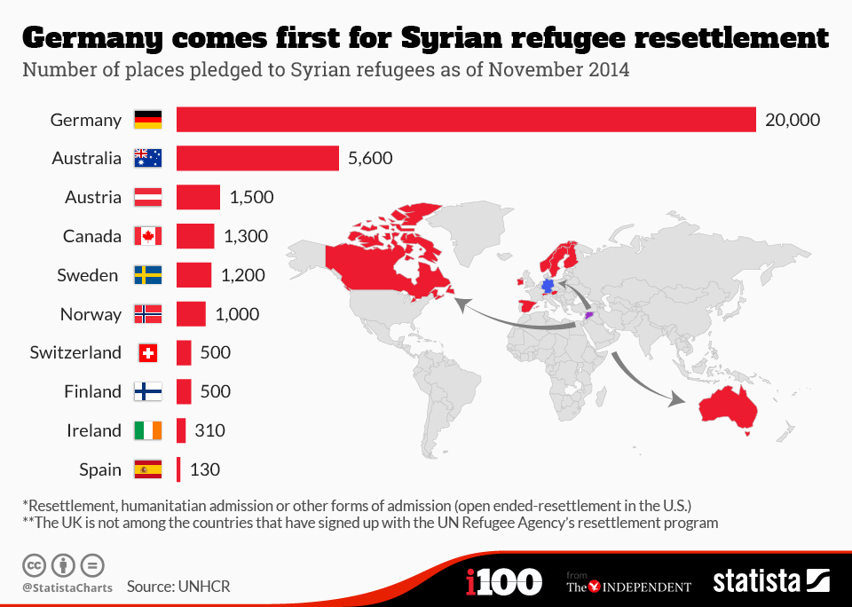
Map of ISIS Territory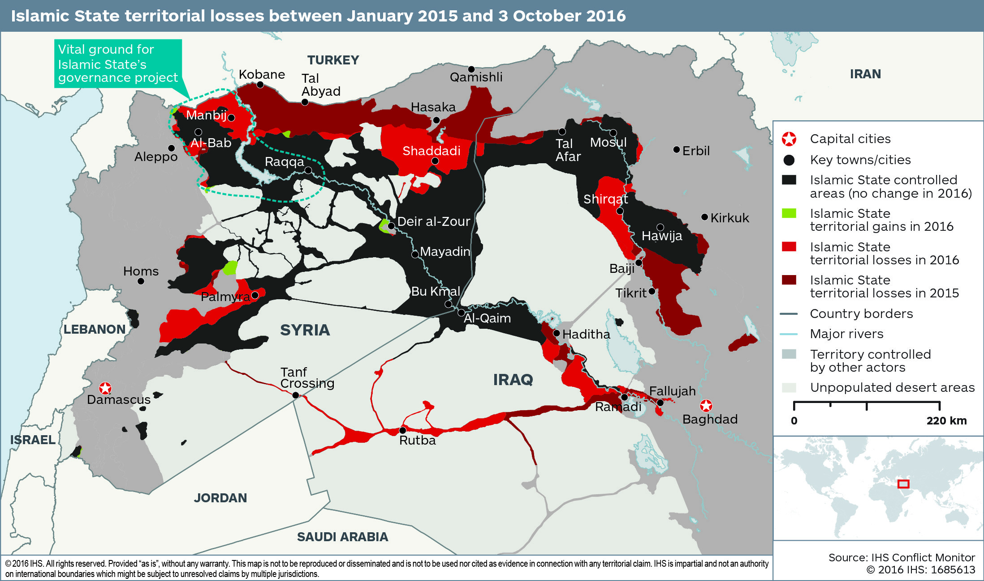

Sample Positions:
- The United States realizes that ISIS is a threat and believes they should be handled physically with acts such as air strikes.
- China realizes that ISIS is a threat but believes that military involvement will just further the conflict.
- France feels that ISIS is a threat and supports acts to resolve said threat.

Questions to Consider:
- How will military involvement add to the refugee crisis?
- If military involvement is believed to be the answer how should the UN divy up the responsibility?

Sources:
http://theweek.com/articles/589924/brief-history-isis
http://www.bbc.com/news/world-middle-east-27994277
http://www.cnn.com/2015/12/17/world/mapping-isis-attacks-around-the-world/index.html
http://www.bbc.co.uk/newsround/16979186
http://www.un.org/en/sections/what-we-do/maintain-international-peace-and-security/

