Cherokee Trail High School Model United Nations

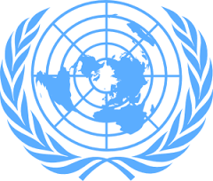

Beginner
SECURITY
COUNCIL

Redefining Arctic Circle Ownership
Background Guide

Table of Contents
Introduction…………………………………………………….. 3
Topic………………………………………………………….... 3
Timeline…………………………………………………….. 3-10
Background………………………………………………….... 10
Russia……………………………………………….... 10-11
Denmark/Greenland……………………………………... 11
Norway…………………………………………………... 11
United States…………………………………………. 11-12
Canada………………………………………………….... 12
Territorial Map………………………………………………...12
Sample Positions…………………………………………….... 13
Questions to Consider……………………………………….... 13
Sources………………………………………………………... 13

Introduction to the United Nations Security Council
It is the job of the United Nations Security Council to peacefully settle acts of aggression and threats to global peace. The Security Council also has the authority to impose sanctions, deploy Peacekeeping Operations, formulate plans to regulate armaments, call on Members to impose economic sanctions, and in some situations authorize the use of force to maintain international peace and security. The overall agenda of this Security Council is to resolve the matters at hand and maintain peace and security.

Topic 1: Redefining Arctic Circle Ownership
The high seas, which includes the North Pole and the region of the surrounding Arctic Ocean, are not owned by any country under international law. The Arctic includes internal waters, territorial seas, high seas, land, and exclusive economic zones. Previously, all land, internal waters, territorial seas, and exclusive economic zones have been under the jurisdiction of Canada, Norway, Russia, Denmark through Greenland, and the United States. The United Nations Convention on the Law of the Sea (UNCLOS) is an international agreement which coordinates the rights and responsibilities of nations in accordance with their use of the world’s oceans, management of marine natural resources, the environment, and establishing guidelines for businesses. The UNCLOS agreed that a country has a ten year period to make claims on an extended continental shelf. If the claim is validated it gives rights to resources on or below the seabed to said country. Issues with the status of the Arctic sea region include that no country being within 12 nautical miles, disputes regarding seaway passages, and disputes about the Hans Island.

Timeline:

1907

20 February
Canadian Senator Pascal Poirier proposed a resolution before the Canadian Senate to declare possession of the lands and islands between Canada and the North Pole. He deemed the resolution necessary to protect Canada's right to the Arctic.
1909

1 July
Captain Joseph Bernier unveils a plaque on Melville Island in the Arctic Archipelago.
The plaque officially claimed the Arctic Islands for Canada.

6 April
Admiral Peary plants flag of the United States at the North Pole. Peary, claimed to have reached the North Pole and placed a note in a glass bottle: 'I have this day hoisted the national ensign of the United States of America at this place, which my observations indicate to be the North Polar axis of the earth, and have formally taken possession of the entire region, and adjacent, for and in the name of the President of the United States of America.'

1910-1915
The Arctic Ocean Hydrographic Expedition represented a great effort by the Imperial Russian Navy to explore, survey, and chart the Northern Sea Route for commercial purposes.
1925

1 June
Amendment to the Northwest Territories Act.
Canada became the first State to claim that its boundaries extended into to the Arctic and up to the North Pole.

1926

15 April
USSR Central Executive Committee issued its Arctic Decree. In it, the USSR declared that all lands and islands, between the USSR and North Pole, were territory of the USSR. The Decree was seen as a response to previous Canadian claim to the territory between its mainland and the North Pole the previous year.
19 July
Canada establishes the Arctic Island Game Preserve. Originally created to preserve muskoxen populations for Inuit populations in the region, the Preserve also addressed the issue of sovereignty in the Arctic Archipelago. By establishing the Preserve, Canada asserted its sovereignty over much of the Archipelago.

1945

28 September
President Truman established Proclamation 2667. In his proclamation, President Truman sought to preserve and utilize the natural resources of the subsoil and sea bed of the continental shelf (beyond the 3-mile limit) beneath the high sea that extended from the United States' shores. He made clear that the right to free and unimpeded navigation would not be affected. President Truman affirmed that the United States had exclusive jurisdiction over its continental shelf resources.

1946

July
Canadian Ambassador Lester Pearson, attempted to claim not only the islands, but the frozen sea north of the mainland between the meridians of Canada's east and west boundaries, extending up to the North Pole under Canadian sovereignty.

1969

24 August - 14 September
US oil tanker, the SS Manhattan, becomes the first commercial vessel to cross the Northwest Passage. Humble Oil, a US based company, attempted to determine the economic and logistical feasibility of sending oil tankers through the Canadian Archipelago. The company retrofitted the tanker to handle the rough ice breaking conditions necessary to traverse the Passage. Humble Oil did not formally ask Canada for permission to cross - the US did and does not consider the NW-Passage part of Canada's internal waters, but a strait in international waters. In spite of successfully crossing the ice covered portions of the Passage, Humble Oil deemed that backing the Trans-Alaska pipeline was more economically feasible.

1971

22 December
The Nixon Administration establishes National Security Decision Memorandum 144.
After reviewing the NSC Under Secretaries Committee's recommendations, conclusions and report regarding United States Arctic policy and organization arrangements for its implementation, President Nixon, decided that the US would support "sound and rational development" minimize adverse risks to the environment; promote international cooperation in the Arctic; and provide for the protection of security interests in the region.

1973

17 December
Canada and the Kingdom of Denmark sign and submit agreement on the delimitation of the continental shelf between Greenland and Canada to the United Nations. The agreement was designed to distinguish territory for the purposes of exploration and exploitation of the natural resources of the continental shelf. Both delayed any decision regarding the sovereignty of Hans Island which lies on both sides of the territorial divide.

1982
10 December
The United Nations Convention on the Law of the Sea (UNCLOS) is signed and opened to ratification by States. UNCLOS contains the Commission on the Limits of the Continental Shelf (CLCS) under Article 76, which allows for a nation to extend sovereignty beyond the limits of the exclusive economic zones of the CLCS verifies that a country's continental shelf extends further.

1984

28 July
The Danes raise their national flag on the disputed Hans Island. Both Canada and Denmark (via Greenland) claim the island that exists on both Canadian and Danish sides of the Strait.

31 July
US Arctic Research Commission established under the Arctic Research and Policy Act of 1984. The commission established the national policy, priorities, and goals necessary to construct a federal program plan for basic and applied scientific research in the Arctic. The federal agency provides the President and Congress with reports, recommendations, and advice on Arctic research.

1985
The United States Coast Guard's Polar Sea traverses the Northwest Passage (from Greenland to Seattle) without formal permission from Canada. The US government notified the Canadian government of the impending voyage, but did not seek formal permission into what Canada considers its internal waters. The event provoked much opposition and controversy within Canada, in which, many claimed the event was a violation of its national sovereignty.

1988

11 January
Agreement on Arctic Cooperation between Canada and the United States. Following the United States Coast Guard Polar Sea's crossing of the Northwest Passage without formal Canadian governmental consent, the Canadian government established straight baselines around Canada's perimeter. The act reaffirmed Canada's position that the Northwest Passage lays within its internal waters.
1991
10 December
The Russian Federation submitted its claim - the first Arctic State to do so - to 1.2 million square kilometers of territory, including the North Pole to the CLCS in accordance with UNCLOS provisions.

1994

16 November
The UN Convention of the Law of the Sea (UNCLOS) enters into force one year after its sixtieth signature.
1996

19 September
Arctic Council emerges from the Ottawa Declaration of 1996.
The Arctic Council is created as a high-level intergovernmental forum to provide a means for promoting cooperation, coordination and interaction among the Arctic States, with the involvement of the Arctic Indigenous communities and other Arctic inhabitants on common Arctic issues.
24 June
Norway ratified UNCLOS. Norway can submit disputed territorial claims to the CLCS.
1997

12 March
The Russian Federation ratified the UNCLOS. Russia can submit disputed territorial claims to the CLCS.
2001

20 December
The Russian Federation delivered submission to the CLCS claiming that the Lomonosov Ridge was an extension of its continental shelf. Russia stood to potentially acquire nearly one-half of the Arctic Ocean, including the North Pole. In 2002, the UN Commission neither rejected nor accepted the proposal, recommending additional research was necessary.

2003

7 November
Canada ratified the UNCLOS. Canada can submit disputed territorial claims to the CLCS.
2004

16 November
Denmark ratified UNCLOS. Denmark can submit disputed territorial claims to the CLCS.
2005

20 July
Canadian Minister of National Defence, Bill Graham, poses for pictures with the newly erected Canadian flag - placed on 13 July - on Hans Island during Exercise Frozen Beaver.

13 July
Exercise Frozen Beaver (Operation Sovereign Inukshuk) represents the first visit to Hans Island - an uninhabited island that both Canada and Denmark (via Greenland) claim - by Canadian Forces. Canadian Forces helicopters and Canadian Rangers landed on the island, and replaced a previously planted Danish flag with a Canadian one as well as left a plaque and an Inukshuk (a stone marker) on the island to symbolically claim sovereignty.
2006

1 December
The Norwegian Government releases its "High North Strategy" The Arctic is Norway's number one foreign policy priority in the coming years. The initiative seeks to clarify long-term Norwegian policy in the Arctic in order to secure economic resources and its security into the future.
27 November
Norway submits claim to the CLCS to clarify disputed territory. Norway, who ratified UNCLOS on 24 June 1996, sought to resolve territorial sea disputes, called the Loop Hole in the Barents Sea, the Western Nansen Basin in the Arctic Ocean, and the Banana Hole in the Norwegian Sea. Norway submitted evidence substantiating its claims to the areas in dispute.
2007

2 August
Russian explorers symbolically claim the North Pole by planting a deep-sea flag on the seabed (14,000 feet) below the North Pole during the Arktika sea expedition. During the expedition. explorers planted the flag to assert that the seabed beneath the North Pole belongs to Russia. Samples were submitted as evidence to the CLCS that the Lomonosov Ridge is an extension of the Eurasian continental shelf. This would give the Russian Federation sole access to nearly one-half of the Arctic and the region of the North Pole.

2008

May
The US Geological Survey (USGS) completed its "Circum-Arctic Resource Appraisal: Estimates of Undiscovered Oil and Gas North of the Arctic Circle." The USGS estimates that 90 billion barrels of oil, 1,669 trillion cubic feet of natural gas, and 44 billion barrels of natural gas liquids may remain in the Arctic. The report suggests that 84 percent of the resources are expected to occur in offshore areas.

6 February
Chukchi Sea Lease Sale 193: under the Bush Administration, roughly 80 million acres in Arctic waters were opened to energy development as part of the 2007-2012 offshore drilling plan. Six sales were planned, but only one occurred - Chukchi Sea Lease Sale 193 - before the DC Circuit Court of Appeals declared the plan illegal.
2009

27 March
Norway receives recommendations from the Commission on the Limits of the Continental Shelf (CLCS) on its 27 November 2006 submission to the Commission. The CLCS recommends that Norway and Russia pursue individual agreements.
28 May
The Ilulissat Declaration given following a political level meeting between the five coastal States bordering the Arctic Ocean - Canada, Denmark, Norway, the Russian Federation, and the United States - in Ilulissat, Greenland. States met to discuss the Arctic in the face of coming climatic changes. The parties remain committed to the existing legal framework and to the orderly settlement of any possible overlapping claims without the need to create an extensive international regime to govern the Arctic Ocean. Parties agreed to the legal framework discussed in Oslo on 15 and 16 October 2007.
2010

27 October
The United Nations Environmental Program (UNEP) releases "Protecting Arctic Biodiversity: Limitations and Strengths of Environmental Agreements." The report urges for further and more proactive protection of Arctic biodiversity, noting the threats and changes currently taking place from climate change and other anthropogenic causes in the region. The report attempts to analyze Arctic multilateral environmental agreements (MEA) and the role of the environment on impacting and influencing each MEA.

15 September
Norway and the Russian Federation sign Treaty on Maritime Delimitation and Cooperation in the Barents Sea and the Arctic Ocean.
1 February
The Department of Defense releases its "Quadrennial Defense Review". The QDR states that climate change in the Arctic is significant, and urges for the Department's need to adapt and prepare for the decades ahead. The report suggests the need to coordinate efforts with the Coast Guard and the Department of Homeland Security to effectively address gaps in Arctic communications, domain awareness, search and rescue, environmental observation and forecasting capabilities. To achieve these goals, the QDR, "strongly supports accession" to UNCLOS.
2011

22 August
Denmark, releases "Kingdom of Denmark: Strategy for the Arctic 2011 - 2020." Denmark's strategy - with preparation from the governments of the Faroe Islands and Greenland - lays out the kingdom's Arctic interests and intents in the coming years. The main objectives of the Arctic strategy are to "ensure a peaceful, secure and safe Arctic, with economic growth and development, with respect to the vulnerable Arctic climate, environment and nature and close cooperation with our international partners."

12 July
President Obama establishes Executive Order 13580 - Interagency Working Group on Coordination of Domestic Energy Development and Permitting in Alaska. The Executive Order establishes the Interagency Working Group on the Coordination of Domestic Energy Development and Permitting in Alaska. The Chair, Deputy Secretary of the Interior David Hayes, will coordinate efforts across all federal agencies to develop energy in the Arctic. The executive order is intended to coordinate, streamline and efficiently share information and efforts by the Federal agencies responsible for overseeing energy development in Alaska and help reduce US dependence on foreign oil.

7 July
The Kingdom of Norway and the Russian Federation ratify the Treaty on Maritime Delimitation and Cooperation in the Barents Sea and the Arctic Ocean. Ratification of the Treaty resolved a 40-year dispute over a 175,000 square kilometer (67,000 square miles) area in the Barents Sea that persisted between the boundaries of the two States. The treaty divides the disputed territory nearly in half. Both States have been previously unable to explore oil and gas development in the disputed area, which is believed to contain vast reserves.
2012

31 December
Shell's oil Conical Drilling Unit (CDU) - the Kulluk - runs aground on the northern tip of Ocean Bay, located on the southeast side of Sitkalidak Island, Alaska, after tow connections were lost and regained over several days starting on 27 December. The unit has since been towed safely to harbor intact without any oil or hazardous substance release to the environment; the unit contained nearly 150,000 gallons of diesel, aviation fuel and industrial lubricants. Many critics mark this incident - and the Deepwater Horizon spill in the Gulf of Mexico - as clear demonstrations that oil companies are not ready to safely explore and develop energy resources in the Arctic. Critics assert that the slow response in the relatively calm waters in the Gulf pail in comparison to the difficulties present in the Arctic.

17 October
US Department of Interior's Bureau of Safety and Environmental Enforcement (BSEE) approved of Shell Gulf of Mexico Inc.'s (Shell) Oil Spill Response Plan (OSRP) for the Chukchi Sea. This has been documented by many as the last major hurdle to allow Shell to move forward with offshore oil drilling in the Chukchi Sea off the North Coast of Alaska. Shell has already gained a number of oil drilling leases from the Department of Interior in the Chukchi Sea. These steps are in line with President Obama's commitment to an "all-of-the-above energy approach," which includes a focus on safe and responsible production of domestic oil and natural gas resources.
2013
Canada is expected to submit a claim to the CLCS, within UNCLOS, to prove the Lomonosov Ridge is a continuation of its own continental shelf. Canada is expected to claim that the ridge is an underwater extension of Ellesmere Island. If it's proven that the Lomonosov Ridge is an extension of Canada's continental shelf, Canada would obtain unfettered access beyond their exclusive economic zone (EEZ) of 200 nm, and instead, would gain access to the seabed and its resources across the continental shelf. Canada would be required to submit bathymetry, seismic and gravity data to substantiate its claim.
2014

16 December
Denmark is expected to submit a claim to the United Nations Commission on the Limits of the Continental Shelf (CLCS) within the United Nations Convention on the Law of the Sea (UNCLOS), to attempt to prove that the Lomonosov Ridge is an extension of Greenland's land mass. Within the 2011 "Kingdom of Denmark: Strategy for the Arctic 2011 - 2020," Denmark asserts that it will submit data and other material to the CLCS as a basis for extension of the continental shelf beyond 200 nm on three areas near Greenland, including the Lomonosov Ridge. Proof that the Lomonosov Ridge extends from Greenland's continental shelf would give Denmark unfettered access to much of the seabed surrounding the North Pole. Currently, Canada, the Kingdom of Denmark and the Russian Federation assert that the Lomonosov Ridge are continuations of their own continental shelf, while the US claims it to be an oceanic ridge and thus not an extension of any State's continental shelf.
Background:

Russia:
Russia presented a written claim in August, after the United Nations committee that arbitrates disputes over sea boundaries had rejected an earlier application in 2002 by Russia for the North Pole. In a statement, Mr. Donskoy (minister of natural resources) said he would lay out Russia’s arguments, based on scientific evidence that the continental shelf extends north from the Eurasian land mass far under the planet’s ice cap. Russia is staking a claim, Donskoy said, “to the seabed beyond the 200-mile zone along the entire Russian polar sector including the zone under the North Pole.” If the geological shelf extends far out to the sea, the nation can claim mineral resources in the seabed beyond that zone. Furthermore, if the United Nations committee accepts Russia’s claim, the seabed under the North Pole would be subject to Moscow’s oversight for activities like oil drilling, though Russia will not have sovereignty over the water or the ice.

Denmark/Greenland:
Denmark has presented a claim to the UN, arguing that the area surrounding the North Pole is connected to the continental shelf of Greenland, a Danish autonomous territory. The focus of the dispute is the Lomonosov Ridge, a 1,800km-long (1,120 miles) underwater mountain range that splits the Arctic in two. "The Lomonosov ridge is the natural extension of the Greenland shelf," Christian Marcussen of the Geological Survey of Denmark and Greenland told AP news agency. Jon Rahbek-Clemmensen of Denmark’s Syddansk University said the government in Copenhagen had staked its claim, partly to show the world that Denmark could not be pushed about, but also to prove a political point to the people of Greenland by conveying to Greenland that it is capable of taking its interest into account.

Norway:
2011 may be the year when Russia’s Gazprom, Norway’s Statoil and France’s Total finally commit to joint development of the Shtokman project. Even if this is not accomplished, Norway’s oil and gas industry will still develop its ties to Russia, as Arctic exploration and production move eastward, and as the new Barents Sea border and cross-border operations gain significance relative to Norway’s bilateral relationship with the UK in the North Sea. Hence, Norway’s present-day Arctic strategy is focused on cooperation, rather than on contest. Cooperation with other Arctic nations is, according to Norway, essential for ensuring sustainable resource management, and for supporting UNCLOS as a framework for Arctic governance. Additionally, it is to avoid dispute over Svalbard, where all signatory states to the Svalbard Treaty of 1920 are given non-discriminatory access, and where the equal access provisions apply to the archipelago’s potential economic zone.

United States:
In May 2013, Washington released a new national strategy for the Arctic region, setting priorities to advance U.S. security interests and strengthen U.S. and allied collective interests in the region. Specifically, the United States seeks to enhance its Arctic search and rescue and military infrastructure, improve its intelligence-gathering options in the region, and work closely with its allies in resolving Arctic environmental, security and economic issues. The U.S. military is interested in the region as well. Building on the Cold War legacy of early warning radar systems laid out in the Distant Early Warning Line, the United States and Canada maintain the North Warning System in the Arctic, guarding against potential incursions across North America’s polar region. Nuclear ballistic missile submarines and nuclear attack submarines in Russia’s Northern Fleet also operate constantly in Arctic waters. Rather than engaging in an Arctic military race with Russia, the United States is building consensus, working through bilateral agreements as well as promoting multilateral venues.

Canada:
Canada plans to make a claim to the North Pole in an effort to assert its sovereignty in the resource-rich Arctic, the country's foreign affairs minister has said. The government had asked scientists to work on a future submission to the United Nations arguing that the outer limits of the country's continental shelf include the pole, which so far has been claimed by no one.
The submission that Canada filed with the UN is essentially a series of undersea coordinates that map what the government claims is the country’s extended continental shelf. The UN submission was also political, said Michael Byers, an expert on Arctic and international law at the University of British Columbia. “[Harper] does not want to be the prime minister seen publicly as having surrendered the North Pole…” Byers said. “What he's essentially doing here is holding this place, standing up for Canadian sovereignty…”

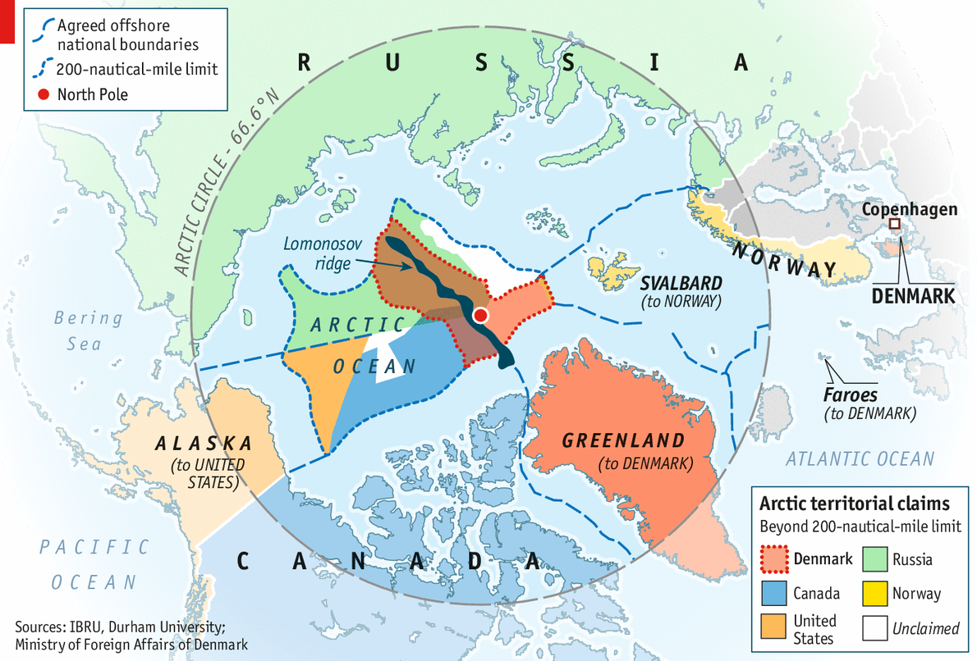

Sample Positions:
- Russia OR Denmark OR Norway OR United States OR Canada should have complete ownership of the North Pole.
- A cooperative approach is the most effective with regards to claiming land within the Arctic Circle.
- Whoever takes ownership of the Hans Islands is the rightful owner of the Arctic region.

Questions to Consider:
- What resources are present within the Arctic region?
- For what purpose do various countries want ownership over specific regions of the Arctic Circle?
- With reference to scientific evidence, which country should own the North Pole?

Sources:
https://mobile.nytimes.com/2016/02/10/world/europe/russia-to-present-revised-claim-of-arctic-territory-to-the-united-nations.html
http://www.bbc.com/news/world-europe-30481309
http://globalbrief.ca/blog/2011/06/27/norwegian-grand-strategy-and-the-arctic/
https://worldview.stratfor.com/analysis/us-stakes-its-claim-arctic-frontier
https://www.google.com/amp/s/amp.theguardian.com/world/2013/dec/10/canada-north-pole-claim
https://www.stimson.org/content/evolution-arctic-territorial-claims-and-agreements-timeline-1903-present

