 | Boulder High School  Model United Nations  Conference | 

Background Guide

World Health Organization
Combating the Development of Drug Resistant Diseases
Written by Bryce Anderson-Gregson
October 5th, 2013
Pertinent Data
- There are at least 20,000 potential genes for resistance (r genes) predicted from the bacterial genome.
- 19.1% of worldwide deaths are caused by infectious and parasitic diseases. HIV/AIDS, malaria, and tuberculosis cause the most deaths of all single microbes (rather than classes of microbes).
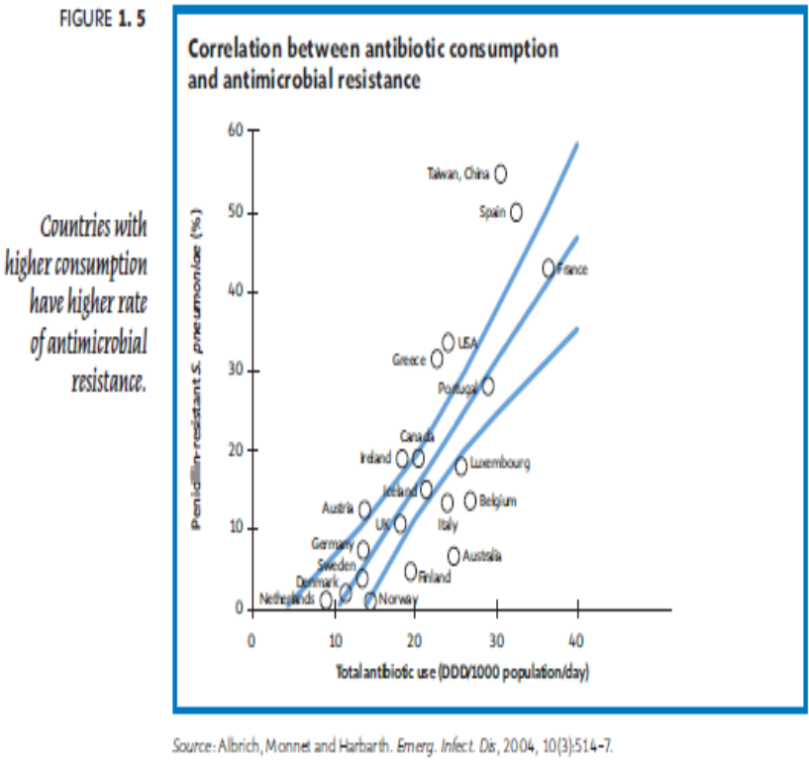
- New resistance mechanisms have emerged that will make the latest generation of antibiotics virtually ineffective.
- All efforts to prevent horizontal gene transfer, a primary mode for the transfer of resistance among bacteria, have failed.
- The death rate for patients with serious, drug-resistant infections treated in hospitals is about twice that of patients with drug-sensitive infections.
- 70% of all antibiotics sold in the United States are used for farm animals. 90% of those antibiotics are used merely to promote animal growth and prevent infection, while only 10% are actually used in the treatment of diseases.
- A John-Hopkins study of a concentrated animal feeding operation concluded that human exposure to the facility provided a potential pathway for the transfer of resistant bacteria from animals to humans.
- A 2005 report estimated that North Carolina and Iowa each use an estimated 3 million pounds of antibiotics in animal feed additives each year – the same amount of antibiotics used for human medical treatment in the entire United States.
- The CDC reported in 2004 that antimicrobials used in animal feed additives contain genes that can confer resistance to bacteria, increasing antibiotic resistance.
- A Colorado State University study reported the presence of antibiotics used in livestock in public waterways, indicating the spread of antibiotics (and possibly resistance bacteria) to the public.
- The Institute of Food Research of the United Kingdom found that a probiotic diet makes chickens healthier and safer to eat without the use of antibiotics.
- In 1998, Denmark, the largest exporter of pork in the world, instituted a ban on the use of antibiotic growth promoters in animals. The cost of raising pigs increased by only 1%, while the amount of antibiotics used on farms declined by 50%. Additionally, pork production increased 50%. Before the ban, 60-80% of chickens had bacteria resistant to 3 or more bacteria, while after the ban, only 5-35% of chickens had such bacteria.
- From 1974 to 2000, Methicillin-resistant Staphylococcus aureus (MRSA) prevalence increased from 2% to over 50% of staph infections in US hospitals.
- There have been no new first-line drugs for tuberculosis in 50 years. Penicillin now effectively treats only half of tuberculosis strains.
- Extensively drug-resistant tuberculosis, which is resistant to first and second-line drugs, has been found in 84 countries. First-line drugs are the first choice for the treatment of a disease. Second-line and third-line drugs are less effective or harmful to the patient, and are often more expensive.
- All available anti-malarial drugs have shown decreased efficacy with rising resistance to treatment.
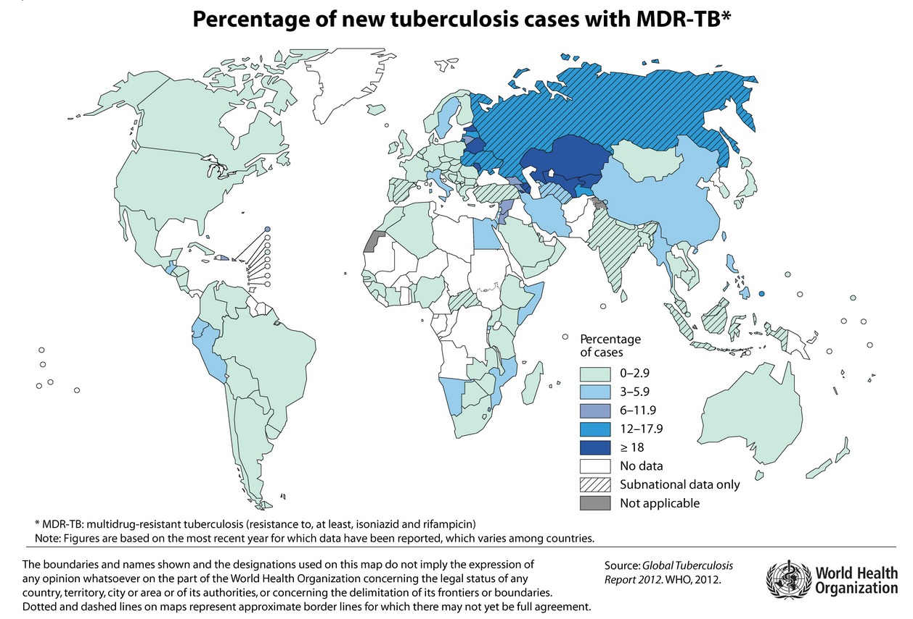
- In developing countries, drug expenditures represent 20-60% of health care costs. The development of resistant bacteria would increase those costs even more. For example, it costs 200 times more to treat extensively drug-resistant tuberculosis than it does to treat drug-susceptible tuberculosis.
- It is estimated that only one in ten cases of drug-resistant tuberculosis are detected, allowing the disease to spread farther and contributing to insufficient awareness of drug resistance.
History
Antibiotics were first discovered in 1928 when Scottish scientist Andrew Flemming noticed a mold that prevented the spread of bacteria. The mold, later named Penicillin, was capable of killing bacteria and provided the initiative for a revolution in the treatment of infectious diseases. Prior to the discovery and development of antimicrobials, humans lived in a world with few effective and efficient ways to combat the spread of infectious diseases or treat victims. People relied on home remedies and unregulated commercial treatments that sometimes contained harmful substances such as arsenic and mercury (Kam). Surgical procedures were severely limited because the lack of antibiotics left patients vulnerable to infection post-operation, resulting in a 50% fatality rate (Miller, Rahimi, and Lee). Diseases contributed to the fall of empires and posed a significant threat to human development. The discovery of antibiotics opened a new realm of disease treatment that allowed for better patient health and greatly lessened the spread and impact of diseases.
Effective antibiotics were first prescribed in 1937 and became widespread during the 1940’s. Antibiotics are credited with a large drop in rates of bacterial infection and death caused by bacteria, as well as an 8 year increase in life expectancy from 1944 to 1972 (Miller, Rahimi, and Lee). US Surgeon General William Stewart even claimed that it was “time to close the books on infectious diseases” in 1969. However, the stormy skies of antimicrobial resistance had already begun brewing. Resistance to penicillin was reported within four years of the beginning of its use in combatting infections (Miller, Rahimi, and Lee). In the 1950’s genetically transferable resistance was identified in Japan (Davies and Davies). However, the medical community and countries around the world were slow to recognize the true threat of resistance.
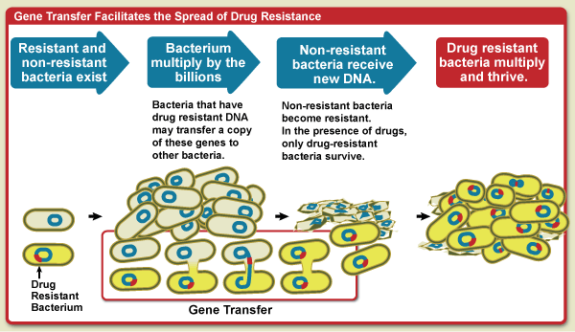
The Japanese discovery of genetically transferable resistance became an important element for the understanding of antibiotic resistance. Drug resistance is commonly understood as a function of natural evolution. Humans developed antibiotics to kill microbes that invade human cells. If any of the microbes have a mechanism to resist the antibiotic they will survive, while those without the mechanism will die. Any microbes that survive will reproduce and pass on the genes that provide the mechanism to their offspring, thus creating a drug resistant strain of the microbe. However, the Japanese discovery led to the understanding that bacteria have another method to produce resistance called horizontal gene transfer. In this process, bacteria transfer genes to other existing bacteria using a plasmid, allowing resistance to spread without reproduction. Since plasmids can contain multiple genes for resistance and transfer quickly through the bacterial population, horizontal gene transfer has expanded antibiotic resistance and the difficulties in combatting it. The strain of Shigella diarrhea that caused an epidemic responsible for 12,500 deaths in 1968 derived its resistance from a plasmid that contained genes for resistance against four antibiotics.
Process of bacterial evolution and gene transfer.
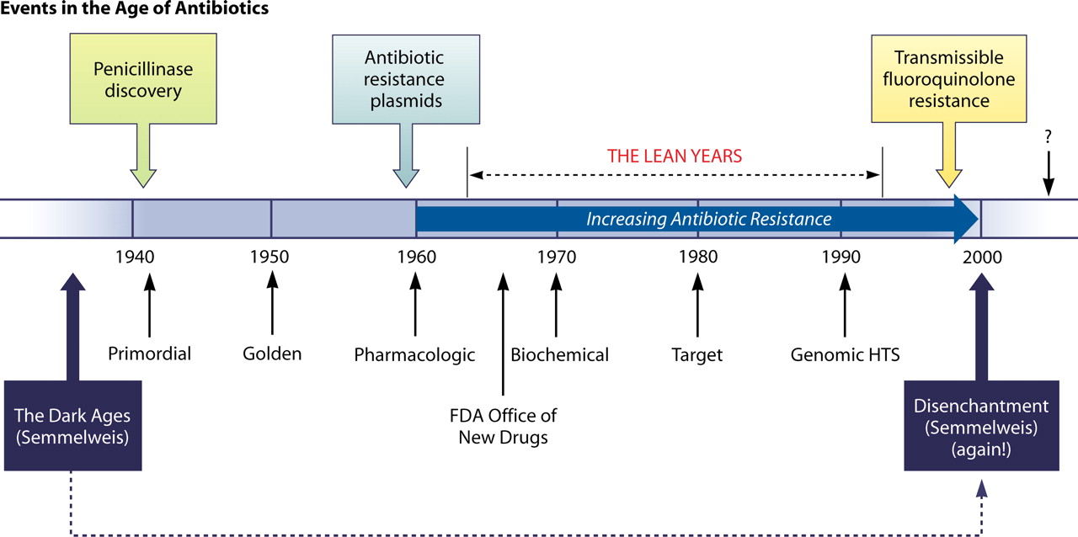
Drug resistance that would have been a natural occurrence has been accelerated by the misuse and overuse of antibiotics. During the second half of the 20th century, the development of applications of antibiotics beyond the treatment of diseases in humans expanded the use of antibiotics. Antibiotics have become widely used in animal feed to promote growth and prevent infections in animals grown for commercial production. Antibiotics were first used in agriculture in the 1940’s when farmers noticed the drugs promoted growth in poultry (Hannon, et al.). When animal testing of other antibiotics revealed the same results across species, antibiotic use in animals became common practice. The animals are exposed to low doses of multiple antibiotics over long periods of time, often entire lifetimes, creating a prime environment for the development of antibiotic resistance. Even if the strains developed are not initially capable of transfer to humans, contact with human handlers and consumption of animal meat can lead to the development of strains that infect humans.

Timeline of the history of antibiotics. Semmelweis refers to a physician who pioneered antiseptic procedures such as hand-washing.

Antibiotics were also found to have additional therapeutic uses in human treatment. Antibiotics initially intended to fight bacterial infections have become therapeutic options in anti-viral, anti-tumor, and anti-cancer applications (Davies and Davies). They are also commonly used for infection prevention in patients with compromised immune systems. The percentage of cancer patients receiving fluoroquinolines, a broad-spectrum antibiotic used in the case to prevent infection, increased from 1.4% to 45% between 1983 and 1993. Between 1983 and 1990, E. coli resistance in the entire group of cancer patients increased from 0% to 28% of strains (Lewis). Additionally, antibiotics have become overused and misused. A culture of excess prescription has taken hold, as doctors are pressured by drug companies and patients themselves to prescribe antibiotics unnecessarily. Patients often stop taking antibiotics when symptoms disappear, rather than completing the course of antibiotics which allows resistance to develop and can cause the disease to resurge in the patient with resistance. While hospitals can control antibiotic regimens in inpatient settings, there is no regulation of patients taking antibiotics in an outpatient setting.
Once drug resistance was recognized as a growing problem, intensive research began into methods of preventing resistance and drugs tailored against drug-resistant diseases. Methicillin was the first drug designed to overcome resistance, specifically penicillin resistance in Streptococcus aureus, which causes staph infections. Penicillin resistance was first noted in S. aureus in 1947 and methicillin was released in 1959. At the time it was a major breakthrough in combatting resistance, but S. aureus soon developed into methicillin-resistant strains now known as MRSA. Methicillin was the first semi-synthetic antimicrobial. Synthetic drugs came to dominate in the development of antibiotics, particularly as synthetic drugs such as fluoroquinolines and chlorquine were developed for treatment of tuberculosis/respiratory infections and malaria respectively. Since the 1940’s, though, antibiotic production has consistently decreased. With the convergence of the misuse of antibiotics and declining antibiotic development, antibiotic resistance has emerged as a threat on the verge of catastrophe.
Present Situation
Despite increased awareness of and concern over drug resistance, the medical community is still struggling to combat this rising issue. Efforts to regulate antibiotic are often unsuccessful. As resistance mechanisms spread to new diseases, scientists fear the development of an epidemic caused by a drug resistant disease. The combination of prohibitive costs, high patient health risks, and higher fatality rates related to the factor of drug resistance would make such an epidemic devastating. There are other worries over the “perfect storm” of drug resistance. While drug resistant organisms and mechanisms for drug resistance have increased, the production of new antibiotics has decreased dramatically. Humans may soon face a complete lack of effective antibiotics, which is particularly frightening considering the capability of drug resistant organisms to develop high transmission rates. In several key areas - the use of antibiotics in animals, the decrease in new antibiotic production, antibiotic regulation, and disease surveillance - there is a disturbing lack of progress.
While almost every North American and European public health authority agrees that antibiotic use in animal feed increases resistance, the practice has continued. The EU and South Korea have banned the use of antimicrobials in animal feed. However, the top three producers of meat in the world – China, U.S., and Brazil, which make up close to half of all meat production – do not limit the amount of antibiotics in animal feed. Specific drugs have been banned for use in animal feed, but bans are often unsuccessful because the drugs can be bought under alternative names. Worldwide, 50% of antibiotics are used for animals.
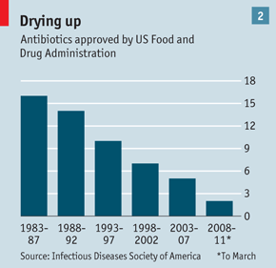
Furthermore, research and production of new antibiotics has severely declined. Between 1983 and 1992, 30 new antibiotics were approved by the FDA, while between 2003 and 2012 only seven were approved. The lack of financial incentive is primarily to blame for this decline. Antibiotics are less profitable than drugs for lifestyle diseases such as high cholesterol and blood pressure, because they are only taken for a short period of time. They are expensive to develop, and it is difficult to find patients with rare diseases for the clinical trials required for the approval of the drug. Scientists had hoped that the sequencing of the bacterial genome would allow researchers to tailor antibiotics to drug-resistant bacteria. Efforts were ineffective, though, and researchers have been forced to return to the old system of antibiotic discovery, in which thousands of potential compounds are tested for their effectiveness against bacteria and subsequently for safety in human use. The process is painstaking and inefficient, and partly responsible for the fact that only two large drugmakers still have substantial antibiotic programs (The Economist, “Drugmakers”). It is imperative that new drugs be developed to combat current, if not future, resistant strains of bacteria, yet progress in new drugs becomes slower every day.

The lack of new antibiotics has been combined with increasing misuse of old ones. The proper regulation of antibiotics has continued as a primary issue in preventing drug resistance. Regulation concerns the proper prescription and use of antibiotics. According to the WHO, “more than half of all medicines are prescribed, dispensed or sold inappropriately” and “half of all patients fail to take them correctly.” Additionally, less than half of all countries are following basic procedures to promote correct antibiotic use and two-thirds of all antibiotics are sold without a prescription. This has become especially problematic in developing countries, where prescription is often not a common practice. When doctors’ visits are not required, people are even less likely to use antibiotics correctly. High costs for quality and quantity of antibiotics is also a common cause leading to sub-standard and incomplete treatment that contributes to resistance. Developing countries also face the greatest costs from drug resistance. Since the cost of drug treatment makes up the majority of most developing countries health care expenditures, the increase in cost related to drug-resistant diseases has the largest impact on the countries least equipped deal with it.
A researcher searches for potential antibiotics using a tedious trial and error process.
Finally, data and surveillance of drug resistant diseases has been recognized by the WHO as one of the most important areas needed to improve to effectively combat drug resistance. Drug surveillance helps with “orienting treatment choices, understanding [antimicrobial resistance] trends, informing public health policy, identifying priority areas for interventions, and monitoring the impact of interventions to contain resistance.” (WHO, “Evolving Threat”). Surveillance has greatly improved in developed countries and international organizations such as the Pan-American Health Organization (PAHO) and European Antimicrobial Resistance Surveillance Network (EARS-Net) have contributed to other improvements. Surveillance is extraordinarily difficult in developing countries, though, where lack of medical infrastructure limits diagnosis and understanding of drug-resistant diseases.
Today’s resistance poses a significant threat to future human health. In an address to the EU in 2012, WHO Director General Margaret Chan predicted a future “post-antibiotic era” and an “end to modern medicine as we know it” if drug resistance continues on its current path. Without effective antimicrobials to combat infections, diseases now thought of as easily treatable will once again become fatal, and surgical treatments will become practically impossible to perform. While the Millennium Development Goal target of reversing the tuberculosis epidemic by 2015 has been met, the advent of drug-resistant TB is threatening to reverse progress. Malaria is becoming increasingly resistant, and new strains in South-East Asia have shown resistance to the most effective drug currently available. Scientists at the U.S. Institute of Health recently announced a breakthrough developing a vaccine for malaria, but it likely will not be ready for another seven to eight years and may not be practical for use in countries with compromised infrastructure.
On top of the development of resistance, globalization in the form of increasing tourism and trade contact is allowing diseases to spread easier and faster than ever. The most unfortunate fact of drug resistance is inaction. Though effective measures against drug resistance have been well understood for years, drug resistance has grown because those effective measures have not been implemented. The daily costs of inaction against resistance are increasing along with the potential for a devastating epidemic of drug-resistant infections.
WHO History
The World Health Organization first formally recognized the issue of drug resistance in 1998, when resolution WHA51.17 was adopted calling for countries to take action against the issue. The resolution asked member-states to develop surveillance systems and education programs regarding drug resistance, improve upon existing practices to prevent the spread of infection, strengthen legislation to prevent the sale of antibiotics without a prescription, and reduce the use of antibiotics in food production. The resolution additionally called for the WHO to support countries in these efforts, encourage research into antibiotics, and develop a system to distribute information regarding drug resistance.
Following the resolution, the WHO published its first recommendations regarding resistance in 2001 with the WHO Global Strategy on Containment of Antimicrobial Resistance. The report was created to aid countries in the process of developing and implementing national policy on antibiotic resistance, primarily with regard to the appropriate use of antibiotics. The WHO later expanded on this vein with resolutions and reports outlining the rational use of antibiotics. Unfortunately, few if any of the WHO’s policy recommendations were implemented and action against antibiotic resistance has languished.
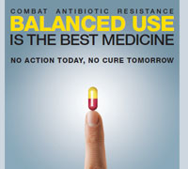
The WHO recognized the lack of momentum in policy changes and named antibiotic resistance the theme for World Health Day in 2011. With the slogan “No action today, no cure tomorrow,” the WHO attempted to renew efforts against drug resistance and bring attention to the rising global issue. The WHO reframed its “critical actions” in a six point policy package:
- Commit to a comprehensive, financed national plan with accountability and civil society engagement
- Strengthen surveillance and laboratory capacity
- Ensure uninterrupted access to essential medicines of assured quality
An advertisement from the 2011 World Health Day.

- Regulate and promote rational use of medicines, including in animal husbandry, and ensure proper patient care
- Enhance infection prevention and control
- Foster innovations and research and development for new tools
Key Concerns
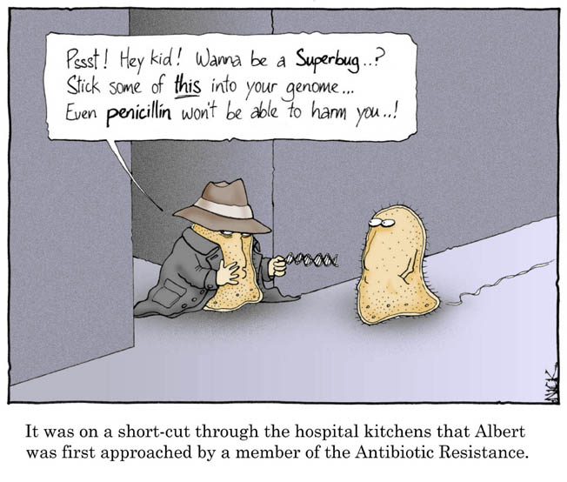
- What areas of improvement should receive priority in combatting drug resistance?
- How can countries effectively promote research into new drug development?
- What is the role of the WHO in promoting new drug development?
- How can surveillance of drug-resistant diseases be effectively increased?
- How can diagnostics be improved and drug availability regulated?
- How can unnecessary use of antibiotics, such as use in animal feed, be limited?
- Should the WHO advise the expedited approval of drugs with potential efficacy against drug resistant diseases?
- How can drug resistant diseases be prevented from spreading through globalized travel?
- How can hospitals prevent the development of “superbugs” in patients?
- How should the WHO plan for a potential epidemic or pandemic of a drug-resistant disease?
Key Opinions
The WHO has six offices that focus their efforts on different regions of the world.

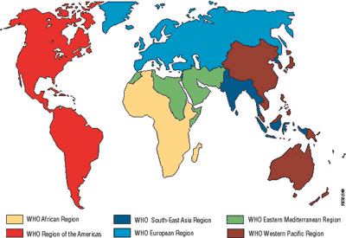
- African Region: The African region has only 10% of the world’s population, yet it has the heaviest burden of disease from HIV, tuberculosis and malaria. These countries have problems with surveillance and evaluation of drug resistant diseases because of difficulties with infrastructure and reporting. Even when drug resistant infections are discovered, patients may not receive treatment because there is little access to second and third line drugs. Additionally, regulation of drug use has been a major issue. To date, there has been little evidence of malaria resistance to the newest antimalarials in Africa, but the development of this resistance in Thailand has been extremely concerning for African countries. It would be easy for these developing strains to spread into Africa through global travel and reverse gains in malaria treatment.
- American Region: The Americas experience disease burdens from both malaria and tuberculosis. Tuberculosis surveillance has improved in recent years and there is now an estimated 81% detection rate. However, tuberculosis control is more difficult because of social inequities that limit access to health care. The US and Canada have seen recent outbreaks of rarer drug resistant diseases that have developed in hospitals, as well as outbreaks of drug-resistant food-borne illnesses. Unlike tuberculosis and malaria, these diseases have a higher potential for unexpected epidemics, since they are less well known and have a penchant for developing high transmissibility.
- European Region: The European Region is primarily burdened with multi-drug resistant and extensively-drug resistant tuberculosis, particularly in Eastern Europe, including Russia and Kazakhstan. Europe has been the most progressive region regarding limiting antibiotic use in animal feed. Since Europe includes some of the world’s most developed countries, it along with the US has seen problems with the development of drug resistant strains of rarer diseases. These diseases typically develop within hospitals and have the potential to spread to the general population.
- South-East Asian Region: In the South-East Asian region, promoting rational use of medicine is seen as one strategy in a long-term WHO goal to achieve universal health care. Action in South-East Asia has been particularly fragmented. It has focused on small-scale projects and education regarding drug resistance. Establishing national and international agencies to establish and implement a plan of action is seen as one solution. Malaria has developed increasing resistance to the newest anti-malarials in Thailand, and threatens to spread beyond South-East Asia to other regions.
- Eastern Mediterranean Region: The Eastern Mediterranean region has been less affected by drug-resistant diseases than most of the other regions. Malaria has remained problematic in countries like Pakistan, Sudan, and Somalia, but in many other countries malaria incidence has increased by more than half in the past 10 years. Tuberculosis mortality was halved in 2010 compared to 1990. The region has expressed concern over the spread of drug resistance across borders, and expressed interest in establishing common strategies at borders to prevent the spread of infections.
- Western Pacific Region: The Western Pacific region bears more than a quarter of the worldwide burden of tuberculosis, particularly in China. China has seen several epidemics of drug-resistant tuberculosis. In 2013, resistance to first-line anti-malarials spread from South-East Asia to the Western Pacific region. In 2011, the WHO Western Pacific Region established the Pacific Malaria Drug Resistance Monitoring Network.

Within this council, the countries within each region are:
- African Region: Central African Republic, Chad, Democratic Republic of the Congo, Nigeria, South Africa, Zimbabwe
- American Region: Argentina, Brazil, Canada, Mexico, United States
- European Region: Denmark, France, Germany, Italy, Kazakstan, Norway, Russia, Ukraine, United Kingdom
- South-East Asian Region: Bhutan, India, Indonesia, Thailand
- Eastern Mediterranean Region: Jordan, Morocco, Pakistan, Saudi Arabia, Somalia, Syria
- Western Pacific Region: Australia, China, Japan, Vietnam
The Council

The World Health Organization is an agency of the UN dedicated to “the attainment by all peoples of the highest possible level of health”, with health being defined as “a state of complete physical, mental and social well-being and not merely the absence of disease or infirmity” (WHO). In pursuit of this ambitious goal, the WHO facilitates collaboration among existing local, national, and international organizations and oversees global progress toward improved public health. With the cooperation of its 193 member states, the WHO promotes “the development of comprehensive health services, the prevention and control of diseases, the improvement of environmental conditions, the development of human resources for health, the coordination and development of biomedical and health services research, and the planning and implementation of health programmes” (UNHCR/WHO).
The WHO is funded by assessed contributions from member states as well as voluntary contributions from members and other organizations. The World Health Assembly convenes annually to allocate funds and determine areas of focus for the upcoming year. An executive board comprised largely of health experts advises the Assembly, while the secretariat, led by the director-general, monitors the implementation of the Assembly’s decisions.
The World Health Assembly in session.
The WHO fulfills its duties as an international organization through the core functions assigned to it through its constitution:
- providing leadership on matters critical to health and engaging in partnerships where joint action is needed;
- shaping the research agenda and stimulating the generation, translation and dissemination of valuable knowledge;
- setting norms and standards and promoting and monitoring their implementation;
- articulating ethical and evidence-based policy options;
- providing technical support, catalysing change, and building sustainable institutional capacity; and
- monitoring the health situation and assessing health trends.

To achieve these functions, the WHO primarily adopts policy recommendations and the adoption of national standards, along with programs designed to achieve specific health goals. However, the WHO does have the power to adopt binding conventions and agreements with a two-thirds vote of member states (the conventions and agreements must then be approved through the constitutional process of each member-state).
Historically, the WHO has been instrumental in the eradication of smallpox and the near-eradication of polio, and has overseen efforts to research and contain diseases ranging from cholera to HIV/AIDS. The WHO’s efforts to improve sanitation and prevent water-borne illness have greatly improved health in less developed regions, while ongoing campaigns for healthier lifestyle choices and prevention of chronic diseases have extended life expectancies in m ore developed areas. Due to its broad mission and broad definition of health, a range of health-related endeavors fall under the purview of the World Health Organization, including efforts to support mental health in conflict regions and to prevent the spread of multi-drug resistant diseases.
Sources
Australian Broadcasting Corporation. "Antibiotics 1928 - 2000." Antibiotics 1928 - 2000. Australian Broadcasting Association, n.d. Web. 11 Aug. 2013.
Avart, Sandra. "Strategies That Work: Alternatives to Antibiotics in Animal Health." Agricultural Research 60.5 (2012): 4-7. USDA Agricultural Research Service. USDA, 15 Mar. 2012. Web. 11 Aug. 2013.
BMJ-British Medical Journal. "Do antibiotics in animal feed pose a serious risk to human health?." ScienceDaily, 11 Jul. 2013. Web. 21 Aug. 2013.
Davies, Julian, and Dorothy Davies. "Origins and Evolution of Antibiotic Resistance." Microbiology and Molecular Biology Reviews 74.3 (2010): 417-33. Microbiology and Molecular Biology Reviews. American Society for Microbiology. Web. 11 Aug. 2013.
Davies, Julian. "Antibiotic Discovery: Then and Now." Microbiology Today 39.4 (2012): 200-03. Society for General Microbiology. SGM. Web. 11 Aug. 2013.
The Economist. "Drugmakers and Antibiotics: The Path of Least Resistance." Editorial. The Economist 12 May 2012: n. pag. The Economist. The Economist. Web. 11 Aug. 2013.
The Economist. "Resistance to Antibiotics: The Spread of Superbugs." The Economist 31 Mar. 2011: n. pag. The Economist. The Economist. Web. 11 Aug. 2013.
Hannon, Gillian, Alexandra Frosina, Becka Levin, and Matthew Egan. "Antibiotic Use for Farm Animals." MicrobeWiki. Kenyon College, n.d. Web. 11 Aug. 2013.
Lewis, Ricki, PHD. "The Rise of Antibiotic-Resistant Infections." The Rise of Antibiotic-Resistant Infections. FDA Consumer Magazine, n.d. Web. 11 Aug. 2013.
Kam, Katherine. "A Look Back At Old-Time Medicine." WebMD. Ed. Louise Chang, MD. WebMD, n.d. Web. 11 Aug. 2013.
MedicineNet. "Antibiotic Resistance." MedicineNet. MedicineNet, 28 Feb. 2012. Web. 11 Aug. 2013.
Miller, Jason T., BS, Scott Y. Rahimi, MD, and Mark Lee, MD, PHD. "History of Infection Control and Its Contributions to the Development and Success of Brain Tumor Operations." Neurosurgical Focus 18.4 (2005): 1-5. Medscape. WebMD. Web. 11 Aug. 2013.
"The Rise of Antibiotic-Resistant Infections." The Rise of Antibiotic-Resistant Infections. FDA Consumer Magazine, n.d. Web. 11 Aug. 2013.
WHO. "Antimicrobial Resistance Fact Sheet." WHO. WHO, May 2013. Web. 11 Aug. 2013.
WHO. "The Evolving Threat of Antibiotic Resistance: Options for Action." WHO. WHO, n.d. Web. 21 Aug. 2013.
WHO. "The Pursuit of Responsible Use of Medicines: Sharing and Learning from Country Experiences." WHO. WHO, n.d. Web. 21 Aug. 2013.
WHO. "The World Medicine Situation 2011: Rational Use of Medicines." WHO. WHO, n.d. Web. 21 Aug. 2013.

