 | Boulder High School  Model United Nations  Conference | 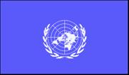

Background Guide

North Atlantic Treaty Organization
Security and Stability in Post-Arab Spring North Africa
Written by Kara Hartig
October 5th, 2013

Pertinent Data
- The Arab Spring, a series of anti-government protests, uprisings, and armed rebellions beginning in early 2011, consumed 8 countries across the Middle East and North Africa.
- The U.N authorized outside regional organizations to enforce a no-fly zone over Libyan territory following the start of the uprising in February 2011 under Security Council resolutions 1970 and 1973. By March 31, NATO had taken control of all military operations in Libya and was authorized to carry out air and naval strikes against threats to civilians. Since the U.N has no standing military of its own and NATO requires either an attack on one of its members or a U.N resolution to justify military action, the two organizations often work in tandem to ensure that international military involvement is undertaken responsibly.
- As many as 30,000 people were killed in Libya’s uprising, over 3,700 people per month.
- Roughly 900 people were killed and 6,400 injured in Egypt from the start of the country’s protests to the removal of President Hosni Mubarak less than a month later.
- On January 16-19 of 2013, terrorists captured the In Amenas natural gas facility in Algeria, killing 80 people and taking hundreds of others hostage.
- In Transparency International’s 2011 Corruption Perceptions Index, every North African country scored below a 4 on a scale of 0 (highly corrupt) to 10 (very clean). Scores ranged from Libya being very corrupt at 2 and Tunisia moderately corrupt at 3.8.
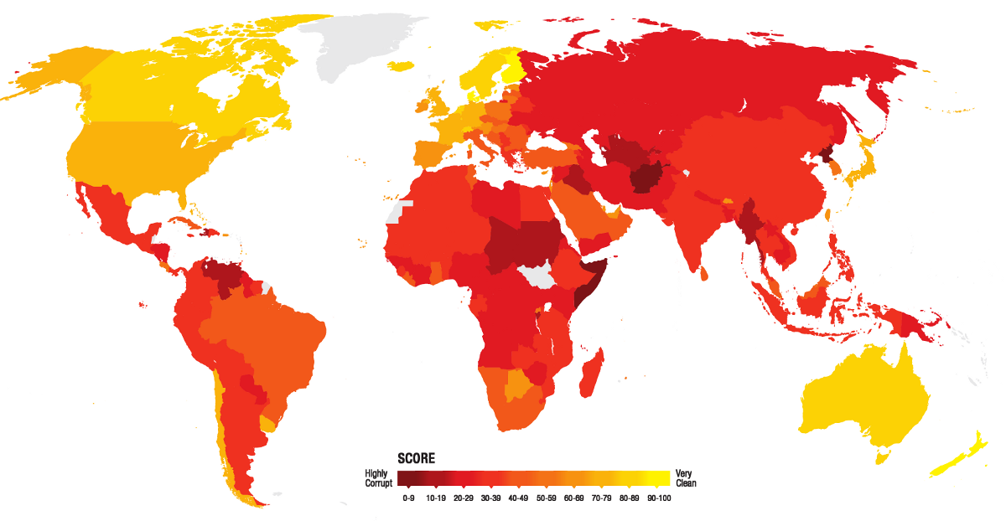
- According to the Government Defense Anti-Corruption Index, published in early 2013, all North African and Middle Eastern countries assessed earned a D, E, or F on a scale of A (very low risk of corruption) to F (critical risk). Egypt, Libya, Syria, Yemen, and Algeria all scored an F, indicating critical risk of corruption in the defense sector.
Corruption Perceptions Index 2012
- Military spending in the Middle East and North Africa (MENA region) has averaged about $100 billion per year over the last 5 years. In comparison, the MENA region spent only $66 billion on health care in 2009.
- If it was a country, the MENA region would rank number 3 in the world on military spending, just below the US ($682 billion) and Russia ($166 billion) based on 2012 data.
- According to the Stockholm International Peace Research Institute (SIPRI), which carries out research on international security, armaments, and disarmament, military spending increased by around 8 percent in the Middle East and North Africa last year [2012], while global arms spending dropped for the first time in more than a decade.
- Average real Gross Domestic Product (GDP) economic growth in North Africa and the northeastern Middle East fell from 4.2% in 2010 to 2.2% in 2011, its lowest in over a decade. The hardest hit were core states of the Arab Spring – Libya, Tunisia, Egypt, Syria, and Yemen.
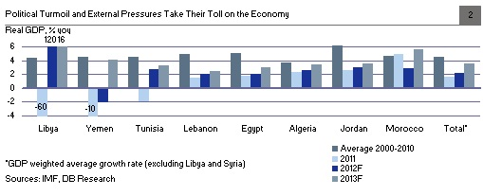

- The number of tourists to Egypt dropped from 14 million to 9.5 million from 2010 to 2011, a sharp blow to an industry that makes up 13% of Egypt’s GDP.
- Immigration to Organization of Economic Co-operation and Development (OECD - wealthy,
- democratic, capitalist) countries from the Mediterranean Arab States [Morocco, Algeria, Tunisia, Libya, Egypt, Jordan, Palestine, Lebanon and Syria] increased by 42% from 2001 to 2010, with 91% of those emigrants destined for Europe, particularly Spain, Italy, and France.
- A 2010 terrorism report by Europol, the European Union’s joint police force, warned that, due to Arab Spring unrest, EU countries saw a 50 percent jump in the number of arrests linked to Islamic terrorism from 2009 to 2010.
- The 2013 EU Terrorism Situation and Trend Report states: “Religiously inspired terrorists carried out 6 attacks on EU territory in 2012 compared to 0 attacks defined as terrorism in 2011. Arrests related to religiously inspired terrorism [in EU states] increased from 122 in 2011 to 159 in 2012.”
- The same report indicates that, “The instability in the Middle East and North Africa post ‘Arab Spring’ continues to be exploited by extremist groups, which have capitalised on the profusion of unsecured weapons and reduced security levels in some states in order to consolidate their presence.”
- The International Monetary Fund (IMF) forecasts that economic growth for the Middle East and North Africa is expected to decrease from 4.2% to 3.7% in 2013, with political instability being a driver of the slowdown.
- Algeria alone supplies 15% of EU gas imports (especially to Italy and Spain).
- Libya supplies 11% of EU oil imports (especially to Italy, Germany, Spain and the UK).
- From 1950 to 2000, most critical changes in oil markets have coincided with political crises in North Africa and the Middle East. For instance, the 1956 Suez Crisis saw a decrease in global oil production of 10.1%, the 1967 Arab-Israeli war a decrease of 7.8%, the 1979 Iranian Islamic revolution 8.9%, the 1980-1988 Iran-Iraq war 7.2%, and the 1990 Iraqi occupation of Kuwait an 8.8% decrease. These production decreases all resulted in a significant rise in global oil prices.
- In a report on the effects of political instability on energy security in North Africa and the Middle East, Dr. Sara Vakhshouri determined that political instability in the region has the highest influence – nearly 39% -- on the security of energy supply in comparison to four other factors. The next greatest factor, sanctions, accounts for only 23% of energy security.
- Desertec, one of the world’s most ambitious clean-energy projects, aims to develop the enormous solar and wind potential of the Middle East and North Africa, potentially delivering as much as 15% of the electricity needed by the EU in the coming decades. With concerns over instability in the region, however, investors are showing concern that the project will never be realized and that interest will be diverted elsewhere to avoid creating energy dependencies on an unstable and politically hostile region.
- Because of its plentiful sunshine, North Africa could be one of the world’s major growth markets for the solar industry. But a recent survey of nearly 400 executives from solar companies by CSP Today, part of a business intelligence group in London, indicated that nearly 40 percent of respondents thought political stability would be the major issue in coming years for developing solar in North Africa and the Middle East. By comparison, about 27 percent of the respondents said financing was the major issue.
History
North Africa’s political situation and industrial development have been closely linked to those of Europe for over a century. By the end of the 19th century, all of North Africa was under the control of European colonial powers. European rule there was often brutal and oppressive and racist, laying the foundations for the deep-seated mistrust that many North Africans hold for Europe and its institutions today. In the decades after World War II, colonialism clashed with renewed ideals of freedom from oppression and self-determination, Europe gradually relaxed its grip on Africa. Libya, under the control of Italy from 1911-1942 and both Britain and France after that, achieved independence in 1951. Egypt was next, throwing off British military occupation the next year. Morocco and Tunisia followed, gaining freedom from France and Spain in 1956. Algeria, first of the region to be put under colonial rule in 1830, was also the last to escape it in 1962 – after a very brutal, protracted, and bitter war of independence from France.
After so many years of occupation, however, many colonial powers had sent large numbers of European immigrants to their African territories and to this day feel an obligation to intervene in African affairs on their behalf.
European withdrawal from North Africa was often badly handled. After decades of control, much of North Africa was vulnerable to exploitation of prejudices against Europe, its ideals, or other indigenous groups. While a few, newly independent African and Middle Eastern states transitioned to effective democracies, most came under the control of dictators or military factions or endured many years of civil war. Authoritarian regimes became common, flourishing in countries like Egypt, Libya, and Tunisia as their respective rulers held power for many decades, often declaring military law or a state of emergency to justify harsh suppression of dissidents. For the entirety of his time in office, for example, President Hosni Mubarak kept Egypt under emergency law, giving the central government sweeping powers of arrest and denying basic freedoms. Under the leadership of Qaddafi, Libya has long been subject to arbitrary arrest, detention, torture, and disappearances. President Ben Ali of Tunisia similarly has systematically suppressed and silenced opposition to his ruling party, employing a gargantuan state security force of 130,000 to 150,000 police, or one security officer for every 40-50 adults.
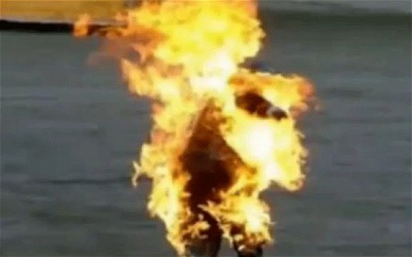
With such rampant oppression and denial of basic freedoms held in stark contrast to the relative security and freedom of the OECD, democratic and wealthy states, seen through the internet and television, in hindsight an explosion seemed imminent. On December 17, 2010, a Tunisian fruit vendor set himself on fire in the city of Sidi Bouzid, Tunisia in protest of government corruption and injustice. Within weeks, mass protests had spread across the country and begun to agitate dissenters in neighboring states as President Ben Ali declared a nationwide state of emergency and granted security forces permission to shoot at any group of three or more civilians who did not disperse. By January 14, 2011, Ben Ali had fled and the prime minister took over control of Tunisia, but by then the Arab world was already in a state of upheaval and turmoil. With the aid of social media like Twitter and Facebook, news reports, and decades of pent-up frustration with established political systems, Egypt, Libya, and Algeria erupted in protests soon after as the revolutionary spirit continued to spread through North Africa and the Middle East.
Tunisian fruit vendor sets himself on fire; December 17, 2010
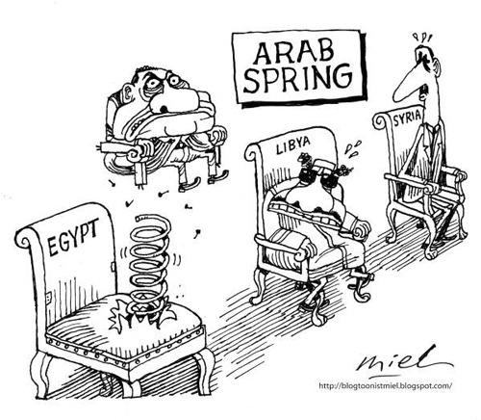
In Egypt, coordinated protests against the oppressive leadership of President Hosni Mubarak began on January 25, turning Cairo into a “war zone”. The central government quickly shut down Twitter, the Internet, and mobile networks in an attempt to curb the spread of protests. Security forces began to respond violently to protests, and the death toll reached 100 by January 29 as hundreds more had been arrested. On February 11, after 18 days of mass protests, the vice-president of Egypt announced that Mubarak would step down and turn his power over to the military. What followed was a power struggle between the military and the newly elected parliament, as the Supreme Council of the Armed Forces (SCAF) announced that the parliamentary elections had been unconstitutional, dissolving the legislative body on June 14. Three days later, SCAF passed an addendum to the constitutional declaration giving itself legislative powers, a role in the writing of the new constitution, and limiting the powers of the new president. On June 24, Mohamed Morsi was announced the winner of the presidential election, becoming the first democratically elected president of Egypt. Morsi repealed the SCAF’s addendum on August 12, frustrating military leaders.
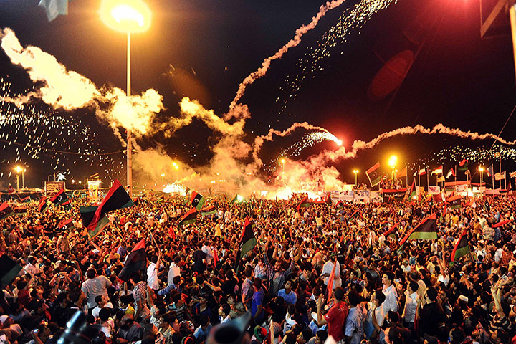
Libya’s protests, which would quickly become the most deadly and globally entangled of North Africa’s Arab Spring, began in Benghazi following the arrest of a human rights campaigner on February 16. By the 18th, dozens of protestors had been reported killed, although the number was unverified due to a media blackout installed by Qaddafi. Two days later, the death toll had climbed past 230 as troops and mercenaries were encouraged to shoot unarmed demonstrators. On March 5, the rebel National Transitional Council (NTC) in Benghazi declared itself the sole representative of Libya. By March 17, the UN Security Council had passed resolutions 1970 and 1973 authorizing a “no-fly-zone, an arms embargo and the authorization for member countries, acting as appropriate through regional organizations, to take “all necessary measures” to protect Libyan civilians. NATO, initially solely in charge of enforcing the no-fly zone, by March 31 had taken control of all military action in Libya under Operation Unified Protector, through which it enforced an arms embargo, implemented the no-fly zone, and carried out air and naval strikes against military forces involved in threats to attack or actual attacks against Libyan civilian populations. After the first air strikes on March 19th, halting Qaddafi’s advance on Benghazi, the rebels slowly advanced towards Tripoli, finally entering the city on August 21, 2011 with little resistance. On August 23 they invaded Qaddafi’s compound as he fled; shortly afterward, he was executed by Libyan rebels. An interim government was established and recognized by the U.N. within weeks after the fall of Tripoli and Operation Unified Protector was deemed no longer necessary and terminated on October 31, 2011.
Libyan rebels celebrate the occupation of Benghazi
Fast-forward two years and the fledgling democracies of North Africa struggle to maintain peace and stability.

Present Situation
Today, the outlook for many previously promising Arab Spring states is decidedly less optimistic than was hoped for when the revolutions began two years ago. Even Tunisia and Algeria, arguably the most stable of the North Africa region, are having trouble containing terrorism and violent political unrest. In February of 2013, Tunisia’s opposition party leader was assassinated, leading to protests that were met with teargas, riot police, and armored tanks as the new government struggles to equitably redistribute power. Algeria is arguably the least affected by the Arab Spring, as the memory of the 1990s civil war, which left 200,000 Algerians dead, and the presence of al-Qaeda in the Islamic Maghreb appear to have curbed political upheaval. Terrorist activity in Algeria is seen as fairly status quo as the government has been involved in the battle against terrorism for many decades, but this year’s January 16 attack on the In Amenas natural gas site, where hundreds of workers were held hostage and over 80 killed, indicates that Algeria is now struggling to contain terrorist activity. Compared to Egypt and Libya, however, Algeria and Tunisia’s relative political stability and government accountability are a remarkable achievement.
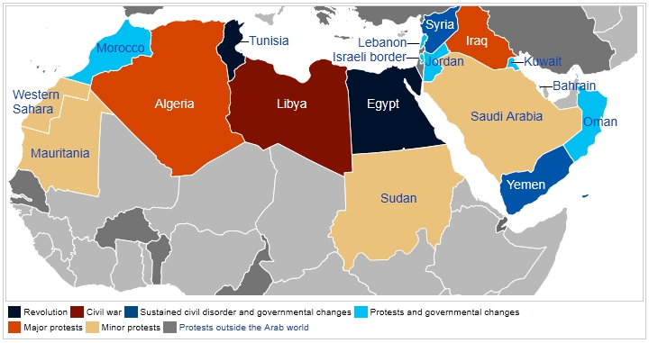
Political Status of Arab Spring states up to January 2013
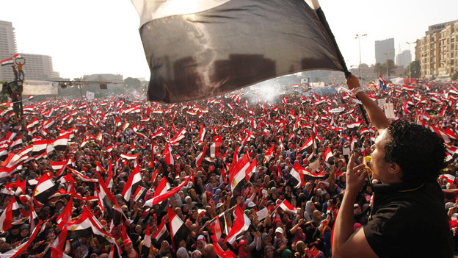
Egypt, once considered the most promising of the Arab Spring states as it succeeded in instituting democratic elections and avoided the large death toll of Libya, now appears on the brink of another violent upheaval. Shortly after his election, Morsi gave his own decrees and laws immunity from judicial oversight and dismissed the public prosecutor, angering civilians who had been counting on the success of a separation of power. A poll in May 2013 recorded that Morsi received only a 30% approval rating from the people whereas the military enjoyed 94% approval. In June of this year, fuel shortages, rising prices, and a failure to improve the economic situation of the country led to mass protests against President Morsi as citizens called for the military to step in. On July 3, they got their wish: the military suspended the constitution, ordering new elections and ousting Morsi as General al-Sisi, Army Chief of Staff, declared the chief judge of the constitutional court the interim president. Within days, hundreds were reported injured and at least 39 dead in clashes between Morsi’s supporters and those of the military, and over a month later bloody clashes are almost everyday occurrences. The Sinai Peninsula, long a relatively lawless zone, has seen almost nightly clashes between militias and police facilities as officials worry that this could be a preview of what is coming to the rest of Egypt if the government fails to reestablish peace. Experts are concerned that the military will be reluctant to give up the power it has gained, leaving the international community extremely uneasy over the fate of Egypt’s democracy. If Egypt descends into chaos, it could threaten the entire Mediterranean region. Abdel Ghaffar Shukr, head of the Socialist People's Alliance Party, told reporters, “The spectre of civil war is not far from Egypt. If the security vacuum in Sinai is not handled wisely and quickly, terrorism hotbeds and Jihadists would move to Cairo, which would lead to infighting and public division."
Protestors opposing Morsi wave flags days before the military coup
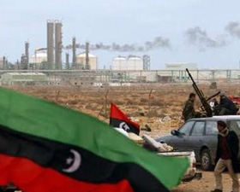
The most deadly and protracted of North Africa’s Arab Spring protests, Libya remains highly unstable and dangerous. A General National Congress was elected in July, but the weak interim government has failed to disband the many armed militias currently roaming the country, end arbitrary arrests and torturing of detainees, or tackle the excessive persecution of people appearing to be pro-Qaddafi. Tribal clashes, destruction of religious sites, kidnappings, targeted killings, and attacks on foreign diplomatic missions and international organizations have plagued Libya throughout the year. The new government struggles to build a new, accountable military and security force in wake of the former military’s support of Qaddafi. Many of the armed groups that sprang up during the clashes between Qaddafi’s forces and the rebels have refused to disband, posing a security threat for civilians and frustrating attempts to rebuild the army. Human Rights Watch’s 2013 report on Libya indicates that not enough is being done by the international community to curb continued violence and take accountability, citing NATO’s failure to investigate at least 72 civilian casualties caused by its air strikes in 2011. Despite initial hopes for the rise of peaceful democracies in North Africa, the region appears to be teetering on the brink of another collapse.
Rebel militias in Libya
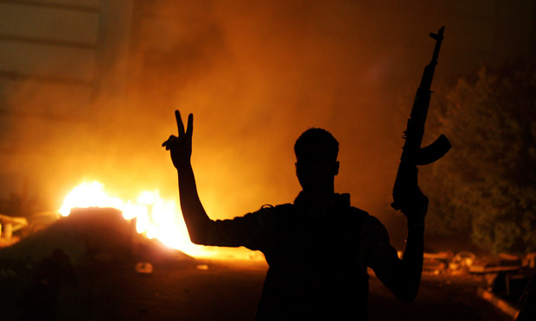
Terrorism is one of the most visible effects of post-Arab Spring instability. Experts worry that region-wide disorder could leave North Africa vulnerable to the establishment of a multi-state cooperative terrorist presence. Algeria’s prime minister stated in a report that the attack on the In Amenas natural gas site appears to have been carried out by terrorists who jumped the border from northern Mali. Further information suggests that the operation received logistical support from Islamic terrorist groups in eastern Libya, supporting the theory of a region-wide terrorist establishment. “It is only a short leap,” says Ambassador Dore Gold, President of the Jerusalem Center for Public Affairs, “from the emergence of a new region-wide al-Qaida infrastructure in North Africa, that crosses international borders, to a direct threat to Europe itself.” Without effective law enforcement and military forces, North African terrorism and organized crime pose a security threat to Europe and neighboring states and can destroy the business climate of the region, creating losses for western companies.
Libyan fighter shows the victory sign in front of the Ansar al-Sharia headquarters
The political instability of North Africa also threatens the economic situation and energy security of Europe. In 2012 Algeria alone supplied about 15% of E.U natural gas consumption and Libya provides 11% of E.U oil imports, particularly to Italy, Germany, Spain, and the UK. The World Energy Outlook agency estimates that between now and 2035, more than 90 percent of future growth in oil production will come from countries in the Middle East and North Africa. Instability in the region could pose a direct threat to the future energy security of Europe, particularly in light of the recent debt crisis. It also presents ramifications for the development of clean energy projects; Dr Gerhard Knies claims that, “Within 6 hours deserts [around the world] receive more energy from the sun than humankind consumes within a year.” The current political instability of North Africa, however, makes investment in clean energy projects in the region very risky and, if it continues, could threaten the sustainable energy future of the world.

NATO History
With the end of World War II, Europe and North America faced a world greatly changed by devastating war. With the end of Nazi Germany, a power vacuum opened in Europe that facilitated the incursion of communism and Soviet influence into Eastern and Central Europe. As the Soviet Union consolidated its power and began to build up its military and industrial capacity, the other Allies of Europe and North America grasped for a way to recover from the staggering human and economic casualties of the war while maintaining a strong defense sector to counter potential Soviet aggression.
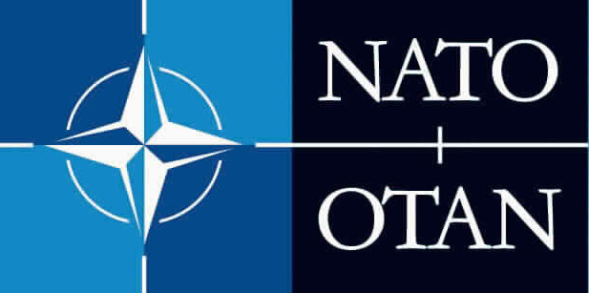
With this in mind, concerned states from Europe and North America came together in 1949 and, after extensive debate, signed the North Atlantic Treaty on 4 April, 1949 in accordance with three central goals: “deterring Soviet expansionism, forbidding the revival of nationalist militarism in Europe through a strong North American presence on the continent, and encouraging European political integration.” In Article 5 of the Treaty, Allies agreed that, “an armed attack against one or more of them… shall be considered an attack against them all,” and, in the case of such an attack, each Ally would respond with “such action as it deems necessary, including the use of armed force.”
While the North Atlantic Treaty Organization (NATO) began as a largely military organization, it has since shifted more focus to the importance of political cooperation and discussion. A report entitled “The Future Tasks of the Alliance” recommended in 1967 that NATO develop a political objective to encourage dialogue and détente between Allies and Warsaw Pact members. This suggestion lead to the negotiation of the Helsinki Final Act in 1975 binding signatories – including the Soviet Union and other Warsaw Pact members – to respect the inherent freedoms of their citizens. By adopting a greater role in global politics in conjunction with military preparedness and cooperation, NATO was able to contribute to the détente between the Soviet Union and democratic Europe. Furthermore, connections forged and trust earned during this process paved the way for many new countries to join NATO following the collapse of the communist system in Europe in 1989.
Today, NATO is composed of 28 member states from North America and Europe as well as a host of Partners from across the globe. Through the Partnership for Peace program, established in 1994, NATO has been able to foster political connections and exchange information with non-member states in Central and Eastern Europe, Central Asia, North Africa, the Middle East, and the Pacific. Internationally, NATO is actively involved in five different operations, the largest being the management of the International Security Assistance Force in Afghanistan (ISAF) coordinating approximately 102,000 troops from 50 different countries. For the other four missions, NATO supplies airlift support to the African Union’s Mission in Somalia, occupies Kosovo under United Nations Security Council Resolution 1244, runs counter-piracy missions off the Horn of Africa, and monitors the Mediterranean Sea in counter-terrorism measures through Operation Active Endeavour.
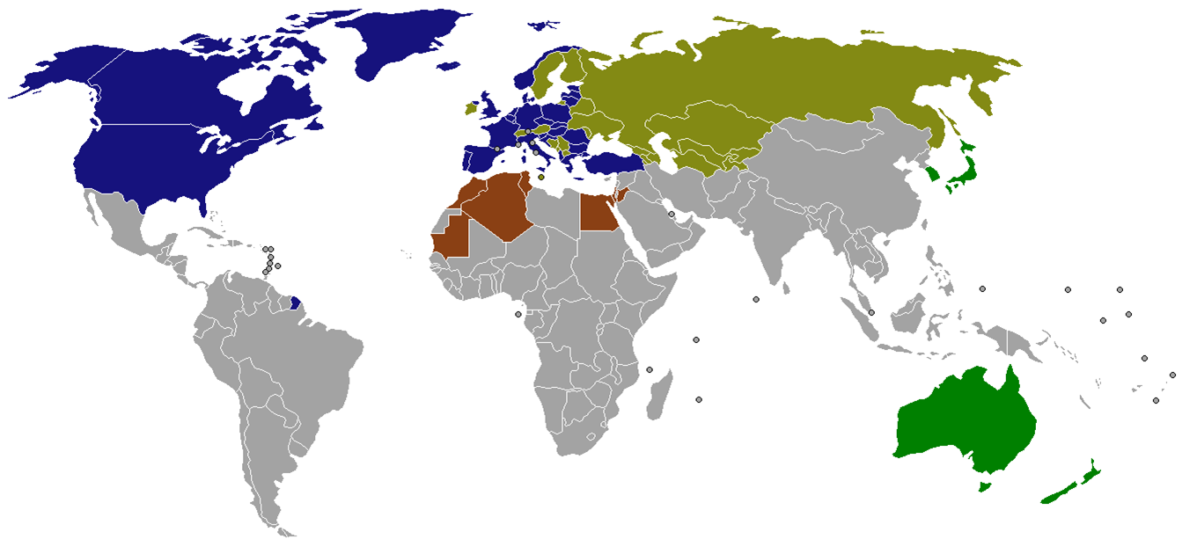 Blue: NATO Member States; Brown: Mediterranean Dialogue; Pale Green: Euro-Atlantic Partnership Council; Dark Green: "Partners Across the Globe"
UN Secretary General Ban Ki-moon recently stated, “Security sector reform is not palliative or short-term…It is a core element of multidimensional peacekeeping and peace building essential for addressing the roots of conflict and building the foundations of long-term peace and development.” In accordance with this view, NATO has recently begun to reassess its role in post-conflict stabilization. In NATO’s 2010 New Strategic Concepts, a revised mission statement following an evaluation of NATO’s role in providing peace and stability, member states agreed that, “Crises and conflicts beyond NATO’s borders can pose a direct threat to the security of Alliance territory and populations. NATO will therefore engage, where possible and when necessary, to prevent crises, manage crises, stabilize post-conflict situations and support reconstruction.” The NATO website goes on to qualify: “The Alliance is not and cannot be a civilian reconstruction agency, but NATO can make a significant contribution provided that it is part of a coherent international response.”
This change in outlook for the organization follows a series of operations through which the Alliance saw the need for post-conflict stabilization. Following the Yugoslavian civil war and in view of the ethnic conflicts at the root of the violence, NATO sent 60,000 troops to the region in 1995 dedicated to creating “self-sustaining peace conditions” under the U.N’s Dayton Peace Agreement. NATO additionally took a small role in stabilizing Iraq from 2004-2011 by training, mentoring, and assisting Iraqi Security Forces. NATO’s ongoing missions also reflect this dedication to reconstruction following violent conflict. Under U.N Security Council Resolution 1244, the NATO-led Kosovo Force remains deployed in Kosovo to maintain a safe and secure environment and freedom of movement for all peoples following the war of 1998-1999. In Afghanistan, NATO currently has 28 Provincial Reconstruction Teams deployed to assist in reconstruction. Beyond ISAF pull-out, scheduled for 2014, NATO is additionally dedicated to training, advising, assisting and contributing funds to the Afghan National Security Forces to facilitate the establishment of peace in the region.
Following the Libyan conflict in North Africa in 2011, NATO has recognized an obligation to provide for post-conflict stability and security in the region. While Qaddafi’s regime was overthrown and the NATO operation terminated by 31 October, 2011, Libya remained unstable and apparently incapable of establishing a sufficient security force to control the armed militias and terrorist groups roaming the country. After Libya made a formal request for help to NATO in late May, a team of experts were sent in June to assess the security situation and determine how NATO could best provide assistance. Even before the security assessment the Alliance was considering military training, but Secretary General Rasmussen stressed that, “this is not about deploying troops to Libya,” adding that training of security forces could take place outside of Libya. Back in May of 2011, Mr. Rasmussen pointed out that, “many allies went through demanding reforms after their own revolutions over 20 years ago and have a wealth of experience to share. Modern defense and security institutions which are fully accountable to democratically elected authorities will be a vital reform priority for Libya and many other countries in the region.” Given the continued violence and instability of the region, however, NATO may reconsider the extent of its security assistance contributions.
Key Concerns
Considering that North Africa is only directly involved with NATO political discourse through the Mediterranean Dialogue partnership, of greatest concern to NATO states is the potential for globally-reaching security issues. While economic concerns may be a motivator for intervention, NATO is principally occupied with ensuring the security of member states and improving the stability of states that threaten international peace and safety.
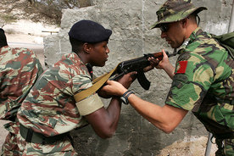
- Which states in North Africa (for the purposes of this council: Morocco, Algeria, Tunisia, Libya, and Egypt) pose the most immediate or greatest threats to NATO’s security?
- Should NATO provide more training exercises for North African forces in defense and counter-terrorism?
- How does NATO best address the growing threat of cooperative terrorist groups in the region?
- How can the Alliance ensure the energy security of Europe in the face of terrorism, political instability, and corruption?
A NATO soldier participates in the assistance mission training African Union forces
- Should NATO be responsible for providing expertise and assistance in defense and security sector development and reform?
- How can NATO make its resources and experience more accessible to North Africa? Should it?
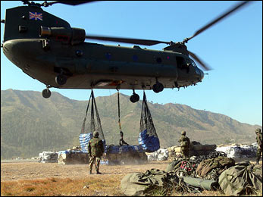
- Should NATO consider sending security forces into Libya or elsewhere to protect civilians currently at risk?
A joint NATO-UNHCR (UN Refugee Agency) airlift
- Which international organizations would be most able to cooperate with the Alliance in providing post-conflict stabilization and establishing accountable security forces?
- How can NATO assist humanitarian relief organizations operating in post-conflict zones in North Africa and prevent further human rights violations?
- Out of training officials and security forces, modernizing defense systems, establishing transparency and accountability in the defense sector, deploying military forces, and improving defense administration capabilities, which is/are NATO responsible and able to provide?
- How can NATO improve cooperation with Mediterranean Dialogue countries and other international organizations in addressing these issues?

Key Opinions
- United States – While the U.S is disengaging from foreign military intervention in Iraq and Afghanistan, Israel, one of its most important allies, is directly threatened by the instability and violence in neighboring North Africa and particularly the Sinai Peninsula of Egypt, with which it shares a border. Israel was forced to briefly close an airport on the Red Sea when Egyptian officials warned of a possible missile strike from militants in the Sinai region. United States embassies and citizens are also threatened by terrorism in the region: the September 11, 2012 attack on the US embassy in Benghazi resulted in the deaths of the American ambassador and 3 other State Department officials, and the In Amenas terrorist attack killed four American citizens. Other violent attacks on US embassies occurred in Cairo, Tunis, Sana’a, and Khartoum last year. That being said, the debt crisis in Europe and resulting austerity measures have forced NATO members to cut back spending by 10% in real terms, which may leave the U.S to take the brunt of NATO military spending.

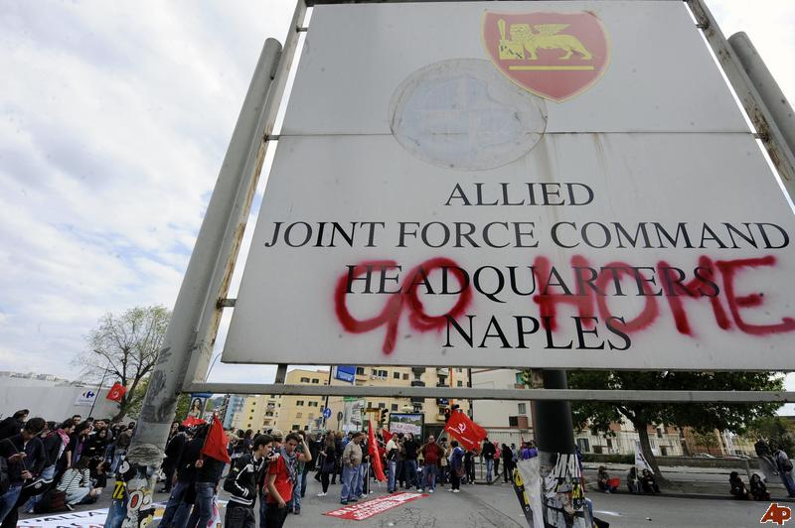
- Spain – Spain is one of the most popular destinations for immigrants from the Mediterranean Arab States to OECD countries, a subset of world immigration that saw a 42% increase from 2001 to 2010. If the situation in North Africa becomes more dangerous for civilians, Spain may see a large influx of refugees from the region in the coming years, straining an already poor economy and abysmal unemployment rate, currently at about 26%. Spain also has a large economic investment in North Africa as one of the principal recipients of both Algerian natural gas and Libyan oil imports to the E.U. and as such is one of the region’s greatest bilateral aid donors.

- Italy – Italy is arguably the most popular destination for emigrants and refugees from North Africa, receiving around 6,700 refugees from Libya in the first 6 months of this year alone. With an unemployment rate that hit 12.2% in May – a record high for the country – Italy is deeply concerned that instability in North Africa may generate even greater numbers of immigrants. Like Spain, Italy is a major recipient of natural gas from Algeria and oil from Libya.
Italians protest NATO’s involvement in Libya at the Allied Joint Force Command HQ in Naples

- France – Another major destination for North African emigrants and refugees and major recipient of Algerian natural gas, France is one of the region’s biggest aid donors. France is additionally concerned that terrorism and instability in North Africa could spread to Mali, Niger, and Mauritania, mineral-rich territories in northwestern Africa that provide uranium vital for France’s nuclear sector. Despite France’s interest in this region, however, the country’s high debt is forcing it to decrease its military budget, leaving the state reliant on cooperative international agents like NATO to carry out long military expeditions in North Africa.

- United Kingdom – With trade between the U.K and MENA exceeding 30 billion euros in 2011 and as another major recipient of Libyan oil, the U.K is highly invested in North Africa’s economic future and energy security. Millions of U.K tourists also visit the region each year, leaving the state concerned about the safety of its citizens abroad. Like France, the U.K’s large debt has forced it to cut back on military spending and has made it equally dependent on international organizations for defense and foreign military action.

- Norway – Norway, a major producer of natural gas, competes directly with Algeria to contest Russia’s natural gas imports to the E.U. Experts forecast that the In Amenas gas site terrorist attack in Algeria may affect 2013 outputs, giving Norway an opening to compete directly with Russian suppliers. Economic concerns aside, however, Norway is wary of terrorism in North Africa; Norway’s Foreign Ministry decided to restrict public access to 15 of its embassies in Africa and the Middle East this August amid fears that a “major terrorist attack was in the works”.
The Council
NATO has both a civil and military structure. At the head of the civil sector is the North Atlantic Council (NAC), the chief political decision-making body with seats for all 28 member states. Chaired by the NATO Secretary General, the NAC meets at least once a week and makes all major policy decisions based on consensus. Decisions made by consensus reflect the will of all members; while there is no voting in NATO, a proposal is “passed” only if there are no objections. A proposal is submitted by an Ally, the Secretary General, or a committee chair and is then circulated to all other members of the council for consideration and discussion, and any objections to a proposal must be submitted to the Chair by a pre-determined deadline. The process of consensus provides ample opportunity for a variety of states to contribute to the language of a decision, reflecting a much greater degree of collaboration than is often seen through other forums. In this atmosphere of collaboration, NATO frequently cooperates with other international actors such as the U.N and the E.U to ensure peace and security for member states and the international community as a whole.
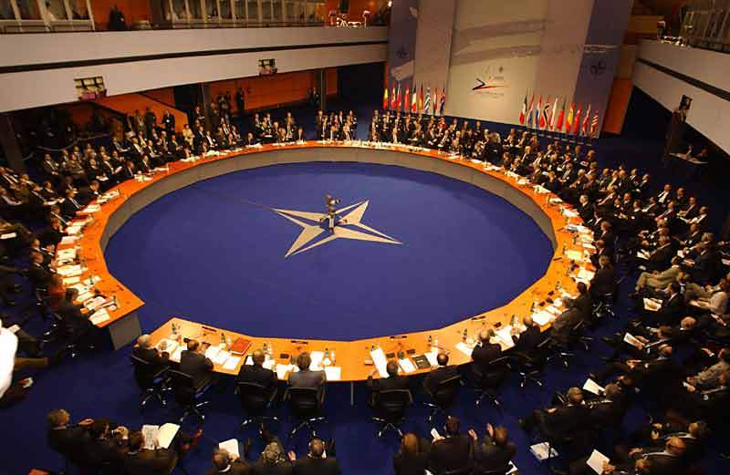
Under the North Atlantic Treaty, the NAC has the power to set up “such subsidiary bodies as may be necessary” and is responsible for overseeing the political and military processes relating to security issues affecting the Alliance. The NAC’s powers and potential courses of action are based largely on precedent and what member states are willing to agree on. Based on past action, NATO is able to: provide airlifts to military or humanitarian relief operations; offer training, education, and exercise programs for foreign security forces and officials; establish more structured forums for cooperation with Partners, non-members, and other international and regional organizations; provide military troops and resources in a support or lead capacity for military action; draw from its Individual Partnership Action Plan to assist a partner in establishing a modern, democratically-accountable defense sector; and use its Planning and Review Process to help partners to modernize and expand the capabilities of their security forces. Without a specific outline or restriction of its powers, NAC is responsible for receiving suggestions from all member states and integrating them into final decisions that are agreeable to all.
The North Atlantic Council
Sources
Blight, Garry, Sheila Pulham, and Paul Torpey. "Arab Spring: An Interactive Timeline of Middle East Protests." The Guardian. Guardian News and Media, 05 Jan. 2012. Web. 09 Aug. 2013.
Michaletos, Ioannis. "North Africa Instability Affects European Energy Security." Worldpress.org. Worldpress, 08 Apr. 2013. Web. 10 Aug. 2013.
"NATO History." NATO. North Atlantic Treaty Organization, n.d. Web. 08 Aug. 2013
"NATO Operations and Missions." NATO. North Atlantic Treaty Organization, n.d. Web. 08 Aug. 2013.
"What Is NATO?" NATO. North Atlantic Treaty Organization, n.d. Web. 08 Aug. 2013.
Allam, Hisham. "Egypt Military 'Split' Over Morsi." IPSNews.net. Inter Press Service, 10 Aug. 2013. Web. 12 Aug. 2013.
"Arab Spring (2013): Two Years of Arab Spring." Arab Spring (2013): Two Years of Arab Spring. N.p., n.d. Web. 05 Sept. 2013.
Gold, Dore. "The North African Threat To Europe." JCPA.org. Jerusalem Center For Public Affairs, 25 Jan. 2013. Web. 10 Aug. 2013.
"Libya's Relationship with NATO." LibyaIntelligence.org. The Libyan Intelligence Group, 24 June 2013. Web. 12 Aug. 2013.
"Middle East and North African Governments Have High Risks of Defence-related Corruption." Transparency.org. Transparency International, 06 Feb. 2013. Web. 12 Aug. 2013.
Tanner, Fred, and Mohammad-Mahmoud O. Mohamedou. The Imperative of Security Sector Reform After the Arab Spring. Issue brief no. 43. European Institute of the Mediterranean, 20 June 2012. Web. 13 Aug. 2013.
"World Report 2013: Egypt." HRW.org. Human Rights Watch, n.d. Web. 12 Aug. 2013.
"World Report 2013: Libya." HRW.org. Human Rights Watch, n.d. Web. 12 Aug. 2013
Masetti, Oliver, Kevin Korner, Magdalena Forster, and Jacob Friedman. "Arab Spring (2013): Two Years of Arab Spring." Current Economics (2013): n. pag.ConsensusEconomics.com. Consensus Economics, 27 Feb. 2013. Web. 12 Aug. 2013

