KENT DENVER SCHOOL AND ST. MARY’S ACADEMY
Model United Nations
Conference
January 25, 2014

Background Guide
Advanced Council
Historical Council February 1, 1892: Carnegie’s Calamity

Madison Taylor
Stefan Pauley

Committee Overview

This is a historical council on events leading up to the 1892 Homestead Strike between the Homestead Steel Mill, owned by Andrew Carnegie, and its workers. Although primarily based in fact, we will be taking some liberties with the crises that are presented to you. For example, we may be introducing crises that did not specifically happen in order to put both sides of the dispute on more equal footing. We ask that you do your best to alter the course of history and formulate different solutions to the problem.

In this committee, our dispute will not only be split up into a “labor” and “Homestead Steel Mill” side, but will consist of a multitude of different groups with varying interests. These groups include: the Pinkerton Detective Agency, the Amalgamated Association of Iron, Steel, and Tin Workers, the Knights of Labor, the Molly Maguires, and Homestead Steel Mill Executives. It is important, when trying to resolve this crisis, that you are not only looking out for your, “side,” but also your individual organizations’ interests.

We ask that you use both personal and public directives throughout the course of the committee. The personal directives you write should focus solely on actions that your character has direct control over. For example, if you are in control of the local police force, you could use that power to either quell or aid the workers. By contrast, public directives should be worked on by multiple people and are conclusions that are come to by a majority consensus. Apart from the usage of private directives, the debate will be structured very similarly to other Model UN simulations. Normal parliamentary procedure will be used almost the entire time. However, there will be distinct times, dictated by the chair, when each “side” (Labor or Homestead Steel Mill) will be separated to talk amongst themselves in an unmoderated caucus-like situation.

History of the Issue

Labor strikes, up until the point of this dispute, had mostly begun in order to improve conditions for workers. Workers and corporations contended with each other over these issues, while corporations attempted to keep themselves profitable. Although these companies held a dizzying amount of power at this time, they also were some of the major employers in their locations, and if a company went under it meant widespread unemployment.

Beginning primarily after the Civil War, companies were able to obtain vast amounts of power and influence as a result of practicing vertical and horizontal integration. Vertical integration, which was used by Andrew Carnegie, “is the merging together of two businesses that are at different stages of production—for example, a food manufacturer and a chain of supermarkets.” Horizontal integration, on the other hand, is “the merging together of businesses that are at the same stage of production, such as two supermarkets, or two food manufacturers” (Hindle). As a result of these practices, it became nearly impossible to topple these companies.

The aims of labor unions and corporations, in the past, have primarily been to get workers back to work as soon as possible. It was expensive to hire a completely new workforce, even if it was cheap immigrant labor, and as such corporations would often at least give the illusion of negotiating with their workers. However, at the same time, some corporations saw negotiating as a sign of weakness and would instead preemptively lock out workers who they believed were planning to go on strike. This robbed workers of both the chance to strike at all and of any agency in negotiating higher wages. When workers did strike, the results often came down to union-member commitment. Workers and labor unions did not have unlimited resources, and as such many strikes were broken simply by “waiting-out” a strike if the employer could afford to do so. Alternatively, some labor disputes were put to rest with the help of the federal government.

The first time that the federal government intervened in a labor dispute was in 1834 under President Andrew Jackson. This action quickly put down a rebellion over poor working conditions and low pay at the Chesapeake and Ohio Canal site, and workers returned to work almost immediately. Unfortunately, this set a precedent for future labor disputes with many business leaders expecting help at every sign of labor unrest ("Jackson Sends Troops to Put Down"). With the rise of the U.S. Populist Party by 1890, which was a political party that “advocated more sweeping federal intervention to offset the economic depression, curtail corporate abuses, and prevent poverty among farming and working-class families,” sympathy for the working class was growing more widespread. As a result, government intervention on the side of big business became less popular (Edwards).

History of the Homestead Steel Mill

After immigrating to the United States in 1848 from Scotland, Andrew Carnegie began working as a messenger in a telegraph office before becoming a telegrapher himself. Although he received no formal education, he eventually became the personal secretary of Thomas A. Scott, President of the Pennsylvania Railroad. Through speculation and careful investment, Carnegie began making an independent profit, while continuing to rise through the Pennsylvania Railroad Company. Following the Civil War, Carnegie then began investing heavily in steel and received numerous lucrative government and private contracts. Furthermore, the quality of his particular steel, known as Bessemer Steel, made it extremely desirable and he began receiving contracts from major railroad companies such as the Pennsylvania Railroad Company. Through shrewd business practices, he was able to continue to turn over profits even during the economic downturn of the 1890s. During this time period, he was able to grow the company by buying out struggling steel companies, including the Homestead Steel Mill in 1883 ("The New Tycoons: Andrew”).

History of the Dispute

The Homestead Steel Mill had been at odds with its workers since it was bought by Andrew Carnegie in 1883; however, it did not face major opposition until 1889 when one of the strongest trade unions, the Amalgamated Association of Iron, Steel, and Tin Workers, went on strike to protest their working conditions and wages. One of the few victories for labor up to this point, the Amalgamated Steel’s victory landed the skilled tradesman a favorable 3-year contract. Unfortunately, this only protected the skilled workers at the plant, as the Amalgamated Association of Iron, Steel, and Tin Workers was only for skilled workers and they represented less than ⅕ of the 3,800 workers at the plant. Shortly after this Carnegie became determined to break the union. With the help of the plant’s manager, Henry Clay Frick, production demands were stepped up in preparation for the 1892 contract renewal date (Foner and Garraty). With the Homestead Steel Mill growing at a rapidly increasing rate, he sought to continue increasing profits further by cutting costs. However, the only way to do this was to demand more from the workers and compensate them less for their time.

Important Organizations

The Amalgamated Association of Iron, Steel, and Tin Workers

The Amalgamated Association of Iron, Steel, and Tin Workers was a labor union formed in 1876 to represent mainly white, English-speaking skilled tradesman in order to improve their working conditions. It joined the American Federation of Labor in 1886, which was a conglomeration of smaller craft unions in order to increase its size and influence (Wright, 37). The organization, led by Samuel Gompers, focused on “bread and butter” issues, which he believed were shared by all craft unions and served as the basis for their unification. The Union sought better wages, shorter hours, and better working conditions. However, each individual union then had its causes that it campaigned for separately (“American Federation of Labor”).

By 1892, the Amalgamated Association of Iron, Steel, and Tin Workers had the most influence of any of the other labor unions of the time (largely due to who they were representing). The only groups who had obtained limited success were those comprised of skilled workers, as they generally had more leverage in a dispute because of their expertise. After successfully negotiating favorable contracts in 1889, the Amalgamated Association of Iron, Steel, and Tin Workers should have the most leverage to negotiate.

The Knights of Labor

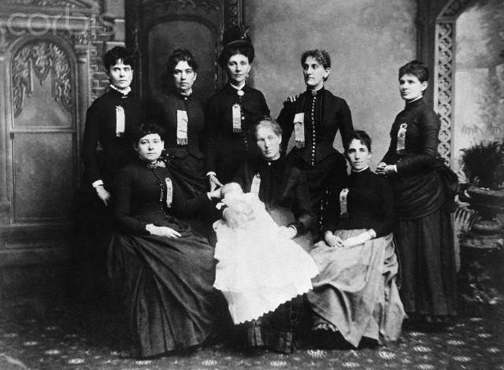
Another important labor group of the time was the Knights of Labor, which was a union that represented workers of all skill levels in a given industry.

Formed in 1869 as a secret society of tailors, the organization was vertically organized, meaning that it included all workers in a given industry. Another distinguishing factor, aside from its acceptance of all skill levels, was its acceptance of both sexes. However, the organization was also staunchly opposed to immigration and supported legislation such as the Chinese Exclusion Act of 1882 and the Contract Labor Law of 1885, both of which attempted to curb immigration to the U.S. The reason for this is that groups representing unskilled laborers typically had limited success in labor disputes because of the rapid immigration rate, which allowed for a constant supply of cheap labor. Therefore, if unskilled groups of laborers went on strike, it was more than likely that they would simply be replaced rather than bargained with. For example, during the Southwest Railroad Strike of 1886 the Knights of Labor were defeated due to the hiring of non-union member workers by corporation head, Jay Gould (Sauter, Stockdale, and McIntyre).

Headed by Terence V. Powderly beginning in 1879, the Knights focused mainly on achieving an eight-hour workday, abolition of child labor, equal pay for equal work, and political reforms. Although the Knights rejected the strike as a negotiating tactic, it was extremely effective for them, and actually led to two major railroad victories for them in the 1880s. However, when the Knights of Labor were connected with a bombing that took place at the Haymarket Square riot of 1886, public opinion turned against them and they quickly lost influence (Foner and Garraty).

In the context of this committee, representatives of this organization will be focusing on protecting the more unskilled workers and lobbying for the above-mentioned policies. Please bear in mind that unskilled workers, at this time, constituted the vast majority of the workforce at the Homestead Steel Mill.

The Molly Maguires

Although many labor unions at this time, such as the ones mentioned above, used moderate tactics in order to pursue their goals, some used more extreme tactics. The Molly Maguires are widely revered as one of the more radical labor groups of the time. In this committee, the Mollies undoubtedly will commit acts of violence and terror in order to weaken corporate interests. Although they will not have a specific presence in this committee, they will be plotting and executing plans behind the scenes.

The Maguires were formed as an Irish secret society in 1845 when the potato famine in Ireland forced many Irish to immigrate to the United States. Once here, many Irish were forced into low-paying mining jobs under extremely dangerous conditions. As a result, some turned to the radical secret society which became known as the “Molly Maguires.” Underlying sectarian tensions were also a cause of their radical nature, as the Mollies were Irish Catholics opposing mostly Protestant mine owners (“The Death of Molly-ism”). At the height of their power, they were responsible for multiple stabbings, acts of arson, beatings, and robberies. However, their radical nature and religious targeting made them extremely unpopular in the media and helped sway public opinion against them and other labor organizations of the time. Although most of their influence ended in 1877 with the hangings of ten of their members, various radical and loyal members remained until the early 1900s. It should be noted that many of their prosecutions were only possible because of testimony provided by the Pinkerton Detective Agency, who had infiltrated the group years earlier (“Molly Maguires in Pennsylvania Cole Region”).
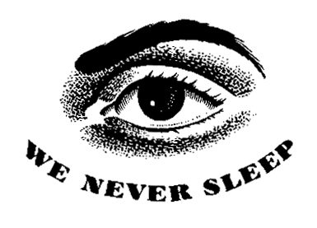
The Pinkerton Detective Agency

One of the most important groups represented in the committee is the Pinkerton Detective Agency. The Pinkerton Detectives were a for-hire militia service that was widely used to break strikes throughout the late 19th and early 20th century.

Formed in 1850 by a Scottish immigrant named Allan Pinkerton, the Agency specialized in tracking down criminals, protecting trade shipments, and eventually breaking strikes. One of the most famous instances that the agency is known for is the pursuit and capture of the infamous Butch Cassidy and the Wild Bunch. The Agency was also used several times by Carnegie and Frick to protect strikebreakers.

This group is especially important in the committee, as they will be responsible for implementing any actions requested by the Carnegie Steel side that cannot be executed by local authorities.

Current Situation

The date of the committee will be February 1, 1892, during the initial stages of the AAISTW and Homestead Steel Mill contract negotiations. At this point in the dispute, the situation has not developed into a full strike and could remain that way granted the negotiations are resolved quickly and advantageously for both parties. For the purpose of committee, all the afore-mentioned groups will sitting in on the contract renewal negotiations. Each group should be lobbying for its own interests and trying to figure out whether a strike can be avoided or is necessary to further its cause. If the negotiations are more favorable to the AAISTW, it could give the other labor unions more leverage to negotiate. At the same time, though, if the negotiations are more favorable to the Homestead Steel Mill then the consequences could be that the Mill gains even more power and refuses to negotiate with the other labor groups.

Frick and Carnegie claim that the AAISTW workers hold too much power over the production at the steel mill and want to take steps to limit this power by cutting wages, issuing individual contracts, and lengthening the work day. With the introduction of a new wage scale in January that cut the AAISTW workers’ wages by roughly 18%, it is evident that another conflict is approaching (Brecher). As such, the unions have been preparing for a strike and are ready to take that action should they decide that is the best way to go.

Labor Side

For all delegates representing the labor side, you must consider the demands and needs of the workers you are representing while taking into account the leverage that you have. Many of the workers going on strike are doing so because the wages they earn are not sufficient to support their families. Furthermore, the hours they are working make simply going to work dangerous because of the exhaustion that they face. Unfortunately, at this point, the workers have very limited power. The difference in demands between labor groups also helps to weaken the workers’ case. While some groups are focusing on very basic and universal issues, such as the afore-mentioned “bread and butter” requests, others are concentrating on more wide-scale reforms that at this point may be unattainable, such as the wide-scale political reforms that the Knights of Labor are lobbying for. The main focus of those representing the labor side should be to improve the conditions that workers face. In order to do this, it is vital that you keep public opinion on your side. In doing so, it is important to distinguish yourselves from radical labor movements, which threaten your public image. The Molly Maguries will be threatening the goals you are trying to see accomplished by their acts of terror. You have no control over what they do; however, you do have control over how you use the media and distance yourselves from them.

The Homestead Steel Mill Side

Delegates representing the Homestead Steel Mill side of the dispute should focus on maximizing profits for the company. Strikebreakers are inefficient and bad for your public image; however, in some cases they may be considered necessary. Unfortunately, replacing skilled workers is not an easy task and you may be forced to concede on a few points in order to get them back to work. While you do have an advantage because of the constant influx of cheap, immigrant labor, the longer this dispute drags on, the more money it could cost the company. Overall, resolving the dispute should be your main priority. In order to do this, you must keep public opinion on your side and continue to portray labor as the enemy.

Questions to Consider

- What are your individual priorities outside of your block positions?
- How are you going to respond if the laborers decide to go on strike?
- Is going on strike the most effective way to resolve this crisis?
- If not, how else can it be resolved?
- What are the points that you are willing to concede to in the negotiation?
- What are the points that you are not willing to concede?
- At what point should the government intervene, and on which side's behalf should they intervene?
- What is a reasonable workday?
- What are reasonable working conditions?
- What are reasonable wages?
- What tactics will you employ if there is a strike? i.e. strikebreakers or violent protests?
- How can you keep public opinion on your side?
- How can you use the media to your advantage?
- What are the ramifications if the labor dispute is not resolved?
- How much power does your organization actually have?
- What can you do to increase your leverage in the debate?

Position Papers

For position papers, we would like you to focus on your individual positions and motives. What does your “character” want for himself beyond just the side you are on? Additionally, we encourage you to think about your own “individual powers” and what you can do on your own to help resolve the dispute. Each person in the crisis has certain domains or areas that he is in charge of, and we encourage you to exploit these throughout the committee. However, we also encourage you to be creative and collaborative in your solutions.

Individual Positions:

Refer to these for more information on each character as well as insight into what position to take and advocate for during the span of the council. Note: not all characters noted below have been assigned in the council at the time this guide was released.

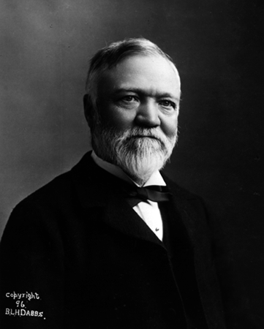
Andrew Carnegie

Andrew Carnegie was born in Dunfermline, Scotland, in 1835. He immigrated to the United States in 1848 with his family who was very poor. Carnegie was a born businessman and this became clear as he started to invest in railroads and other transportation sectors. With the wealth he acquired from his investments and bond sales, he built his very own steel company known to all as the Carnegie Steel Company. Along with being quite the businessman, Carnegie was also an engineer famous for the development of efficient steel production through using what is knows as the “Bessemer process.” His steel company soon grew to be one of the largest in the world and, in an effort to remove rivals, Carnegie bought the Homestead Steel works in 1883. Although he bought the mill, Henry Frick was in charge of its operations since Carnegie placed Frick as manager of all his company operations in 1881.
Carnegie, in the public eye, was in favor of labor unions and even published an article known as “The Gospel of Wealth” in 1889, which noted that the wealthy should distribute their wealth to the less fortunate masses. Even though he supported the notion of philanthropy, he did not wish for unions to interfere with profits and therefore listened closely to Frick’s radical ideas of getting rid of all union workers and making the plant non-union compliant.
Carnegie had full executive power over all proceedings regarding the steel works, including Frick to an extent, yet looking back to the labor strike he allowed in 1887 and their agreement in 1889, it is unclear as to whether or not he would be that lenient with the labor unions again.

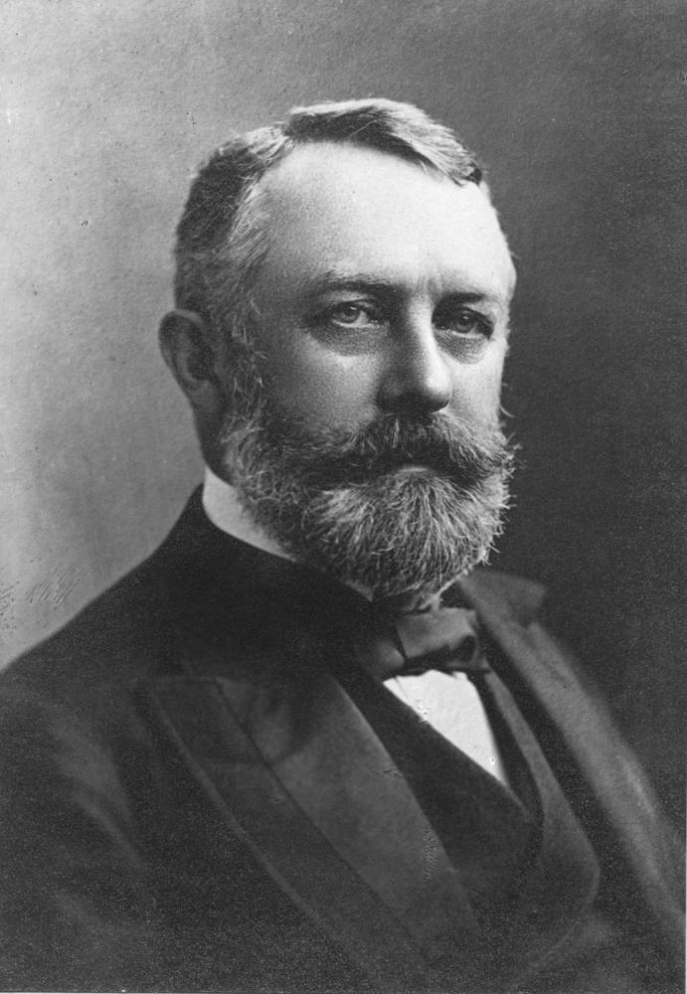
Henry Clay Frick

Henry Clay Frick was born in Pennsylvania in December of 1849. He was the grandson of Abraham Overholt, who was a wealthy owner of a whiskey distillery. Frick attended Otterbein College for a year but did not graduate and, by the time he turned 21, he had joined his two cousins in a business venture to turn coal into coke (substance used for producing steel) by using beehive ovens. This led to the establishment of the Frick Coke Company, known as H.C. Frick and Company after he bought out his business partners. Through this company he employed well over one thousand workers and was responsible for 80% of all coal output in PA. Frick met Carnegie in 1881 while he was on his honeymoon in New York City. They established a business partnership between their two companies. Frick was placed in charge of Carnegie’s company operations, and through business they developed a friendly relationship. Frick was not a supporter of unions, unlike Carnegie who was sympathetic with them, so in 1887 when Frick organized a coalition of coke companies to resist the laborers on strike, Carnegie was able to force him to settle with the workers, because of his considerable stake in Frick's company. Frick was a clear opponent of labor unions and wishes to get rid of them as fast as possible by any means as he believed their demands caused industries to operate at inefficient levels. So far the only thing standing in his way was Carnegie. Frick had full executive powers over Homestead operations, requiring Carnegie’s ‘“OK’” for very few things such as major operational changes or actions that would degrade the company’s public face.

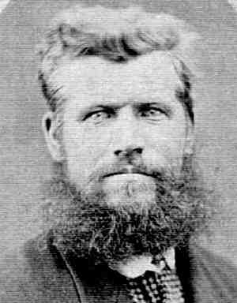
Robert Pinkerton

Robert Pinkerton was born in Chicago, Illinois, in the 1850s, son to Allan Pinkerton. His father had moved to the United States in the early 1840s to the Chicago area. His father was appointed the first detective of Chicago in 1849, whilst Allan's brother, also named Robert, decided to go his own path and created “Pinkerton&Co.” a railroad detective agency, which was derived from a railroad contracting company. The business grew exponentially as Robert (Sr.) used his contacts in the railroad industry to secure contracts with major corporations such as Wells Fargo. These contracts were to provide guards on stagecoaches as the crossed the country. Allan and Robert Sr. joined forces and changed the company name to the Pinkerton National Detective Agency. From this point forward the company provided services ranging from general detective services to private military contractors and the capture of counterfeiters and train robbers.
Their organization gained its fame after uncovering an assassination plot against Abraham Lincoln and, in turn, was put in charge of creating a secret service for the president to provide protection and spy on Confederate forces. After his fathers death on the 1st of July 1884, Robert (Jr.) took full control of the company along with his brother William and, as a result, had full directive powers over the operations of the Pinkerton Detective Agency. The Agency suffered a loss in reputation after failing to catch the James-Younger Gang in the early 1870s and wished to regain its reputation through successful contracts in the future. It is for these reasons that Robert wished to ensure that subsequent contracts would be completed without failure, using whatever resources or force necessary.

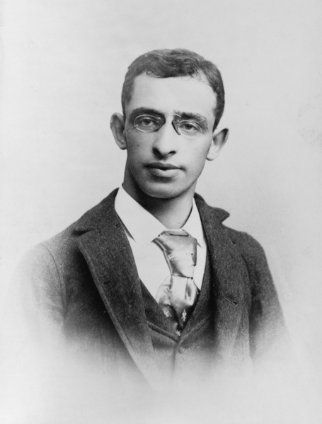
Alexander Berkman

Alexander Berkman was born in the Russian Empire in November of 1870. He immigrated to the United States in 1888 and lived in New York City, where he became involved in the American anarchy movement. He joined the Jewish anarchist group in the US known as the Pioneers of Liberty in 1886. The Pioneers of Liberty organization took part in labor strikes in the garment industry and helped establish some of the first Jewish Labor Unions in the city throughout the 1880s. Over the years, he became more involved in anarchist organizations, and aligned himself mostly with an anarchist group called the Autonomists. The Autonomists emphasized individual freedom and opposed the establishment of anarchist organizations that wanted dominance by a single individual/leader. He worked for autonomist publications such as ‘“Der Anarchist’” and ‘“Die Autonomie,” which promoted peaceful advocacy, although this did not affect his personal beliefs. Berkman believed that the best tool for inspiring or pressuring revolutionary change to occur is through violent action. Up to this point in history, Berkman had not found an opportunity to use violent action in order to create a public uproar. He wished to do so in order to bring to attention the poor condition of industrial workers into the scope of the media, especially as campaigning for the 1892 presidential campaign was ongoing. He believed that once violent action was taken against business leaders who suppressed their workers, the working class would unite and revolt against their employers and the capitalistic system under which they operated. It can be assumed that Berkman would be very interested in the potential for a Homestead Strike, as it would be a perfect opportunity for him to finally act out in order to promote anarchism.

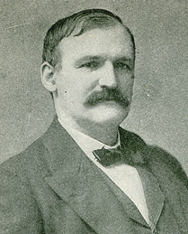
Gov. Robert E. Pattison

Robert Emory Pattison was born the 8th of December 1850 in the state of Maryland. He practiced law and was elected Controller of Philadelphia in 1880. In 1882, at the tender age of 32, he became a Democratic candidate for governor and won, leading him to be Governor of Pennsylvania for the span of 1883-1887. Due to the constitution at the time, he was not able to run for a consecutive term and had to wait four years before running for office and becoming the Governor again, from 1891 -1895. Pattison knew of the tension that had been building up between union workers and Frick at the Homestead Steel Works, but he had been waiting it out and hoping for peaceful negotiations to occur before the agreement established between the two in 1889 expired on June 30th 1892. Pattison knew from the strike of 1889 that the union was able to rally the townspeople to its cause, which could ultimately turn violent.
Pattison wished to maintain order in his state and did not wish to allow any public mayhem to occur. He possessed full directive powers of a state governor, yet the most significant power in regard to a strike situation was that he was able to send out the state militia. This was only to be done in dire situations and Pattison would most likely let the situation play out to a point where local police enforcement became powerless before authorizing the state militia to intervene.

William Weihe

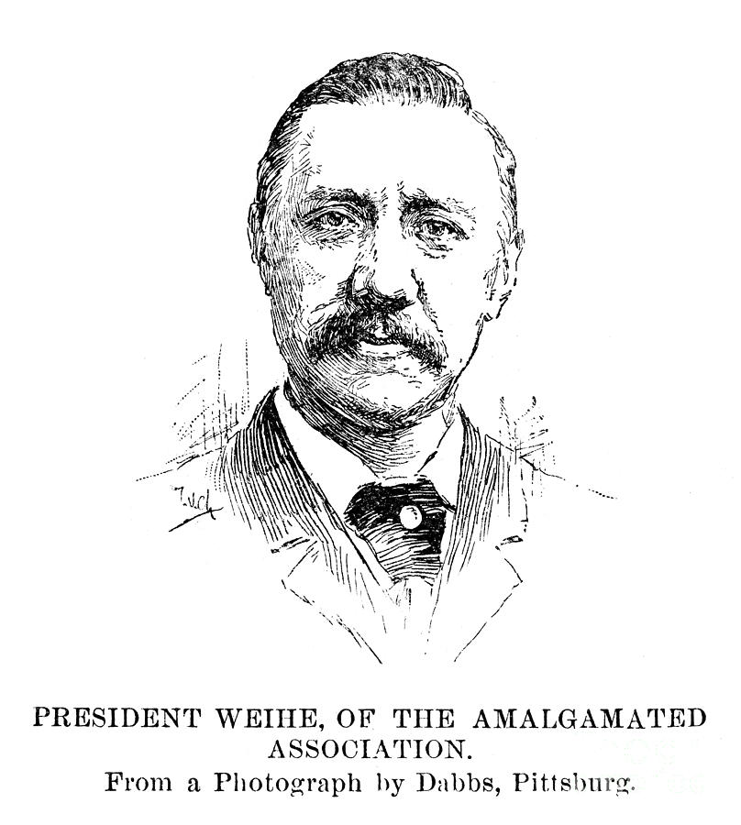
William Weihe, presumably born in the homestead at an unknown date, was the ongoing international president of the Amalgamated Association of Iron and Steel Workers. As the leader of the AA, he had his fair share of dealings with both Frick and Carnegie over the past decade through the union victory of an earlier 1882 homestead strike in which he was able to prevent the Homestead Steel Works management from forcing workers to sign non-union contracts. Along with this there was the 1889 strike through which the union succeeded in creating a contractual agreement with Carnegie in order to secure work-rules and set working conditions for workers. Since the agreement of 1889, the AA saw its membership double as well as a large increase in its treasury funds.
Weihe represents all of the union members and henceforth the representation he gives of the union to the managers and owners of the steel plant is essential to union success. Union members are already fed up with Homestead management and will not react well to any compromises taken in terms of work-rules and wages in the new agreement that is to be made before June 30th, the expiration of the 1889 agreement. Weihe has directive power over all actions taken by the AA, yet he cannot command union members to do anything, merely recommend certain actions. Negotiations between the AA and company leaders have already begun. It is in the AA’s best interest to ensure no negative compromising occurs in the negotiations and that a new agreement is brought forward peacefully.

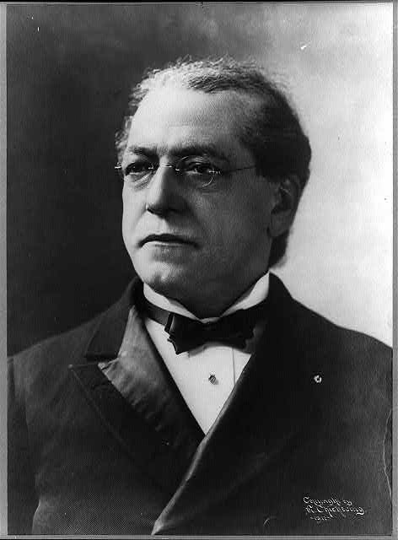
Samuel Gompers

Samuel Gompers was born in January, 1850, in London, England. Gompers was born into a Jewish family so poor that after his 10th birthday he was sent to work at a cigar factory as an apprentice. His family immigrated the United States in 1863 and moved to New York City. During his free time as a teenager, he formed a debate club with his friends and through this process he mastered public speaking as well as parliamentary procedure. Through his club and working at David Hirsch & Company (cigar makers), he learned about the International Workingmen’s Association, an organization with the goal of uniting socialist, communist and anarchist groups that was based on the working class and supported trade unions. Gompers was elected as president of the Cigar-makers International Union in 1875 and founded the Federation of Organized Trader and Labor Unions in 1881 that was reorganized into the American Federation of Labor in 1885. As the president of the AFL, Gompers is able to influence the opinions of AA members, as he is a role model for most middle-class workers, as well as give advice to AA leaders in terms of what to do in the negotiation process. Gompers does have limited directive powers in order to reign in the AFL to support the AA, yet it is very unlikely that Gompers would like to intervene physically in the strike or instate a boycott of Carnegie products.

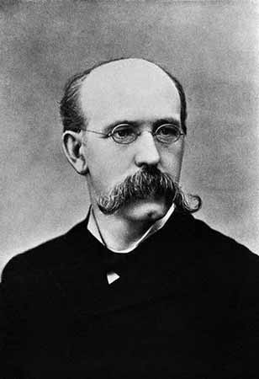
Terence V. Powderly

Terence V Powderly was born in Pennsylvania in January, 1849. He became a lawyer and was elected as the 5th Mayor of Scranton in 1878. Powderly also served as US Commissioner General of Immigration for many years, although he was best known for his position as the head of the Knights of Labor. The Knights of Labor was the largest US labor organization in the 1800s next to the American Federation of Labor and its ultimate goal was to organize all industry workers into a large united union that fought and advocated for workers’ rights as well as economic and social reform. Powderly joined the organization in 1876 and was elected as President, or ‘“Grand Master Workman,”’ as it was known in 1879.
The Knights of Labor were very active throughout the late 1800s, yet the public image and membership rate of the organization plummeted after they were associated with the Haymarket Riot of 1886, in which a demonstrator at a peaceful strike threw a stick of dynamite at police which caused a bloody battle to ensue.
Powderly has full directive power over the Knights of Labor and sees the tensions building up at Homestead as a possibility to help rebuild the name of his organization. He could do so through helping the AA with their negotiations and possible strikes yet would ensure all actions to be non-violent in order to help remove the radical association the party has gained.

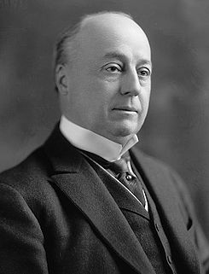
Philander Knox (Not assigned)

Philander Chase Knox was born in Pennsylvania on May 6, 1853. His family was wealthy, and he was able to attend private primary and secondary schools after which he attended Mount Union College, earning a BA in 1872. Next he attended law school at West Virginia University, from which he graduated in 1875. After getting his law degree, he served as the Assistant United States District Attorney for Pennsylvania before opening a law firm practice known as Knox and Reed.
Knox became the Carnegie corporation attorney in the mid 1880s and it is his job to ensure that neither Carnegie nor Frick lose the tens of lawsuits annually placed on them by labor unions and workers alike. He is known as one of the most powerful corporate lawyers in the nation and it is unheard of to win a case against him. As the lawyer of the Carnegie Corporation, it is Knox’s job to ensure that neither Carnegie nor Frick commit any deeds for which they can be put on trial. This means that he ensures the actions taken by them are within the law or within reasonable terms for him to be able to acquit charges pressed against them. It is in his and his clients' interests to ensure that all actions taken during and after negotiations with the AA goes smoothly.

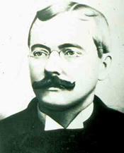
John McLuckie

John McLuckie was a steelworker, union member and is burgess (equivalency to mayor) of Homestead. He is in charge of the welfare of the citizens of the town, who nearly all work at the Steel Factory.
McLuckie has directive powers as mayor of the town. He is able to mobilize and order local law enforcement to do tasks and has lawful authority over the citizens of Homestead. As Mayor, McLuckie is very nervous about to ongoing building of tensions between the union and the organization and hopes that the negotiations turn out well. He seems to make it clear to the townspeople that defending the peace is of utmost importance yet peace in his mind does not necessarily mean a state without violence and conflict. McLuckie was a steelworker and avid union member so his interpretation of preserving the peace might lean more to the side of ensuring a union victory in terms of negotiations and any events that could follow.

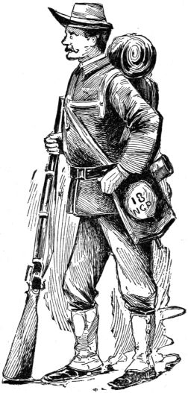
Sheriff William H. McCleary

William McCleary is the sheriff of Allegheny County, Pennsylvania. He has full legal jurisdiction in his county and has a large number of deputies at his disposal which will be crucial in order to control the people and establish peace if the negotiations between the AA union members and the Carnegie Corporation do not end well. One thing to remember is that if any action is to be taken against the Homestead steel plant, which is the property of Carnegie and Frick, it would be seen as an assault on private land and the Sheriff would have to stop whatever is happening as well as subject all partakers to due process of the law.

Deputy Joseph H. Gray (not assigned)

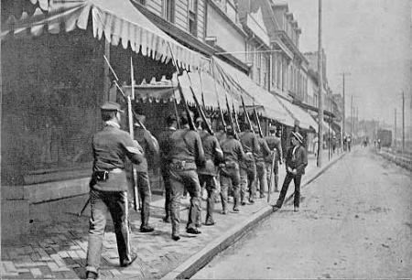
Joseph Gray is the chief deputy to Allegheny County Sheriff William McCleary. As chief deputy, Gray has directive powers over deputies under his control as well as civilians in his county. He is McCleary’s right hand man and he is always placed in charged of operations McCleary himself does not lead. Gray has felt the tensions of workers in the Homestead Steel Works plant rise over the course of the preceding months as he and John Alfred Potter, the superintendent of the Homestead plant, had been negotiating with them since early in the month of January. Gray has more insight into the workings of the plant as well as the true intentions of the plant management as he works alongside them, so the information he provides to McCleary is of essential importance, as it can help shape the actions the Sheriff initiates.

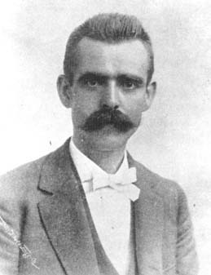
Hugh O'Donnell (not assigned)

Hugh O’Donnell is a worker at the Homestead Steel Works plant. He works as a heater in the facility, a job that subjects him to extreme conditions every day and has helped to shape his opinions about labor laws over the course of his career. O’Donnell is known by his peers to have a very reasonable outlook on life, making conservative decisions and not jumping to harsh conclusions. He has a very thick and fetching mustache, which makes him appear very wise, and it is this combined with his handsomely deep voice that causes people to instinctually listen to him and regard what he says with seriousness. It is for this reason that he has been considering to join the union panel in the negotiations against the corporation. He believes the atmosphere he creates will greatly help the union, and if the union is to fail at negotiating, he will be a very fit candidate to lead the Homestead workers in a strike.
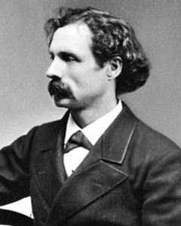

Whitelaw Reid

Whitelaw Reid was born in the town of Cedarville, Ohio, on the 27th of October, 1837. He attended Miami University from which he graduated with honors. His early career consisted of him working as an editor for the New York Tribune before he became a leader of the Liberal Republican Movement in 1872. As an avid Republican, he continued his work in the political field by service as ambassador to France for the US before becoming the Republican vice presidential nominee for President Benjamin Harrison in 1892. As the nominee for Vice-President on the Republican ticket, it can be assumed that Reid would be interested in maintaining peace in a tariff-based industry such as the Carnegie Steel Company (Homestead Steel Mill). Reid is very interested in the ongoing rise in tension between the union and the company in Homestead, as it would be best for his image to ensure the company does not cease to operate and that negotiations with the union run smoothly.

Works Cited (Historical Background Guide)

"American Federation of Labor." U.S. History. Independence Hall Association,
n.d. Web. 19 Nov. 2013. <http://www.ushistory.org/us/37d.asp>.

Brecher, Jermey. "The Homestead Strike, 1892- Jeremy Brecher." Libcom.org. N.p.,
n.d. Web. 19 Nov. 2013. <http://libcom.org/history/
homestead-strike-1892-jeremy-brecher>.

"The death of Molly-ism." History.com. N.p., n.d. Web. 19 Nov. 2013.
<http://www.history.com/this-day-in-history/the-death-of-molly-ism>.

Edwards, Rebecca. "The Populist Party." Vassar.edu. Vassar College, 2000. Web.
15 Dec. 2013. <http://projects.vassar.edu/1896/populists.html>.

Foner, Eric, and John A. Garraty, eds. "Homestead Strike." History.com. Houghton
Mifflin Harcourt Publishing Company, n.d. Web. 19 Nov. 2013.
<http://www.history.com/topics/homestead-strike>.

Foner, Eric, and John A. Garraty, eds. "Knights of Labor." History.com. Houghton Mifflin Harcourt Publishing Company, n.d. Web. 19 Nov. 2013. <http://www.history.com/ topics/knights-of-labor>.

Hindle, Tim. "Vertical Integration." The Economist. The Economist Newspaper
Limited, 30 Mar. 2009. Web. 15 Dec. 2013. <http://www.economist.com/node/
13396061>.

"Jackson Sends Troops to Put Down Labor Riot." History.com. N.p., n.d. Web. 22
Nov. 2013. <http://www.history.com/this-day-in-history/
jackson-sends-troops-to-put-down-labor-riot>.

"Molly MacGuires in Pennsylvania Cole Region." American History 12 June 2006: n.
pag. Web. 19 Nov. 2013. <http://www.historynet.com/
molly-macguires-in-pennsylvania-coal-regions.htm>.

"The New Tycoons: Andrew Carnegie." U.S. History. Independence Hall Association,
n.d. Web. 19 Nov. 2013. <http://www.ushistory.org/us/36c.asp>.

The National Amalgamated Association of Iron, Steel, and Tin Workers, 1892-1901
Carroll D. Wright The Quarterly Journal of Economics , Vol. 16, No. 1 (Nov., 1901), pp. 37-68 Published by: Oxford University Press, http://www.jstor.org/stable/1882902.

Sauter, Michael B., Charles B. Stockdale, and Douglas A. McIntyre. "The 10
Biggest Strikes in American History." Fox Business. Fox News Network, LLC,
9 Aug. 2011. Web. 15 Dec. 2013. <ttp://www.foxbusiness.com/markets/2011/
08/09/10-biggest-strikes-in-american-history/>.

Works Cited (Individual Positions)

"1892 Homestead Strike." AFL-CIO. N.p., n.d. Web. 10 Dec. 2013. <http://www.aflcio.org/About/Our-History/Key-Events-in-Labor-History/1892- Homestead-Strike>.

"1892: The Homestead strike." libcom.org. N.p., n.d. Web. 10 Dec. 2013. <http://libcom.org/history/1892-the-homestead-strike>.

"Andrew Carnegie." History.com. A&E Television Networks, n.d. Web. 11 Dec. 2013. <http://www.history.com/topics/andrew-carnegie>.

"Battle of Homestead Foundation." Battle of Homestead Foundation. N.p., n.d. Web. 12 Dec. 2013. <http://www.battleofhomesteadfoundation.org/battle.php>.

"Berkman Biography." Berkman Biography. N.p., n.d. Web. 13 Dec. 2013. <http://dwardmac.pitzer.edu/anarchist_archives/bright/berkman/bio.html>.
Burgoyne, Arthur Gordon. The Homestead strike of 1892. Pittsburgh: University of Pittsburgh Press, 1979. Print.

"Detective Allan Pinkerton Was Born in Glasgow, Scotland." Detective Allan Pinkerton Was Born in Glasgow, Scotland. N.p., n.d. Web. 10 Dec. 2013. <http://www.americaslibrary.gov/jb/nation/jb_nation_pinkerto_4.html>.

"Full text of "The Homestead Strike"." Full text of "The Homestead Strike". N.p., n.d. Web. 11 Dec. 2013. <http://archive.org/stream/jstor-1819234/1819234_djvu.txt>.
Geringer, Joseph . "Other Horizons." Allan Pinkerton & His Detective Agency: "We Never Sleep" Crime Library on truTV.com. N.p., n.d. Web. 22 Dec. 2013. <http://www.trutv.com/library/crime/gangsters_outlaws/cops others/pinkerton/6.html>.
"History of the International Workingmen's Association." History of the International Workingmen's Association. N.p., n.d. Web. 13 Dec. 2013. <http://www.marxists.org/history/international/iwma/index.htm>.

"Homestead Steel Strike of 1892 Shocked America." 19th Century History. N.p., n.d. Web. 10 Dec. 2013. <http://history1800s.about.com/od/organizedlabor/a/Homestead-Strike- 1892.htm>.

"Homestead Steel Works." Homestead Steel Works. N.p., n.d. Web. 12 Dec. 2013. <http://www.riversofsteel.com/routestoroots/3RsWindows/homestead_works.htm l>.

"Homestead Strike." History.com. A&E Television Networks, n.d. Web. 12 Dec. 2013. <http://www.history.com/topics/homestead-strike>.

"Homestead Strike." Homestead Strike. N.p., n.d. Web. 12 Dec. 2013. <http://www.u-s- history.com/pages/h769.html>.

New York Times. "That Tin Plate Game." New York Times [New York City ] 18 June 1891: -. Print.

"Philander Chase Knox - People - Department History - Office of the Historian." Philander Chase Knox - People - Department History - Office of the Historian. N.p., n.d. Web. 11 Dec. 2013. <http://history.state.gov/departmenthistory/people/knox-philander-chase>.

"Philander Knox Historical Marker." Explore PA History. N.p., n.d. Web. 13 Dec. 2013. <http://explorepahistory.com/hmarker.php?markerId=1-A-3C3>.

"Pinkerton National Detective Agency." Library of Congress. N.p., n.d. Web. 10 Dec. 2013. <http://lcweb2.loc.gov/service/mss/eadxmlmss/eadpdfmss/2003/ms003007.pdf>.

"Pinkerton Resource Page." Pinkerton Resource Page. N.p., n.d. Web. 11 Dec. 2013. <http://freepages.genealogy.rootsweb.ancestry.com/~pinkerton/the_pinkertons_in _bruce.htm>.

"Strike at Homestead Mill." PBS. PBS, n.d. Web. 17 Dec. 2013. <http://www.pbs.org/wgbh/amex/carnegie/sfeature/mh_horror.html>.

"The Bloody Homestead Strike of 1892 (Labor) by Dick Meister." The Bloody Homestead Strike of 1892 (Labor) by Dick Meister. N.p., n.d. Web. 11 Dec. 2013. <http://www.dickmeister.com/id86.html>.

"The Homestead Strike of 1892 (University)." The History Project at UC Davis. N.p., n.d. Web. 12 Dec. 2013. <http://historyproject.ucdavis.edu/lessons/view_lesson.php?id=17>.

"The Pinkerton Detective Agency - Operating for 150 Years - Page 2." The Pinkerton Detective Agency - Operating for 150 Years - Page 2. N.p., n.d. Web. 10 Dec. 2013. <http://www.legendsofamerica.com/we-pinkertons2.html>.

