UNA-USA Colorado
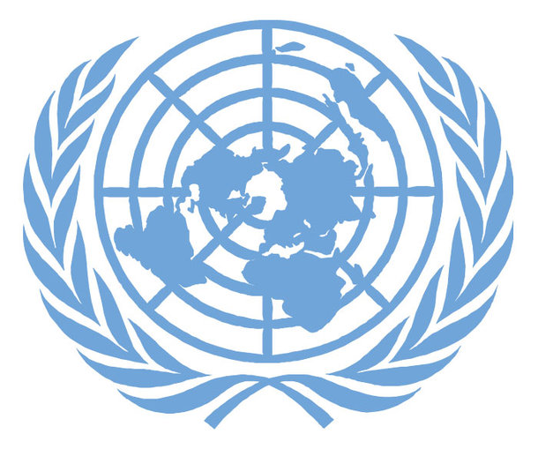

Boko Haram Terrorism and Brutality Towards Women:
Combatting Sexual Violence in Relation to Extremism

Boulder-Fairview H.S. Model United Nations Conference
Beginner’s Security Council
October 10th, 2015

A Background Guide written by
James P. Donahue, Fairview High School
James A. Snow, Fairview High School

Introduction
Hello! Our names are James Donahue and James Snow, and we are this background document's authors and will be the presiding officers in one of the nine, beginner level Security Council at the Boulder-Fairview H.S. Model United Nations Conference. We are quite happy that you will be attending the conference and that you have taken the time to educate yourself on the issues at hand by reading this Security Council background guide. We both are attending Fairview High School in south Boulder, and are truly looking forward to presiding over one of the Security Councils.
The issue at hand is arguably one of the most pressing matters that the United Nations has addressed in the past year: terrorism that includes violence and brutality towards women, particular in association with the terrorist organization that was once called Boko Haram, or what is now known as Islamic State's West Africa Province (ISWAP). We will be using the terms ‘Boko Haram,’ ‘BH,’ and ‘ISWAP,’ throughout the background guide: for clarifying purpose, these names are all associated with the same group.
Faculty Sponsor Note: This Beginner Security Council is focused ONLY on how to stop Boko Haram terrorism and its brutality towards women, and NOT whether sexual violence towards women in warfare is ever, or has historically been justified.

A History of The Issue
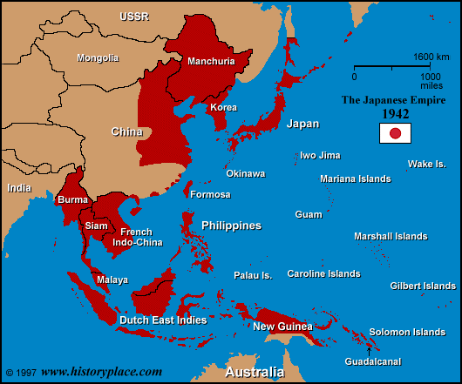
Brutal treatment of women unfortunately has been both a consequence of warfare and a military tactic of terrorism and domination over time. War based violence towards women by extremist groups is one of the many crimes that continue to plague regions of the world today. Brutal and cruel treatment of women in warfare has been both a symbol of a more powerful military force's victory over a defeated and subjected group of people and a strategy to terrorize weaker peoples. It is essentially a bio-political strategy using (or more accurately, abusing) the distinction between the self and the body.
One of the most accurately documented cases of widespread, war related violence towards women occurred during the Second World War. Japanese war crimes against Chinese women in Nanjing were quite possibly some of the most gruesome events to occur during WWII, where thousands of women, young and old, were arbitrarily selected for kidnappings and were then later sexually assaulted by Japanese soldiers during late 1937 and early 1938. The estimated death toll of Chinese women during this time ranges from 40,000 to 300,000.
Soviet sexual assaults against German civilian women during the occupation of Nazi Germany were widespread, extensive, and brutal - reflecting USSR military policy. Soviet propaganda proclaimed that the Red Army had ‘entered Germany to punish all Germans.’ This occupation led to the violent assaults of up to two million German women.
Documented accounts of American soldiers’ sexual violence towards Japanese women during and after the Battle of Okinawa is additional evidence of soldiers’ abusive behavior against female civilians.
Half a century later, reporters, journalists, non-governmental organizations, and human rights organizations have documented many cases of large scale, war related, sexual violence against women during the conflicts in Liberia, Sierra Leone, the Balkans, Rwanda, Uganda, the Democratic Republic of the Congo, and Sudan.
One of the most extensive cases of widespread brutality towards women during recent wars took place during the Bosnian War in the southeast European, Balkan region, and during the Rwandan genocide (effort by a central state government to eliminate an ethnic minority by various means).
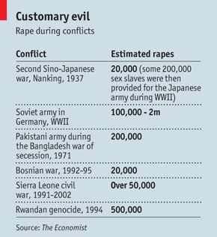
During the 1992-1995 Bosnian War, between 12,000 to 50,000 women were raped. These widespread, violent assaults were carried out by the Bosnian Serb Army (Army of Republika Srpska), against a large population of Bosniak (Bosnian Muslim) women as a part of the Army’s proclaimed “ethnic cleansing program.” The Bosnian-Serb Army also committed other large-scale assaults on 20,000 women in Albania, from 1998 to 1999.
|The International War Crimes Tribunal in The Hague was particularly ineffective in dealing with rape in Kosovo [a small, majority Muslim nation that declared itself a sovereign/independent state in 1992]. Kosovar women who had been raped by Serbian forces and who had been convinced to testify as anonymous witnesses found that while their identities were protected while at the Tribunal in the Hague, they were revealed back in Kosovo by Milošević’ [president of Serbia from 1989-1997] team. They felt betrayed by the Tribunal, and some reportedly threatened to commit suicide rather than return to Kosovo.|

The Rwandan genocide was a similar case of large-scale, violent assaults on women in the early 1990's. Close to 500,000 women were raped over a period of just one hundred days. This mass sexual violence was carried out by the Interahamwe militia (Hutu military with the backing of the government at the time), members of the civilian population, the Rwandan military, and the Rwandan Presidential Guard. This brutality was directed at the national and local levels by political and military leaders in the furtherance of their goal, the elimination of the Tutsi ethnic group.
|As a corollary to this, though less overtly stated, extremists aimed at reclaiming the lost ground of patriarchy (male dominance) and re-asserting a male dominance that had probably
never existed in Rwanda's actual history. Tutsi women were pivotal enemies in the extremists'
struggle to reclaim both patriarchy and the Hutu Revolution, because in many respects they
were socially positioned at the permeable boundary between the two ethnic groups. It was
much more common in pre-genocide Rwanda, for example, to find Tutsi women married to
Hutu men than to find Hutu women married to Tutsi men.|

Boko Haram Background Information
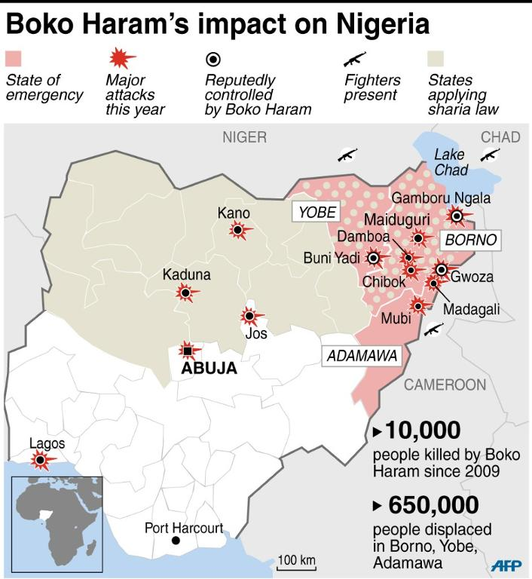
With the rise of new extremist groups such as the Islamic State (ISIS), Boko Haram, and the Lord’s Resistance Army (LRA), sexual assaults on women during a time of war and unrest has unfortunately increased. Boko Haram, an Islamist militant group, has attacked Nigeria's police and army, politicians, schools, religious buildings, public institutions, and civilians with increasing regularity since 2009. More than ten thousand people have been killed in Boko Haram-related violence, and 2.3 million have been displaced. B-H has committed terrible atrocities including the 2014 kidnapping of 276 schoolgirls in Chibok, Nigeria. Boko Haram soldiers or members have raped over 12,000 Nigerian women in the last few months alone. The proclaimed goal of the Boko Haram sexual attacks is forcing local women into pregnancy.
Hundreds of women and girls captured by Boko Haram have been raped, many repeatedly, in what officials and relief workers describe as a deliberate strategy
to dominate rural residents and possibly even create a new generation of Islamist militants in Nigeria. In interviews, all of the women described being locked in houses by the dozen, at the beck and call of fighters who forced them to have sex, sometimes with the specific goal of impregnating them.| Boko Haram is translated as "Western education is sin," for the group's rejection of Western concepts, such as evolution. This terrorist organization aims to establish a fully Islamic state in Nigeria, including the implementation of harsh, fundamentalist, Sharia criminal courts across the country.
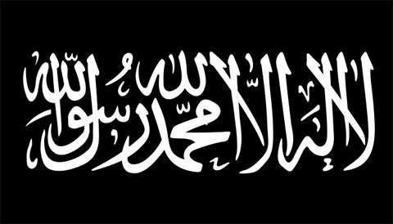
Boko Haram's brutal campaign includes a suicide attack on a United Nations building in Nigeria's capital city Abuja in 2011, repeated attacks that have killed dozens of students, the burning of villages, and ties to regional terror groups. The Nigerian government has not been able to stop the insurgency, and violence has spread to neighboring states Cameroon, Chad, and Niger. Terrorist acts against civilians, like the murder of 65 students while they slept at the agricultural college in Yobe, Nigeria in September 2013, chainsaw beheadings of truck drivers, and the killing of hundreds on the roads of northern Nigeria raised doubts about the central government's ability to control territory and increased fears of protracted violence in the country. Nigeria is Africa's largest economy and most populous country, with more than 174 million people and nearly 350 ethnic groups speaking 250 languages. The country is split between a Christian majority in the South and a Muslims majority in the North, with 10 percent of the people belonging to indigenous sects. Despite a per capita income of more than $2,700 and vast wealth in natural resources, Nigeria has one of the world's poorest populations. An estimated 61 percent of the population lives on less than $1 a day. Economic differences between the North and the rest of the country are dramatic. In the North, 72 percent of people live in poverty, compared to 27 percent in the South. Sectarian (religious groups/sects) violence, especially in the central region of the country, where religious groups as well as farmers and herders collide, increased the death toll. More than 34,000 people have been killed in Nigeria since 2011, factoring in Boko Haram-related violence. Human Rights Watch stated in a 2011 report that "corruption is so pervasive in Nigeria it has turned public service for many into a kind of criminal enterprise." Police brutality and impunity added to the tensions. A 2009 Amnesty International report stated that Nigerian police were responsible for hundreds of unjustified, illegal killings and disappearances each year that largely "go uninvestigated and unpunished." The group said in a later report that nearly one thousand people, mostly Islamist militants, died in military custody in the first half of 2013. Some experts view Boko Haram as an armed revolt against government corruption, abusive security forces, and widening regional economic differences. They argue that the Nigerian government should do more to address strife between the disaffected Muslim North and the Christian South. The U.S. Department of State designated Boko Haram a foreign terrorist organization in 2013. In May, 2014, the United States deployed a small group of military advisers to help find the 276 kidnapped, Chibok girls, and France sent soldiers to Niger to help coordinate military action in February, 2015. In March, 2015, Boko Haram pledged to support and be loyal allies with ISIS. In May, 2015 the U.S. announced $6.8 million in funding for regional aid efforts to help over 2 million refugees fleeing the Boko Haram violence and attacks around the Lake Chad Basin, that includes northeast Nigeria. U.N. diplomats warned that the aid emergency in Lake Chad Basin risked being forgotten amid other humanitarian crises in Syria, Yemen and South Sudan.
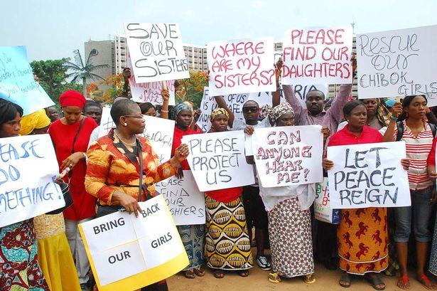
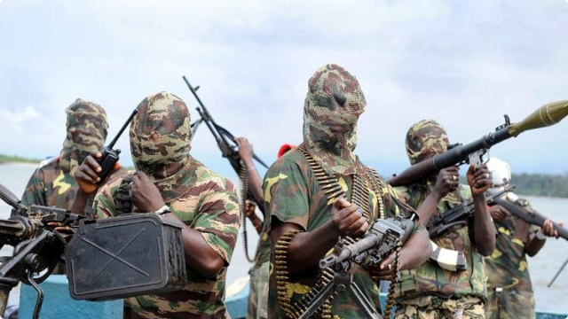
Current Situation The African Union now has a United Nations authorized, Multinational Joint Task Force (MJTF) of 10,000 soldiers from Nigeria, Benin, Cameroon, Niger, and led by Chad to fight Boko Haram. Chad has a hardened and well-renowned desert-fighting force that has developed a reputation for success. Large proportions of Chadian troops belong to the Kanuri and Shuwa-Arabic groups, whose languages are widely spoken, making them well placed to gather intelligence. These successes stem from the familiarity with the terrain and type of warfare. This record should, it is argued, translate into similar success in Nigeria. Success of the African Union Multinational Joint Task Force however, will depend on effective co-operation between the African opponents of Boko Haram. Yet regional power struggles have prevented this. The countries that occupy the Lake Chad Basin have a history of tense relations, linked to territorial disputes around the resource-rich lake. Obstacles also include political rivalries, funding, logistics, long borders, and the sharing of sensitive information between foreign armies. The Chadian military reports that there have been no joint operations undertaken with Nigeria. Nigeria clearly is reluctant to host an international force and has at times denied its military partners permission to start military operations near the Nigerian border.
U.S. President Obama on Sept. 25, 2015 announced an additional $45 million in military equipment and training to support Benin, Cameroon, Chad, Niger, and Nigeria's efforts to defeat Boko Haram. This allows critical airlift support and other assistance, including help to the Lake Chad Basin countries to move troops and equipment to the border region where Boko Haram terrorists continue to launch brutal attacks on civilians, including sexual assaults of women. The United States also continues to share information with African regional partners, provide advisors and victim support. On October 1, 2015, the Nigerian Military said it will not be in a hurry to rescue the 276 secondary schoolgirls who were abducted from Chibok in April 2014. Acting Director of Defense Information, Col. Abubakar, said that while it was of utmost concern to the military to rescue the girls, the operation required demanded adequate patience and planning.
United Nations Action The United Nations has taken steps to combat sexual violence and Boko Haram, starting in 2000, when Resolution 1325 was one of the first passed related to U.N. Millennium Goal 3, to promote gender equality. The resolution affirmed that women and girls are protected from sexual violence under international law, and emphasized the responsibility of each state to take actions to prevent and stop sexual violence and other war crimes. Other relevant resolutions include:
Resolution 1820 (2008) - Declares that all forms of sexual violence can constitute war crimes or crimes against humanity.
Resolution 1888 (2009) - Mandates peacekeeping missions to protect women and children from sexual violence. Widely praised, specifically by Hillary Clinton.
Resolution 1960 (2010) - The Secretary General was asked to provide a public list of all suspected offenders, which the council would take action against.
2106 (2013) - Focused more on women’s political empowerment, but added key point about increased accountability for perpetrators of sexual violence.
1267 Sanctions List (May, 2014) - The Security Council cut off important foreign funding, travel, and weapons trade to Boko Haram and its occupied regions.
U.N. approved, authorized African Union military actions against B-H (Feb 2, 2015) U.N. Secretary-General Ban Ki-moon welcomed the decision of the African Union
to join forces in the fight against the "murderous campaigns" waged by terror group
Boko Haram. Mr. Ban stressed the importance of the continent's collaboration with
the United Nations, emphasizing that "lives depend on preventive diplomacy and peacekeeping. "Regional and international efforts must focus on protecting
communities in northern Nigeria and across borders. More than a million internally displaced people and refugees must be able to return home", the Sec.-General stated.

Committee Goals and Questions to Ask
- What is the best way to stop Boko Haram's terrorism, killing of civilian non-combatants, and brutalizing girls and women?
- Has your country been involved (perpetrators or victims) in cases of war related violence towards women? If so, how has it influenced your proposals on how to reduce it?
- How has your nation successfully (or unsuccessfully) dealt with violent or brutal treatment of women? What were the consequences of those actions or inactions?
- How can the Security Council deal with war related sexual violence in regions where there are minimal chances of assisting victims due to the inherent dangers of war?

Nation-by-Nation guide to the issue
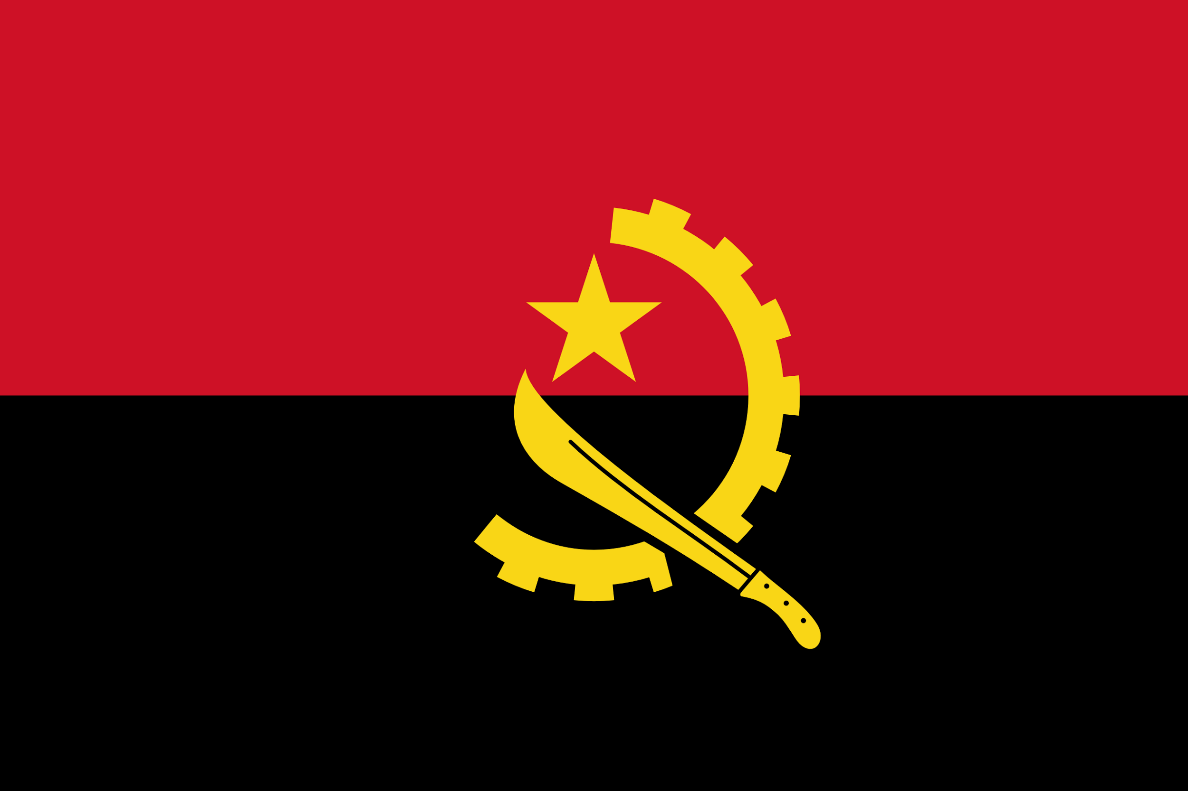
Angola: This state/country has experienced tumultuous cases of war related sexual violence, including a case where Angolese border guards brutalized Congolese women:
|Congolese victims said Angolan security guards repeatedly raped them while they were held in deportation areas for weeks in cage-like enclosures.|
Over 650 women were raped in just one month (October of 2010), and the issue received very little international news coverage. Angola has weak domestic laws on this issue, but the fact that Angolan government military officers committed the crime is indicative that governmental change is needed. Preventing soldiers from committing war related sexual violence within its country could be a significant part to an Angolan delegation’s agenda.
Chad: There have been well-documented cases of war related sexual violence within Chad and Darfur (a region east of Chad that is located in Western Sudan).
|Many women were raped in the torrent of violence that forced them to flee their villages. Sudanese security forces, including police deployed to protect Internally Displaced Persons (IDPs) and allied Janjaweed militias (including those from eastern Chad), have been implicated in acts of rape and sexual violence. Women IDPs and refugees report also being forced to exchange sexual favors for desperately needed goods and services. The Office of the Prosecutor of the International Criminal Court has identified "high numbers of… mass rapes and other forms of extremely serious gender violence."|
The majority of sexual violent acts in eastern Chad and Darfur are categorically considered Crimes Against Humanity. With lack of a stable government, it will be difficult to stop a problem that domestic military soldiers are causing.

Chile: From 1973-1990, a totalitarian Chilean government ruled the land with a brutal hand. The military has been found guilty of thousands of cases of sexually assaulting female civilians.
|Pinochet’s regime carried out many gruesome and horrific acts of sexual abuse against the victims. In fact, several detention sites were solely instituted for the purpose of sexually tormenting and humiliating the prisoners. Women were the primary targets of gruesome acts of abuse. According to the Valech Commission, almost every single female prisoner was a victim of repeated rape.|

While these crimes occurred over 25 years ago, the chair urges the Chilean delegation to bring up the past examples of sexual violence in Chile, and how those precedents can assist the council in solving the issues at hand regarding violence against women in western Africa.
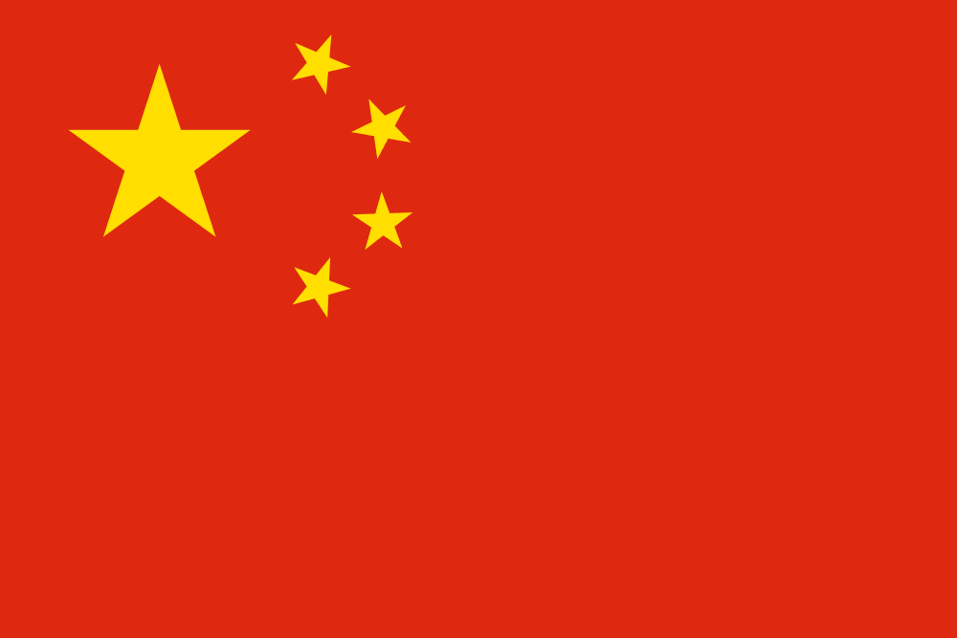
China: As earlier noted in this background guide, the 1937-38 Nanking Massacre was arguably the most extensive and notable case of war related sexual violence in recent history. While nearly eighty years have passed since the onslaught carried out by Japanese soldiers, this extremely grim and tragic set of events could bring valuable points to the table. There is little to no data that implicates China as a belligerent or instigator in any war related sexual violence, so a relatively clean slate on this issue should add to the credibility of China. The chair would encourage China’s efforts to hopefully resolve the issue in western Africa.
France: France has recently come under international scrutiny for reports of French soldiers, acting as peacekeepers, sexually assaulting and raping women from The Central African Republic (CAR). It is important that France works towards resolving the issues within its military service, as well as work towards using its power to combat sexual violence by extremist groups like Boko Haram. As a U.N. Security Council P-5, veto state, working to prevent soldiers from such attacks in the future would be strongly encouraged by the chair.
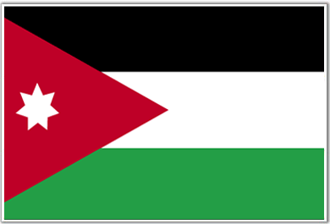
Jordan: While Jordan itself has not dealt firsthand with any major cases of war related sexual violence within its country, it has experienced an unprecedented number of recent Syrian refugees, most of which are women and children. Although the Syrian war crimes go anywhere from military soldiers arbitrarily terrorizing innocent civilians to using extensive amounts of poisonous sarin gas, Jordan has witnessed first hand the brutal effects of female refugees who have been sexually assaulted in their home country. It can use such experiences to assist in addressing and resolving the situation in western Africa with Boko Haram's and the LRA’s many cases of sexual violence.

Lithuania: In recent times, the state of Lithuania has not experienced any extensive cases of mass brutality toward women, however from 1920 up until the 1950s, Eastern Europe as a whole experienced tumultuous times. Lithuania experienced a multitude of war related sexual violence over half-a-century ago. Most of the belligerents through this time period were both Nazi-German soldiers and Red Army (Soviet) soldiers. The chair would encourage the Lithuanian delegation to brings up the past examples of how the Lithuanian government dealt with extensive cases of violence against women, how the U.N. and the international community dealt with sexual violence in Central and Eastern Europe (not just Lithuania, but the surrounding countries as well), and how these past dealings can assist the Council in combatting sexual violence in western Africa.

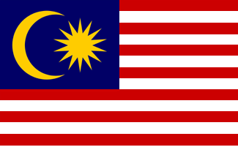
Malaysia: Although it has become highly developed in the past years, Malaysia was another victim of Japanese sexual violence during the Second World War. While the sexual violence during WWII was over seventy years ago, the impacts were still unprecedented, and have not had a match in terms of magnitude ever since:
|Representatives of the 200,000 "comfort women" forcibly drafted into military sexual slavery by Japan from 1928 until the end of World War II are still fighting for restitution. Far from colluding, women from [Listing of other Southeast Asians nations...] Malaysia [...] were "severely coerced" into prostitution. And whether a woman is raped at gunpoint or trafficked into sexual slavery by an occupying force, the sexual abuse will shape not just her own but her community's future for years to come.|
That said, the chair would encourage the Malaysian delegation to bring up past precedents of how the Malaysian government has dealt with extensive cases of sexual violence, how the UN dealt with sexual violence in Southeast Asia (not just Malaysia, but the surrounding countries as well), and how these past dealings can assist the Council in combatting sexual violence in western Africa.

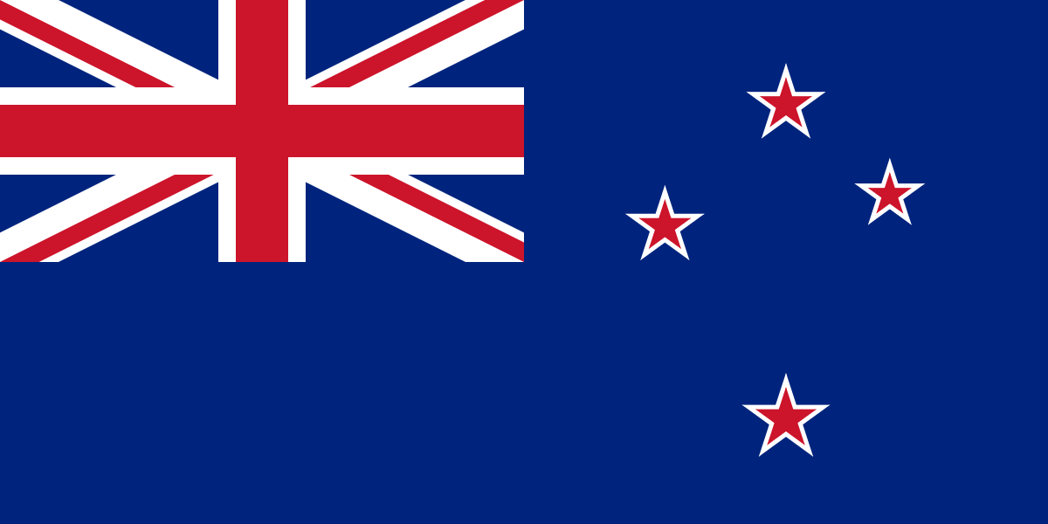
New Zealand: While New Zealand has never dealt with the effects of mass rape and sexual violence within the jurisdiction and boundaries of New Zealand itself, it was a force (amongst other Allied forces) that assisted in halting Japanese sexual violence during the Second World War. The chair would encourage the New Zealand delegation to bring up past precedents where New Zealand has helped combat sexual violence and how New Zealand can assist with combating sexual violence in western Africa.

Nigeria: War related sexual violence has impacted Nigeria first hand with the rise of Boko Haram and their recent crimes against women in the northern part of the country. This was highlighted in April of 2014 when Boko Haram militants kidnapped 276 female students during the night; at this point in time, most of these women are believed to have been sold off as sex slaves. This incident made international headlines, yet Boko Haram still is headquartered in northeast Nigeria. BH continues to plunder villages and rape women there. 2.3 million people have been forced from their homes since May 2013, and a quarter of a million of them have fled from Nigeria into Cameroon, Chad and Niger, many walking hundreds of miles.

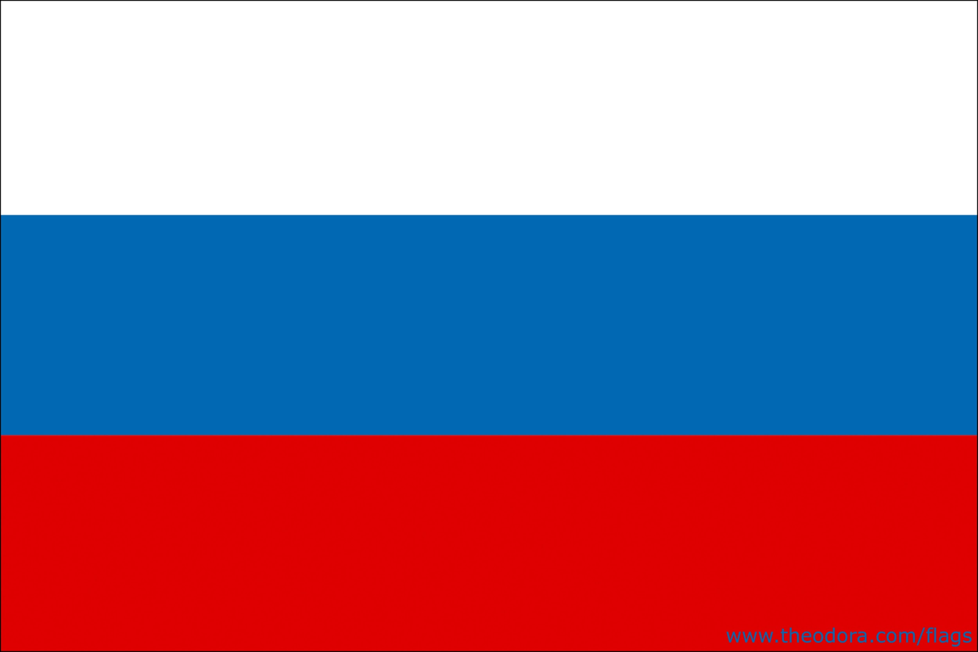
Russia: The Russian Federation (formerly known as the Soviet Union) has committed arguably the most egregious, sexually violent crimes of the twentieth century. During and after World War II, the Soviet Union sexually attacked countless German women for the justified purpose of having ‘entered Germany to punish all Germans.’ ⁴ During the Soviet Union’s reign, the Red Army attacked Polish women while liberating Poland, and the Army had thousands of cases of crimes against women during the Soviet era:
|According to Richard Overy, the Russians refused to acknowledge Soviet war crimes, partly "because they felt that much of it was justified vengeance against an enemy who committed much worse, and partly it was because they were writing the victors' history."|
The chair would encourage the Russian delegation that acknowledges and addresses the lack of consequences towards the USSR by the United Nations, how the Council can move forward from this dismissal of a war crime, and how this precedent can assist the Council in solving the sexually-violent issues in western Africa.

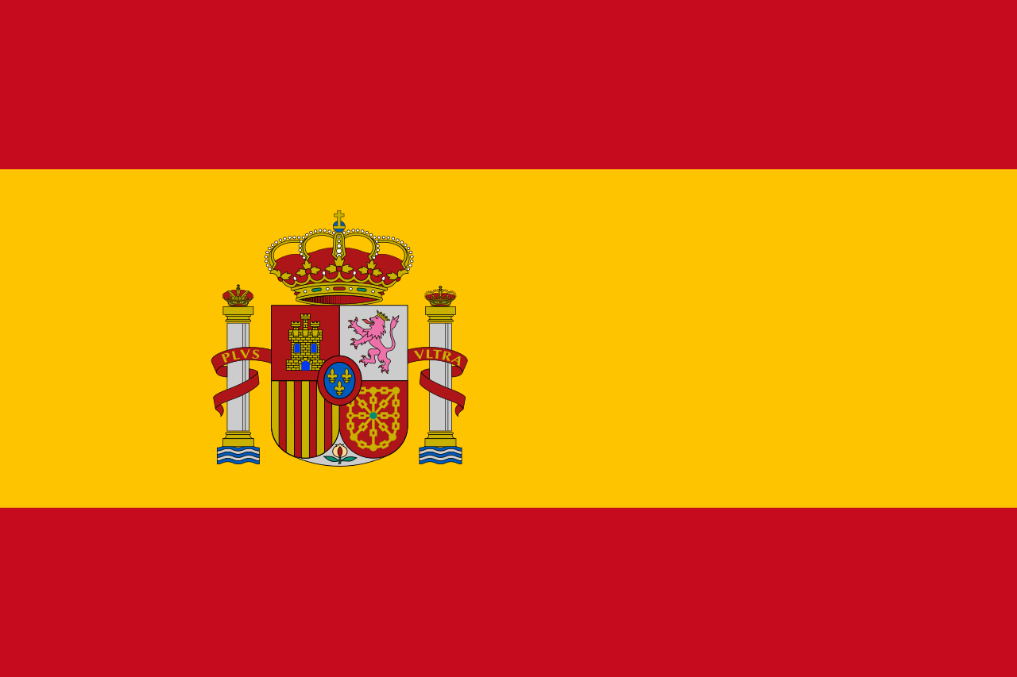
Spain: Brutal cases of war related sexual violence occurred during the Spanish Civil War during the 1930s, where Nationalists (members of the Spanish Fascism movement) fought against Republicans (anti-Fascists). Thousands of cases of sexual violence occurred, the belligerents generally being the Nationalists, and the victims generally being the Republican women. The following quote is demonstrative of the unapologetic nature of the crimes:
|Moreover the colonial troops raped many working-class women and looted the houses of the Republicans. Queipo de Llano, one of the leaders of the Nationalists said:
‘Our brave Legionaries and Regulares have shown the Red cowards what it means to be a man. And, incidentally the wives of Reds too. These Communist and anarchist women, after all, have made themselves fair game by their doctrine of free love. And now they have at least the acquaintance of real men, and not milksops of militiamen’.|
Despite the fact that these crimes occurred before the founding of the United Nations, it would offer the Spanish delegation a set of precedents with dealing with the crimes in western Africa. The chair would encourage the Spanish delegation to address both the past conflicts in Spain (perhaps what could have occurred to hinder and halt the sexual crimes), and the current conflict in Africa (and how to use the past issues in Spain to hinder and halt the issues in western Africa.

United States: The most serious instances of U.S., war related, sexual violence occurred on the Pacific front in World War II, the Korean War, and the Vietnam War. Japanese reports state that more than 10,000 women were sexually assaulted by U.S. soldiers at the battle of Okinawa in 1945. In 1950, the No Gun Ri massacre in South Korea, involved the rape and killing of 500-600 civilians. A very similar incident occurred in Vietnam 1968 at the My Lai Massacre - and prompted global outrage.
Though the United States’ history with war related sexual violence is far from perfect, the U.S. remains one of the most influential states in current affairs, and much more progressive towards limiting sexually violent acts than many less stable or less developed countries. The chair would look favorably on the United States being a driving force in the discussion, using its UN power to be a vocal leader in the discussion on hindering and halting the war related sexual violence in western Africa.
United Kingdom: The United Kingdom has been less guilty of Sexual Violence when compared to its neighboring European countries. However, there were numerous cases of rape during the British occupation of Germany during World War II. Many cases were reported, but never resulted in any punishment and some cases of rape were quite brutal in nature:
|Longden highlights that "Some officers failed to treat reports of rape with gravity." He provides the example of a medic, who had a rape reported to him. In cooperation with the Royal Military Police, they were able to track down and apprehend the perpetrators who were then identified by the victim.|
The chair would encourage the British delegation to take previous British war crimes into account, and uses British precedents (for example, how has the United Kingdom dealt with British war crimes?) to steer the council into the right direction of hindering and halting war related sexual violence in western Africa.

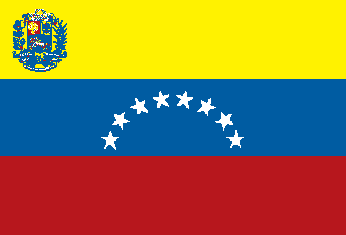
Venezuela: When compared to its South American neighbors, Venezuela is relatively clean in crimes in terms of sexual violence. Despite the fact that there is little to no evidence of war related sexual violence occurring where a Venezuelan citizen has been a perpetrator or victim of a war-induced sexually violent crime, there is evidence that the Venezuelan government is not particularly serious in punishing the crime within the country. The chair would encourage the Venezuelan delegation to address the issues in Venezuela, and also brings any solutions to the table for the sexual violence in western Africa.

Citations:
Biddiscombe, Perry (2001). "Dangerous Liaisons: The Anti-Fraternization Movement in the U.S. Occupation Zones of Germany and Austria, 1945–1948". Journal of Social History 34 (3): 611–647. Accessed July 27, 2015

Beevor, Antony. The Battle for Spain; The Spanish Civil War 1936-1939. Penguin Books. 2006. London. p.91-92

Chalk, Frank (2007). "Journalism as Genocide: the Media Trial". In Allan Thompson. The Media and the Rwanda Genocide. Pluto Press.

Chang, The Rape of Nanking, 1997, p. 40

Diken, Bülent, and Carsten Bagge Laustsen. "Becoming Abject: Rape as a Weapon of War." Body Society 11, no. 1 (2005): 111-28. Accessed July 29, 2015.

"5,000 Hanging Skirts: How Women Remember War Rape in Kosova." juancole.com. June 15, 2015. Accessed August 16, 2015.

Inal, Tuba. Looting and Rape in Wartime: Law and Change in International Relations. Philadelphia: University of Pennsylvania Press, 2013.

Informe de la Comisión Nacional sobre Prisión Política y Tortura,” National Commission Report on Political Prisoners and Torture,” 2005, 249-250

Longden, Sean (2004). To the Victor the Spoils: D-Day to VE Day, the Reality Behind the Heroism. Arris.

Jones, Adam (2006). Genocide: A Comprehensive Introduction. Routledge.

Naimark, Norman M. The Russians in Germany: A History of the Soviet Zone of Occupation, 1945-1949. Cambridge, Mass.: Belknap Press of Harvard University Press, 1995.

"Nigeria: Boko Haram Has Raped 12,000 Women." Ibtimes.co.uk. June 4, 2015. Accessed August 16, 2015.

Nossiter, Adam. "Boko Haram Militants Raped Hundreds of Female Captives in Nigeria." Nytimes.com. May 18, 2015. Accessed August 30, 2015.

Nowrojee, Binaifer (1996). Shattered Lives: Sexual Violence during the Rwandan Genocide and its Aftermath. Human Rights Watch.

Preston, Paul. The Spanish Civil War. Reaction, revolution & revenge. Harper Perennial. 2006. London. p.206

Situation in Uganda, International Criminal Court.

Smith-Spark, Laura. "How Did Rape Become a Weapon of War?" BBC News. December 8, 2004. Accessed August 29, 2015.

"Stopping Mass Rape in Darfur and Chad." http://physiciansforhumanrights.org. 2011. Accessed August 26, 2015.

Summer, Chris. "Red Army Rapists Exposed." BBC News. April 29, 2002. Accessed August 31, 2015.

Tanaka, Yuki; Tanaka, Toshiyuki (2003), Japan's Comfort Women: Sexual Slavery and Prostitution During World War II, Routledge

Taylor, Christopher C. "A Gendered Genocide: Tutsi Women And Hutu Extremists In The 1994 Rwanda Genocide." PoLAR: Political 22, no. 1 (1999): 42-54. Accessed July 28, 2015. Accessed July 29, 2015.

Terrorist Organization Profile: Lord's Resistance Army (LRA)". National Consortium for the Study of Terrorism and Responses to Terrorism, University of Maryland. Retrieved 16 October 2011.

Wood, Elisabeth J. (2013). Miranda A.H Horvath, Jessica Woodhams, ed.Handbook on the Study of Multiple Perpetrator Rape: A multidisciplinary response to an international problem. Routledge.

Diken, Bülent, and Carsten Bagge Laustsen. Body Society 11, no. 1 (2005): 111-28. Accessed July 29, 2015.
Chang, page 40. 1997.
Biddiscombe, Perry. Journal of Social History 34 no. 3: 611–647 (2001). Accessed July 29, 2015.
Naimark, 1995
Tanaka, 2003.
Jones 2006, p. 329
Wood 2013, p. 140
Becirevic 2014, p. 117.
"5,000 Hanging Skirts: How Women Remember War Rape in Kosova," accessed August 16, 2015.
Chalk, 2007, p. 372.
Nowrojee, 1996, p. 1.
Taylor, PoLAR: Political 22, no. 1 (1999): 42-54. Accessed July 28, 2015.
"Nigeria: Boko Haram Has Raped 12,000 Women," accessed August 16, 2015
"Boko Haram Militants Raped Hundreds of Female Captives in Nigeria." Accessed August 30, 2015.
"Stopping Mass Rape in Darfur and Chad."
National Commission Report on Political Prisoners and Torture,” 2005, 249-250
Inal, 2013
"How Did Rape Become a Weapon of War?" Accessed August 29, 2015.
"Red Army Rapists Exposed." Accessed August 31, 2015.
Beevor, 2006.
Preston. 2006.
Longden, 2004

