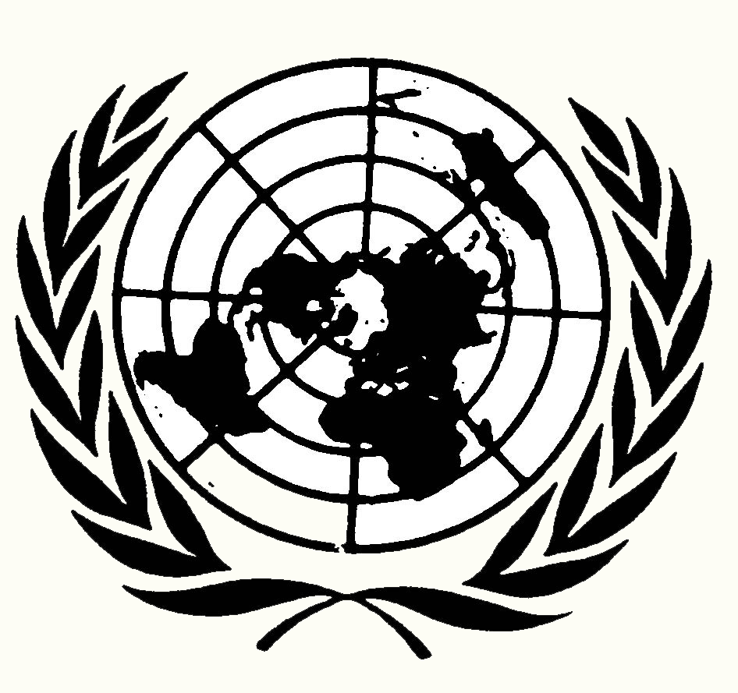
Resolution 201

Boko Haram Terrorism and Brutality Towards Women
Security Council
Submitted by: Malaysia
The Security Council:
Recognizing that Boko Haram's insurgency is a direct result of chronic poor governance by Nigeria's federal and state governments,
Deeply concerned with the increasing and extensive poverty of the Muslim majority in northern Nigeria,
Noting with deep concern Nigeria's military mistreatment of Muslims in northern Nigeria,
Acknowledging that Boko Haram's grievances and complaints against the Nigerian government, police, and military are primarily local,
The United Nations Security Council:

- Calls upon the Nigerian government to reduce the anger and alienation of Nigeria's Muslims in the northern region by ending its gross human rights abuses against Muslim Nigerians by reforming military and police practices and culture;
- Encourages the African Union to assist Nigeria meet the immediate needs of refugees and persons internally displaced by fighting in the northeast and the Lake Chad basin region;
- Authorizes African Union peacekeepers to monitor and protect the movement of refugees displaced by fighting in northeast Nigeria and the Lake Chad basin region;
- Requests that African Union diplomats organize a meeting between Boko Haram, Nigeria, Chad, Cameroon, and Niger to negotiate the release of the Chibok school girls and other captured girls and women;
- Recommends that Nigeria direct its oil revenues profits to improve or build new roads, water and sewage treatment plants, hospitals, and schools in northern Nigeria;
- Endorses the Carter Center to assist Nigeria conduct fair and credible national elections in 2016;
- Encourages United Nations member states to open consulates in the northern city of Kano in order to improve international outreach to that region's predominantly Muslim population; and
- Strongly urges United Nations member states revoke travel visas in their countries held by Nigerians who promote ethnic and religious violence.

Resolution 202
Boko Haram Terrorism and Brutality Towards Women
Security Council
Submitted by: Spain
The Security Council:
Deploring the large scale murder of civilians and enslavement of girls and women by Boko Haram in northeastern Nigeria and the Lake Chad Basin,

Noting with alarm that 2.3 million people have lost or fled their homes due to Boko Haram aggression,

Deeply disturbed with the recent alliance of Boko Haram with the so-called Islamic State (ISIS),

Noting that Boko Haram receives its funding from a variety of sources to engage in terrorist activities,

Recognizing that conflicts involving a terrorist organization operating across borders and in several states are best addressed by a regional organization that understands the culture, languages and religions involved - such as the African Union,

The United Nations Security Council:

- Condemns the actions of Boko Haram murdering innocent civilians and enslaving girls and women;
- Authorizes the African Union's continuing use of force to protect civilians and refugees from Boko Haram aggression;

- Calls upon United Nations member states to work with and finance the United Nations High Commission for Refugees (UNHCR) to build refugee camps in northeastern Nigeria and neighboring states Chad, Cameroon, and Nigeria - and provide quality shelter, food, drinking water, sanitation, and medical care in the camps;
- Strongly urges robustly (heavily) armed U.N. peacekeepers protect U.N. refugee camps in northeastern Nigeria and neighboring states under attack by Boko Haram;
- Encourages the Economic Community of West African States (ECOWAS) apply economic punishment and sanctions against individuals and organizations that sell weapons and armaments to Boko Haram; and
- Strongly urges United Nations member states to provide financial support for African Union military operations and UNHCR efforts to build, supply, and protect needed refugee camps.

