Advanced ASEAN Plus Six Crisis Council Background Document
Maritime Conflicts over Disputed Territory in the East and South China Seas
2015 Boulder-Fairview Model U.N. Conference
Annie Chen and Evan Laugen, Boulder High School

Sept. 29 marked 43 . . .years of normalized diplomatic relations between China and Japan, two countries that spent much of the 20th century in mutual enmity if not at outright war. The anniversary came at a low point in Sino-Japanese relations amid a dispute over an island chain in the East China Sea known as the Senkaku Islands in Japan and Diaoyu Islands in China.
These islands, which are little more than uninhabited rocks, are not particularly valuable on their own. However, nationalist factions in both countries have used them to enflame old animosities; in China, the government has even helped organize the protests over Japan's plan to purchase and nationalize the islands from their private owner. But China's increased assertiveness is not limited only to this issue. Beijing has undertaken a high-profile expansion and improvement of its navy as a way to help safeguard its maritime interests, which Japan — an island nation necessarily dependent on access to sea-lanes — naturally views as a threat. Driven by its economic and political needs, China's expanded military activity may awaken Japan from the pacifist slumber that has characterized it since the end of World War II.
Rodger Baker, Stratfor Global Intelligence, Sept. 2012

Overview of ASEAN Plus Six
States within the ASEAN Plus Six include the 10 states in the Association of Southeast Nations (ASEAN), Australia, China, India, Japan, New Zealand, and South Korea. The ASEAN is a political and economic organization that was formed in 1967 promoting regional cooperation, mostly for economic reasons. The East Asia Summit is an annual forum held by leaders of mostly East Asian countries, which include all states of ASEAN Plus Six. The seventh EAS, held in November 2012, was greatly disrupted by the ongoing tensions resulting from the East China Sea and South China Sea disputes. The ASEAN itself has already negotiated individual free trade agreements with every other country of the ASEAN Plus Six. The ASEAN Plus Six has agreed to finalize the Regional Comprehensive Economic Partnership (RCEP), which was launched in November 2012, by 2016. This will result in the world’s largest free trade agreement. In addition, the pact aims to create a seamless market among the 16 countries, liberalize trade, services, and investment, and promote closer economic cooperation.
Topic 1: East China Sea Disputes
Introduction
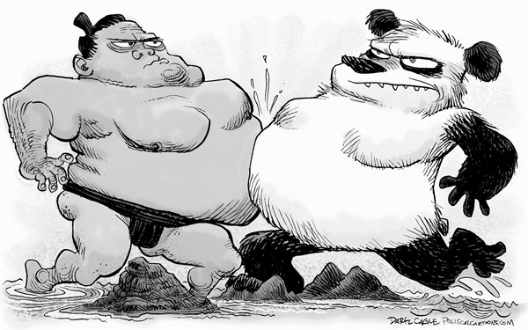
Tensions are running increasingly high as China and Japan struggle to resolve their disputes regarding the East China Sea. The two East Asian states have had their share of past conflicts and unrest. While the disputes over exclusive economic zone (EEZ) claims and over a small group of islands may seem minor, underneath they mask years of mutual hostility. Sino-Japanese relations are at a low point as nationalistic pride begins to pit the countries against each other. The goal of East Asian geopolitical and economic supremacy drives these tensions, as both sides are looking for ways to gain politically, without worsening the situation. Although it appears that neither state would like to introduce military forces in disputed regions, either one may be triggered to do so by domestic pressure, political miscalculation by one side, or an accidental incident. No lives have been lost over the disputed territory thus far, but should that happen due to escalating interactions, crisis management would be difficult for both countries.

History of the Issue and Recent Events
One of the disputes between China and Japan in the East China Sea concerns their exclusive economic zone (EEZ) boundaries, as their maritime claims currently overlap (see figure below). Both nations claim a 200 nautical mile (nmi) EEZ although the East China Sea is only 360 nmi wide.
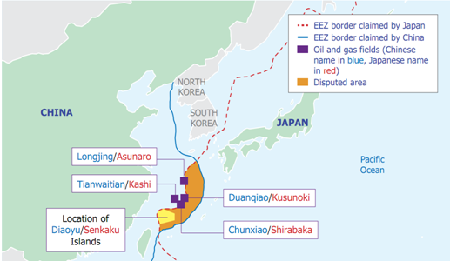
Based on the The United Nations Convention on the Law of the Sea (UNCLOS), China’s Ministry of Foreign Affairs has claimed, “The natural prolongation of the continental shelf of China in the East China Sea extends to the Okinawa Trough and beyond 200 nautical miles from the baselines from which the breadth of the territorial sea of China is measured.”
Japan claims a 200 nautical mile EEZ, but its EEZ law states that its claim will extend to the median line if it overlaps with another nation’s.
China began exploring the East China Sea for resources in the late 1970s and found its first field, the Pinghu field, in 1994. Japan discovered China’s drilling platform at the Chunxiao field in 2004, which is located only 5 km from the Japanese side of the median line. As most scholars assume Japan’s EEZ only extends to the median line, rather than the 200 nmi limit, China claims that Japan effectively conceded a portion of its maritime territory to China and that the Chunxiao field is in Chinese waters.
Japan argues that as the precise coordinates of the line have not been specified, the median line is not a final boundary. Since then, Japan has been stepping away from its proposal of a median line and now claims a full 200 nmi EEZ. As a result, Japan has been protesting Chinese production in all fields near the median line. In particular, it has also requested access to the field’s geological data to ensure that China is not tapping into Japanese reserves. China has consistently rejected Japan’s requests and claims that all fields in the Okinawa trough are within its jurisdiction.
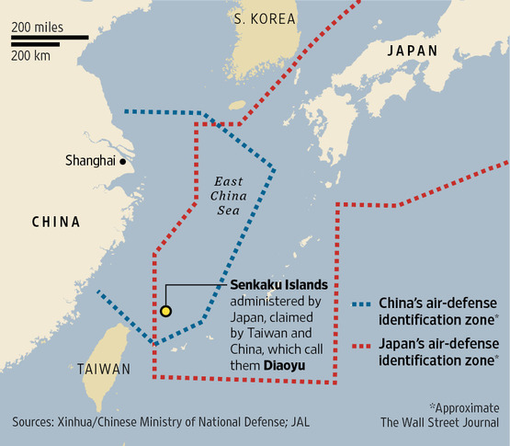
Another dispute concerns a group of islands, known as the Senkaku Islands to Japan and the Diaoyu Islands to China. While they are uninhabited and total only seven square kilometers in area, they have a strategically and economically significant location. In particular, the islands are near potentially large reserves of oil and natural gas and even rich fishing grounds. Also, there are many sea lines of communication (SLOC) nearby, which are crucial to trade and military movements. Overall, control of the islands would also bring control of the region.
They are currently administered under Japan but are also claimed by China and Taiwan. The dispute over these islands are arguably an even bigger threat to international stability than the dispute over EEZ boundaries because unlike resources, small islands cannot easily be shared among states. China claims ownership of the islands since the 14th century while Japan has had ownership since the Sino-Japanese War in 1895. The islands were held under the administration of the United States from 1945 to 1972 as part of the Ryukyu Islands.
China began disputing Japan’s ownership after evidence of oil and gas reserves in the area emerged in the 1970s. China argues that the islands are part of Imperial Japan’s conquests and should be returned as the rest of the conquests, which were reverted after World War II in 1945.
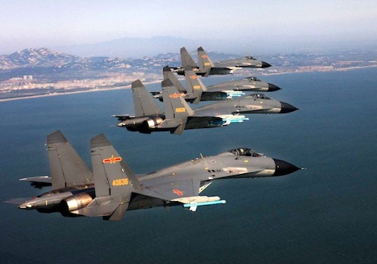
In response, Japan argues not only that there is a lack of evidence that China ever controlled the islands before 1895, but also that as China did not challenge the sovereignty of the islands before the late 1970s, ownership of the islands does not apply to the Chinese argument. Article 121 of the UNCLOS states, “Rocks which cannot sustain human habitation or economic life of their own shall have no exclusive economic zone or continental shelf.” The Japanese claim that the islands have an EEZ and a continental shelf although China has not taken a position on the issue. As a result, some Japanese have even begun claiming a 200 nmi EEZ extending from the islands themselves.
While there were no major incidents surrounding the islands before the 1990s, since then events such as naval encounters and mass public protests have heightened the dispute. The Japanese government began leasing the islands from private Japanese owners in 2004, inciting Chinese protests. A Chinese fishing boat rammed into two Japan Coast Guard (JCG) vessels near the Senkaku/Diaoyu Islands in 2012. In September 2012, Japan further fueled tensions by purchasing three of the five islands. After military involvement escalated, China decided to set up the East China Sea Air Defense Identification Zone on November 23, 2013, a move that Japan called dangerous.

United Nations Convention on the Law of the Sea (UNCLOS)
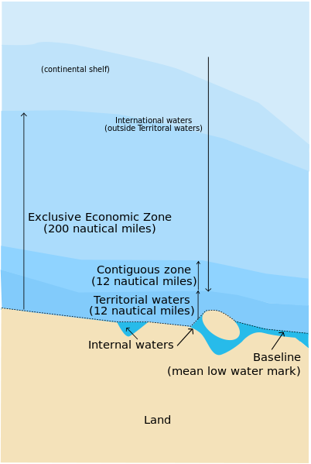
The United Nations Convention on the Law of the Sea is an international agreement concerning the rights of nations with regards to the oceans and their resources. It resulted from the third United Nations Conference on the Law of the Sea, which occurred between 1973 and 1982. The convention defines many areas, including a coastal nation’s internal waters, territorial waters, contiguous zone, exclusive economic zone, and continental shelf.
All of these definitions rely on an established baseline. According to Section 2 Article 5, “The normal baseline for measuring the breadth of the territorial sea is the low-water line along the coast as marked on large-scale charts officially recognized by the coastal State.” Territorial waters, which extend 12 nautical miles from the baseline, are sovereign territory of the coastal state although all states’ ships may pass freely in the area. If one state’s territorial waters overlap with another, then the border is the median point between the states’ baselines.
The contiguous zone, which is typically 12 nautical miles, extends from the territorial waters where the coastal state “may exercise the control necessary to: (a) prevent infringement of its customs, fiscal, immigration or sanitary laws and regulations within its territory or territorial sea; (b) punish infringement of the above laws and regulations committed within its territory or territorial sea” (sec. 4, art. 33).
The exclusive economic zone (EEZ) includes the contiguous zone and extends up to 200 nautical miles from the territorial waters. A coastal nation has sole control of all economic resources in this zone, but the surface waters are considered international territory. Specifically, according to Part 5 Article 56, “In the exclusive economic zone, the coastal State has: (a) sovereign rights for the purpose of exploring and exploiting, conserving and managing the natural resources, whether living or non-living, of the waters superjacent to the seabed and of the seabed and its subsoil, and with regard to other activities for the economic exploitation and exploration of the zone, such as the production of energy from the water, currents and winds; (b) jurisdiction as provided for in the relevant provisions of this Convention with regard to: (i) the establishment and use of artificial islands, installations and structures; (ii) marine scientific research; (iii) the protection and preservation of the marine environment; (c) other rights and duties provided for in this Convention.” Disagreements over exclusive economic zones are at the center of the East China Sea disputes.
Finally, according to Part 6 Article 76, the continental shelf is defined as “the seabed and subsoil of the submarine areas that extend beyond its territorial sea throughout the natural prolongation of its land territory to the outer edge of the continental margin, or to a distance of 200 nautical miles from the baselines from which the breadth of the territorial sea is measured where the outer edge of the continental margin does not extend up to that distance… The continental margin comprises the submerged prolongation of the land mass of the coastal State, and consists of the seabed and subsoil of the shelf, the slope and the rise. It does not include the deep ocean floor with its oceanic ridges or the subsoil thereof.”
According to Article 77, the coastal state has the following rights among others over its continental shelf: “The coastal State exercises over the continental shelf sovereign rights for the purpose of exploring it and exploiting its natural resources… The rights referred to in paragraph 1 are exclusive in the sense that if the coastal State does not explore the continental shelf or exploit its natural resources, no one may undertake these activities without the express consent of the coastal State.”
The main differences between the continental shelf and the EEZ are that (1) the continental shelf can extend beyond 200 nautical miles from the baseline, and (2) the continental shelf only applies to the seabed and subsoil whereas the EEZ applies to all resources to the surface of the waters. The above includes the main ideas of the UNCLOS that will be necessary for this council. However, the convention contains many more details of states’ rights and responsibilities regarding the oceans that may be important to this council: http://www.un.org/depts/los/convention_agreements/texts/unclos/unclos_e.pdf.

Geography and Natural Resources
The East China Sea is a sea bounded on the east by the Ryukyu Islands of Japan, on the south by the South China Sea, on the west by mainland China, and on the north by the Yellow Sea. The East China Sea disputes mainly involve China, Japan and South Korea and their respective exclusive economic zones (EEZs). The main disputes are between China and Japan, and we will focus on those in the council.
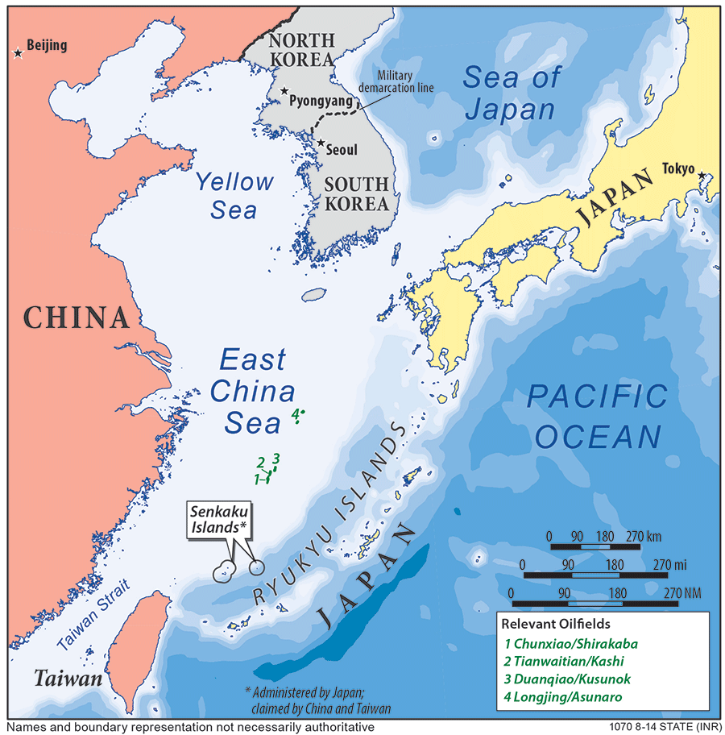
While the region has not been explored yet due to the disputes, the East China Sea may have many abundant natural resources, especially natural gas. Chinese sources estimate that approximately 250 trillion cubic feet (Tcf) of natural gas and 70-160 billion barrels of crude oil are undiscovered but technically recoverable.
However, these estimates of undiscovered but recoverable resources do not factor in other economic issues necessary to bring them into production, which is unlike proved and probable resources. This is why if the disputes are resolved, the East China Sea will likely not become a major supplier of oil anytime soon, as it currently has only an estimated 200 million barrels of oil in proved and probable resources.
Nonetheless, the potential of the sea to be a major domestic source of natural gas is very high. The EIA estimates that between 1-2 Tcf of proven or probable natural gas reserves are in the sea. Both China and Japan are looking for new sources, so the significant potential quantity of energy resources in the East China Sea may be a crucial economic factor for both China and Japan and will therefore be an integral portion of this council.
Unless the disputes are settled, neither nation will be able to explore and exploit these resources. However, it is important to note that resource development likely does not drive nor fully explain Chinese behavior in the East China Sea. East Asia’s proven offshore natural gas reserves are simply a fraction of the region’s energy demand. Therefore, the resources themselves are only one part of the East China Sea dispute—the politics surrounding this resource development are at the true center of these disputes.
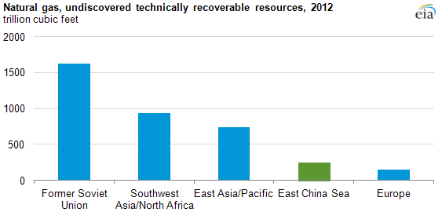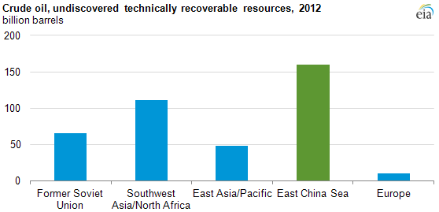
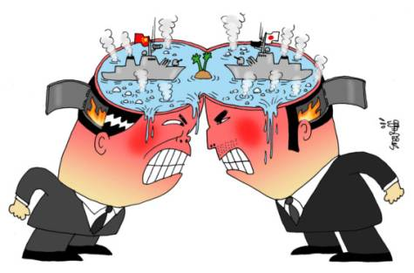
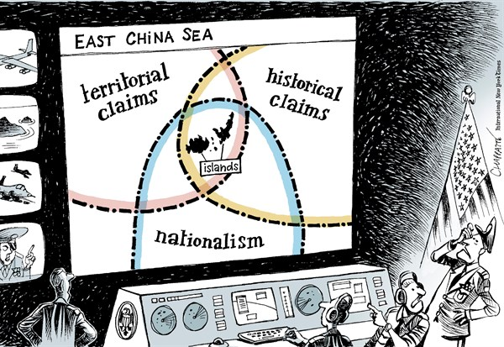
As a result of these disputes, Sino-Japanese relations are at an extreme low, and large-scale protests are being held on both sides. Nationalist rhetoric and historical animosity only continues to add fuel to the unrest. China and Japan have been holding bilateral talks regarding these disputes since October 2004. After four years of negotiations, the nations agreed to develop four gas fields together and to halt exploration of other parts of the disputed area. However, China decided to Tianwaitian/Kashi gas field alone in 2009, arguing that the field was outside the area of consensus, and no joint development has occurred yet.
While both countries have been careful about introducing military forces in the region, hostility between the nations is increasing, and neither have offered concrete solutions for resolving the disputes. Both nations have many incentives to compete for authority in the East China Sea, including islands, oil and natural gas, fisheries, sea lanes, and national pride. Chinese and Japanese officials are constrained by their countries’ shared history. The islands dispute has acquired great symbolic significance in both countries, so attempts to reach a compromise settlement will likely provoke intense domestic opposition. As such, it will no doubt be difficult to diplomatically resolve these disputes.

Timeline of Key Events in the East China Sea:
- 1969: Potential of oil and gas reserves is discovered, leads China to question sovereignty of the Senkaku/Diaoyu Islands.
- April 1978: Thirty-eight armed Chinese fishing boats enter the disputed Senkaku/Diaoyu Island territory and with posters indicating claims to the islands.
- 1995: China discovers a significant number of oil and gas fields in the Okinawa Trough of the East China Sea, including the Chunxiao gas field.
- January 2004: Japanese forces fire a cannon at Chinese fishermen near the islands.
- October 2004: China and Japan begin holding bilateral talks about the East China Sea disputes.
- 2008: The two nations decide to jointly develop four gas fields in the contested area. However, no joint development has occurred to date.
- 2010: A Chinese fishing boat rams into two Japan Coast Guard (JCG) vessels near the Senkaku/Diaoyu Islands, significantly increasing tensions between the two countries.
- November 2011: Japan arrests a Chinese fishing boat captain after a chase near the Goto Islands south of Kyushu.
- August 2012: Major protests erupt in China after reports emerge that Japan is considering purchasing the islands.
- September 2012: Japan purchases three of the five islands.
- December 13, 2012: A small Chinese reconnaissance aircraft enters undetected into Japanese airspace above the islands.
- February 2013: A Chinese frigate allegedly directs fire-control radar on a Japanese Maritime Self-Defense Force destroyer, eliciting a Japanese protest.
- November 23, 2013: China sets up the East China Sea Air Defense Identification Zone.

Works Cited:
"Asean plus Six Likely to Form World’s Largest Economic Bloc." Aseanaffairs.com. N.p., 17 Nov. 2012. Web. 13 Sept. 2015. <http://www.aseanaffairs.com/asean_news/trade/asean_plus_six_likely_to_form_world_s_largest_economic_bloc.
Baker, Rodger. "Understanding the China-Japan Island Conflict." Stratfor.com. Stratfor Global Intelligence, 25 Sept. 2012. Web. 13 Sept. 2015. < https://www.stratfor.com/weekly/understanding-china-japan-island-conflict >.
"East China Sea." Eia.gov. U.S. Energy Information Administration, 17 Sept. 2014. Web. 13 Sept. 2015. <http://www.eia.gov/beta/international/regions-topics.cfm?RegionTopicID=ECS>.
"How Uninhabited Islands Soured China-Japan Ties - BBC News." BBC News. N.p., 10 Nov. 2014. Web. 13 Sept. 2015. <http://www.bbc.com/news/world-asia-pacific-11341139>.
Manicom, James. "China's Energy Development in the East China Sea." Cigionline.org. Center for International Governance Innovation, 12 Sept. 2013. Web. 13 Sept. 2015. <https://www.cigionline.org/articles/2013/09/china%E2%80%99s-energy-development-east-china-sea>.
Meierding, Emily. "Don’t Blame the Oil Rigs for Unrest in East China Sea." Time.com. N.p., 10 June 2015. Web. 13 Sept. 2015. <http://time.com/3903411/oil-rig-resource-war-truth/>.
"Oil and Gas in Troubled Waters." The Economist, 5 Oct. 2005. Web. 13 Sept. 2015. <http://www.economist.com/node/4489650>.
"Regional Comprehensive Economic Partnership (RCEP): An Asian Trade Agreement for a Value Chain World." Asian Trade Center, 10 Feb. 2015. Web. 13 Sept. 2015. <http://www.asiantradecentre.org/talkingtrade/2015/2/10/regional-comprehensive-economic-partnership-rcep-an-asian-trade-agreement-for-a-value-chain-world>.
"Regional Comprehensive Economic Partnership (RCEP)." Trade and Economic Relations. New Zealand Ministry of Foreign Affairs and Trade, 31 Aug. 2015. Web. 13 Sept. 2015. <http://www.mfat.govt.nz/Trade-and-Economic-Relations/2-Trade-Relationships-and-Agreements/RCEP/>.
Saundry, Peter. "East China Sea." The Encyclopedia of Earth, 13 May 2013. Web. 13 Sept. 2015. <http://www.eoearth.org/view/article/151873/>.
Smith, Sheila A. "A Sino-Japanese Clash in the East China Sea." Council on Foreign Relations. Council on Foreign Relations, Apr. 2013. Web. 13 Sept. 2015. <http://www.cfr.org/japan/sino-japanese-clash-east-china-sea/p30504>.
"Timeline: 1955-Present." Center for a New American Security, 2015. Web. 13 Sept. 2015. <http://www.cnas.org/flashpoints/timeline>.
"United Nations Convention on the Law of the Sea as of 10 December, 1982." United Nations Division for Ocean Affairs and the Law of the Sea. United Nations, n.d. Web. 13 September 2015. <http://www.un.org/depts/los/convention_agreements/texts/unclos/UNCLOS-TOC.htm>.

Topic 2: South China Sea Disputes
The South China Sea today carries about one third of the shipping of the entire world due to its strategic location between the Pacific and Indian Oceans. It connects many of the world’s fastest growing and most advanced economies, such as Japan, South Korea, the People’s Republic of China (PRC), Vietnam, India, and Singapore. Annually, more than USD 5.3 trillion worth of trade passes through the South China Sea It also contains large, undersea petroleum reserves and rich fishing grounds. [Glaser]

Because of it’s strategic location and resources, many regional states have laid claim to parts of it. This has led to diplomatic tensions and even violence. In 1974, the People’s Republic of China (PRC) seized the Paracel Islands from the Socialist Republic of Vietnam, killing more than 70 Vietnamese soldiers. In 1988, the two nations clashed again in the Spratly Islands. Vietnam lost about 60 sailors. [“Q&A:…”] More recently, the PRC and the Republic of the Philippines engaged in a month-long military standoff over accusations of intrusions in the Spratly Islands. In the summer of 2014, the PRC placed an oil rig near the Paracel Islands in an area claimed both by the PRC and Vietnam. This led to multiple confrontations between Vietnamese fishing boats and Chinese coast guard ships and multiple Vietnamese vessels were sunk. [“Q&A:…”]

Six states bordering the South China Sea have issued claims to areas of the sea as their territorial waters, over which they have sovereignty. These states are: the PRC, Vietnam, the Philippines, Malaysia, Brunei Darussalam, and Indonesia. All of the territorial claims are currently disputed except those of Indonesia.

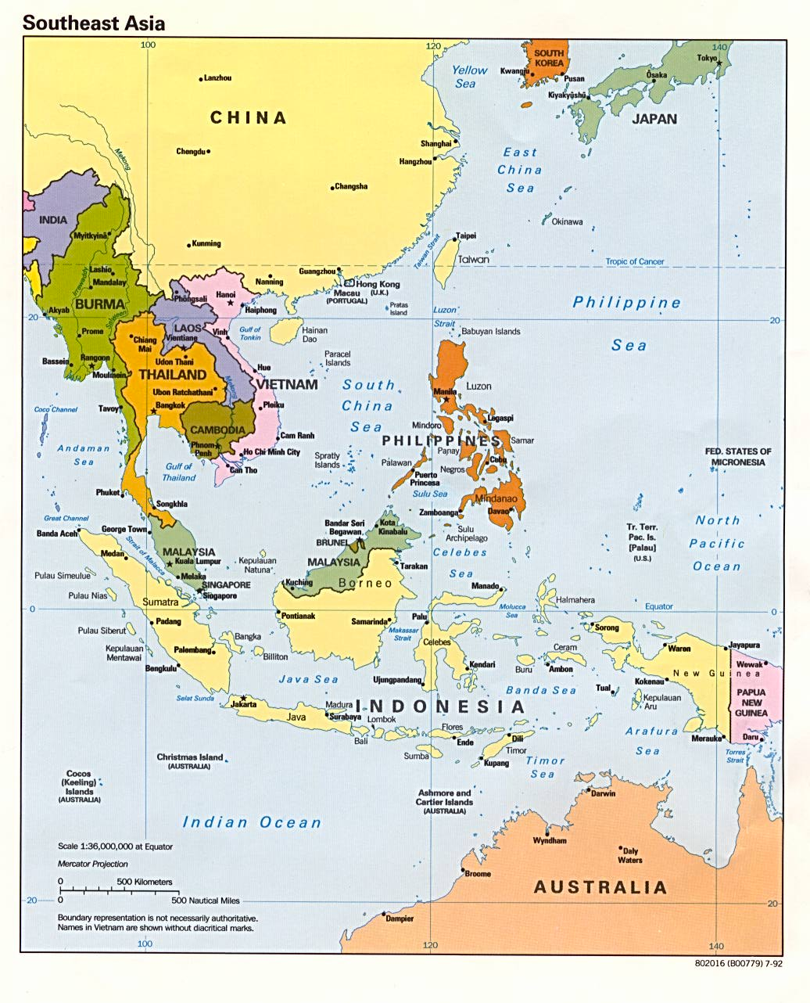
The competing and disputed territorial claims represent more than just a regional threat. Conflict in this reason carries the potential to involve many states world-wide. The United States, for example, conducts more than 1/5 of all trade in the South China Sea and has been a major naval power in the region since World War II. It is bound by a mutual protection treaty with the Philippines, one of the states competing for territory, to intervene for their defense in the event of a conflict. Even if a conflict does not directly involve one of it’s allies, the United States would likely be drawn into the conflict. The Council on Foreign Relations has prepared a contingency planning memorandum in 2012 detailing the implications of a conflict in the South China Sea for the United States. [Glaser] Other states could be drawn into a conflict for similar reasons.

The Association of Southeast Asian States and the PRC signed the Declaration on the Conduct of Parties in the South China Sea in 2002 in order to avoid conflict related to territorial claims. The Declaration (also called the Code of Conduct) commits all signatories to “reaffirm their commitment to the purposes and principles of the (…) 1982 UN Convention on the Law of the Sea,” “reaffirm their respect for and commitment to the freedom of navigation in and overflight above the South China Sea,” and “undertake to resolve their territorial and jurisdictional disputes by peaceful means.” [“Declaration…”]

The Code of Conduct, however, is voluntary and non-binding. Recently the parties to the Code have made little effort to abide by it. ASEAN has no power to enforce the Declaration, so the tensions in the region have continued to grow largely unabated. In talks with ASEAN in August, the PRC agreed to speed up the process of creating a new and binding Code, but Beijing is unlikely to open negotiations in the foreseeable future. [Glaser]

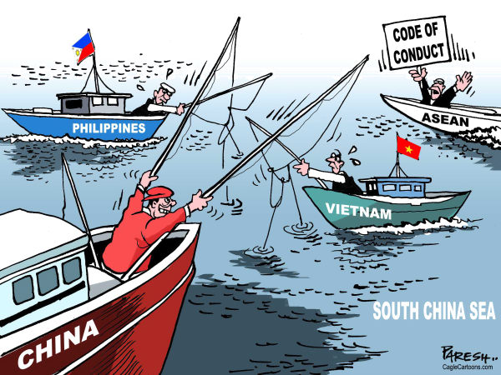
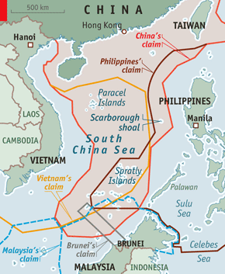
Although a primary purpose of the Code of Conduct is to affirm that parties will abide by the 1982 UNCLOS treaty, most claims blatantly disregard the standards laid out in that convention. The largest territorial claim, and the one most blatantly in violation of UNCLOS is that of the PRC. It covers the majority of the area of the South China Sea and is marked in red on the adjacent map. The claim dates to 1947 when it was first mapped by the Nationalist government of Chiang Kai-shek. After the Nationalists were defeated by the Communists under Mao Zedong in 1949, the communist government continued to use the claim made by the Nationalists. The PRC’s claim is commonly referred to as the “Nine-Dash Line,” because it is often marked on maps with nine dashes. The Chinese affirm that this claim is supported by their historical control of the region. The historical basis for Beijing’s claim is highly contested because UNCLOS does not specify historical possession or ownership as qualifications for a territorial claim. [Malik] The PRC, however, is not the only state to claim territory in the South China Sea beyond its legal 200 nautical mile EEZ. Vietnam and the Philippines have both laid claim to large areas of the sea. Malaysia and Brunei Darussalam have done so to a smaller extent. [Burr]

The UNCLOS treaty allows states that control oceanic islands to claim an EEZ around those islands. For instance, the United States maintains a 200 nautical mile EEZ around the Hawaiian Islands which is not contiguous with the EEZ around the mainland. Therefore, island groups in the South China Sea, specifically the Paracel Islands and the Spratly Islands, are disputed because controlling these islands would allow a state to claim additional area as part of its EEZ and lend legitimacy to a larger territorial claim. A state controlling these island groups would also have a great ability to employ its military policing the sea and to prevent access to the sea to foreign commercial and/or military vessels. Such an action would be against international law, which states that vessels of any state may pass through the waters of an EEZ. Territorial waters, in which a state has the right to restrict access to foreign vessels, may extend no further than 12 nautical miles according to international law. [“United…”]

The Paracel and Spratly islands are a collection of coral reefs and atolls. Most of the islands, if they reach the surface at all, are submerged at high tide, which makes them ineligible to be used to claim an EEZ. [“United…”] That has not deterred states from claiming them. Vietnam, the Philippines, Malaysia, and the PRC have all constructed artificial islands on reefs in the Spratly and Paracel chains. Article 60, Section V of the UNCLOS reads, “Artificial islands, installations and structures do not possess the status of islands. They have no territorial sea of their own, and their presence does not affect the delimitation of the territorial sea, the exclusive economic zone or the continental shelf.” [“United…”]

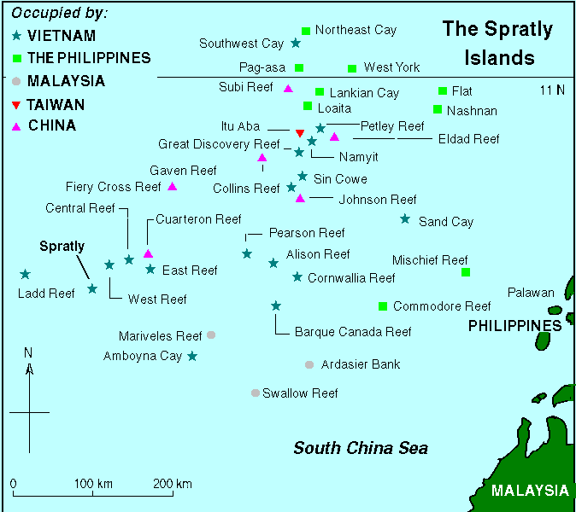
This has not stopped these states from constructing these artificial islands. The PRC recently was accused of deploying artillery pieces on one of its artificial islands, which violates international law. China has also recently asserted its claim to the airspace above the Spratly Islands. An American surveillance plane that flew through the disputed airspace in May, 2015, was warned to stay away by the Chinese navy [Hunt]. This was in violation of international law, because the UNCLOS treaty does not entitle a state to control over the airspace of its EEZ. A state only controls the airspace over its landmass, islands (not artificial), and territorial waters (12 nautical miles from coast) [Hollis].
The South China Sea contains massive reserves of petroleum and natural gas. The United States Energy Information Administration (EIA) estimated in 2013 that there are about 11 billion barrels (bbl) of oil, and 190 trillion cubic feet (Tcf) of natural gas in the South China Sea [“South…”]. This number includes both proved and probable reserves. Much of the area has not been fully analyzed, and estimates of the reserves’ actual volume range from 2.5 bbl (Wood Mackenzie firm, estimate from 2013) to 125 bbl (Chinese National Offshore Oil Company, estimate from 2012) [“South…”].

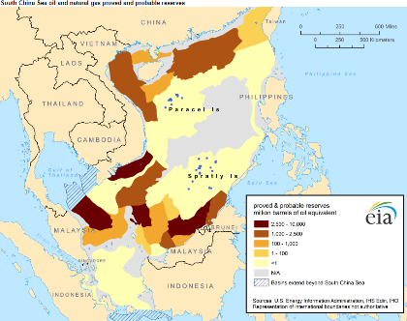
Although the South China Sea contains vast petroleum wealth, much of it still undiscovered, the vast majority is believed to lie well within 200 nautical miles of the coast, meaning within the regular EEZ’s of states bordering the sea. The reserves under the Spratly and Paracel chains are believed to be negligible, as shown in the adjacent map, which was created by the USEIA. Nor is there a likelihood that claiming exclusive economic rights to the waters around the island groups will increase economic opportunities from fishing, because, as the UNCLOS treaty specifies in Part VII The High Seas Section 2 Management and Conservation of the Living Resources of the High Seas, Article 116, “All States have the right for their nationals to engage in fishing on the high seas.” (The high seas being defined as area not claimed as an EEZ.) [“United…”]

The biggest threat to the security and stability of the South China Sea region lies in the lack of a binding agreement among the parties to guide a de-escalation of regional tensions. The Code of Conduct is not sufficient to solve this problem. The South China Sea contains many valuable resources, and thus is a valuable prize. It is the task of this council to try to reach an agreement which most fairly allocates that prize and stabilizes this volatile region.

Timeline of Key Events in the South China Sea:
(From BBC, http://www.bbc.com/news/world-asia-pacific-13748349)
- 1974: The Chinese seized the Paracels from Vietnam, killing more than 70 Vietnamese troops.
- 1988: The two sides clashed in the Spratlys, with Vietnam again coming off worse, losing about 60 sailors.
- Early 2012: China and the Philippines engaged in a lengthy maritime stand-off, accusing each other of intrusions in the Scarborough Shoal.
- July 2012: China angered Vietnam and the Philippines when it formally created Sansha city, an administrative body with its headquarters in the Paracels, which it says oversees Chinese territory in the South China Sea.
- Late 2012: Unverified claims that the Chinese navy sabotaged two Vietnamese exploration operations led to large anti-China protests on Vietnam's streets.
- January 2013: Manila said it was taking China to a UN tribunal under the auspices of the UN Convention on the Laws of the Sea, to challenge its claims.
- May 2014: The introduction by China of a drilling rig into waters near the Paracel Islands led to multiple collisions between Vietnamese and Chinese ships.
- April 2015: Satellite images showed China building an airstrip on reclaimed land in the Spratlys.

*Please Note*
This is a crisis council and delegates will have the ability to make country directives for immediate responses to crises and actions made in council. While these directives do not need approval from the council, they do require approval from the chair before they are put into action. If the directive involves another country in the council, all involved parties must consent to the action before it can be considered. Directives may include, but are not limited to, actions such as: movement of a countries troops/naval forces into or out of a region, signing onto/disregarding international treaties that had been in place before the council begins, and executive orders on your country's policy.

Works Cited:

Burr, J. Millard. "South China Sea Territorial Disputes." American Center for Democracy. N.p., 16 May 2014. Web. 7 Aug. 2015. <http://acdemocracy.org/south-china-sea-territorial-disputes/>.
"China's Maritime Disputes." Council on Foreign Relations. N.p., 2013. Web. 31 July 2015.< http://www.cfr.org/asia-and-pacific/chinas-maritime-disputes/p31345​>.
"Declaration on the Conduct of Parties in the South China Sea." Association of Southeast Asian States, 4 Nov. 2002. Web. 16 Aug. 2015. <http://www.asean.org/asean/external-relations/china/item/declaration-on-the-conduct-of-parties-in- the-south-china-sea>.
Ghosh, P. K. "Artificial Islands in the South China Sea." The Diplomat. N.p., 23 Sept. 2014. Web. 9 Aug. 2015. <http://thediplomat.com/2014/09/artificial-islands-in-the-south-china-sea/>.

Glaser, Bonnie S. "Armed Clash in the South China Sea." Council on Foreign Relations, Apr. 2012. Web. 06 Aug. 2015. <http://www.cfr.org/world/armed-clash-south-china-sea/p27883>.

Glaser, Bonnie S. "This Is Why a Code of Conduct in the South China Sea Can't Wait." The National Interest. N.p., 11 Aug. 2015. Web. 09 Sept. 2015. <http://nationalinterest.org/blog/the-buzz/why-code-conduct-the-south-china-sea-cant-wait-13552>.

Hollis, Daniel. "United Nations Convention on Law of the Sea (UNCLOS), 1982." The Encyclopedia of Earth. N.p., 26 Feb. 2013. Web. 2 Aug. 2015. <http://www.eoearth.org/view/article/156775/>.

Hunt, Katie. "China: Admiral Sun Jianguo Defends Artificial Islands." CNN. Cable News Network, 1 June 2015. Web. 7 Aug. 2015. <http://www.cnn.com/2015/06/01/asia/china-defends-island-building/>.

Malik, Mohan. "Historical Fiction: China's South China Sea Claims." World Affairs Journal. N.p., May-June 2013. Web. 15 Aug. 2015. <http://www.worldaffairsjournal.org/article/historical-fiction-china%E2%80%99s-south-china-sea-claims>.

Nguyen, Chau Bao. "How Should Vietnam Respond to China's South China Sea Oil Rig Return?" The Diplomat. N.p., 24 July 2015. Web. 06 Sept. 2015.

Page, Jeremy, and Julian E. Barnes. "China Expands Island Construction in Disputed South China Sea." WSJ. Wall Street Journal, 18 Feb. 2015. Web. 30 Aug. 2015. <http://www.wsj.com/articles/china-expands-island-construction-in-disputed-south-china-sea-1424290852>.

"Q&A: South China Sea Dispute." BBC News. British Broadcasting Corporation, 17 Apr. 2015. Web. 1 Aug. 2015. <http://www.bbc.com/news/world-asia-pacific-13748349>.

"South China Sea: Overview." United States Energy Information Administration. United States Department of Energy, 7 Feb. 2013. Web. 31 July 2015. <http://www.eia.gov/beta/international/regions-topics.cfm?RegionTopicID=SCS>.

"United Nations Convention on the Law of the Sea as of 10 December, 1982." United Nations Division for Ocean Affairs and the Law of the Sea. United Nations, n.d. Web. 18 July 2015. <http://www.un.org/depts/los/convention_agreements/texts/unclos/UNCLOS-TOC.htm>.

