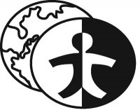
2014 October

^{23rd}

08
Fall

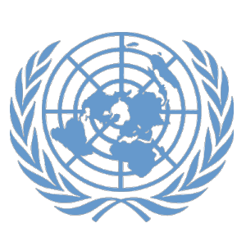

Denver Center for International Studies and South High School

Model United Nations Conference
0

^{Intermediate Security Council:}
Topic: Ukraine-Russia and Cold War Tensions

Authors: Sam Eagleburger, Emily Frazer-Abel
Editor: Dillon Hunter

BACKGROUND GUIDE

Topic: Ukraine-Russia Cold War Tensions

Council Background
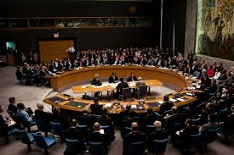
The UN Security council is the only council in the United Nations that has the power to pass resolutions that have actual directive statements in them allowing for action to be done. It has 15 members 5 of who are permanent, 10 of who are elected every two years. The primary objective of the Security Council is to maintain international peace and security. All member states have one vote, there are often observers that do sit in and debate openly in the Security Council but do not have a vote. The 5 permanent members that are in the council have exclusive veto power, meaning each of these 5 individual states can veto a resolution that comes onto the floor without the consensus of the group. The Security Council generally takes the lead in determining issues that may threaten its main objective; it calls upon parties to settle disputes by peaceful means. The Security Council also recommends the General Assembly on the election of a Secretary General, adding new member states, and it works with the General Assembly to elect judges of the international court.
Pertinent Information
The current situation in Ukraine Began in 2004 during what is known as the orange revolution. The then Pro-Russian president elect Viktor Yanukovych was accused of rigging the vote and opposition leader Viktor Yushchenko led street protests and civil disobedience. Mass unrest caused the Supreme Court to annul the election. Yanukovych challenged the results but decided to resign anyways. In 2010 Yanukovych was declared the winner by a free and fair election judged by unbiased third party observers and opposition leader Yulia Tymoshenko was imprisoned for abuse of power.
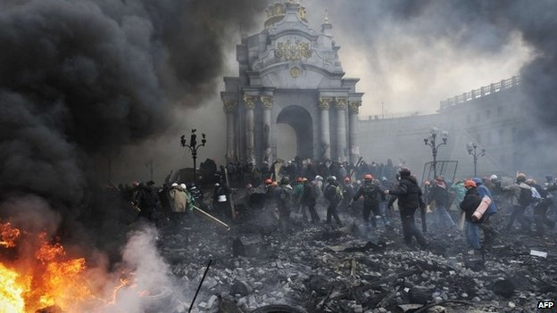
The current crisis began on November 21st, 2013 when President Yanukovych and his cabinet withdraw from a plan for closer ties to the European Union (EU) in favor of closer ties to Russia. This sparked public rage and protests began. By late November 100,000 people were attending demonstrations in Kiev and 35 had been arrested in first of many police raids. The protests continued to escalate throughout the month and by December 2013 800,000 people occupied Independence Square and Kiev Town Hall. Showing support for Pro-Russian policy Putin gave Yanukovych an economic lifeline in the form of buying $15 billion in Ukrainian bonds and reduced oil and gas prices for Ukraine by a third. On January 16-23, 2014, Parliament passed harsh anti-protest laws and the protests turned deadly for the first time in response to these laws; bodies of three protesters were recovered. Protesters stormed government offices.
All 234 prisoners taken since the beginning of protests have been released and protest cooled for a while until February 18, 2014 when police and protesters clashed leaving hundreds wounded and 18 people dead including 7 police officers. 25,000 protesters were encircled by police in Independence Square. February 20th was the worst day of protests seeing 88 people killed. Protesters took over the presidential building and Yanukovych fled the “coup”.
On February 28th Pro-Russian armed militants seize the capital of Crimea. Crimea votes by 97% to be absorbed by Russia and President Putin accepts. Russia begins a troop buildup on the Ukrainian border which draws a lot of criticism from the west particularly the United States. Pro-Russian militants seize government buildings in the east Ukrainian cities of Donetsk, Luhansk and Kharkiv, calling for a referendum on independence.
NATO increased sanctions against Russia to limit and strongly chastised Russia and promised to bolster defensive capabilities in a cold war like escalation tactic.
On September 5th a ceasefire agreement has been reached however shelling at the Donetsk airport threatens this fragile agreement that has abated 5 months of fighting. Reuters has just released that the remnants of Russian tanks have been found in the possession of Russian separatists, but Moscow denies having sent any tanks.

History of the Issue
The North Atlantic Treaty Organization (NATO) was created when the North Atlantic Treaty was signed on April, 4 1949. NATO’s original members were: Belgium, Canada, Denmark, France, Iceland, Italy, Luxembourg, the Netherlands, Norway, Portugal, the United Kingdom, and the United States. In 1952, Greece and Turkey became members of the Alliance. The purpose of this treaty was to oppose the growing block of eastern European countries which had been liberated from NAZI control by the Red Army and whose reconstruction had fallen under the purview of the Soviet Union according to the Potsdam Conference. The Growing influence of the Soviet Union would eventually become the Warsaw pact or as it is more commonly referred to the Iron Curtain. On May 15, 1955 The Warsaw Treaty Organization was formed in an effort to counterbalance the power of NATO. At the time the struggle was primarily over the newly formed Federal Republic of Germany and the German Democratic Republic. However, as the cold war wore on NATO and the Soviet Union became spearheads and armies for two conflicting worldviews and the face of the geopolitical struggle known as the Cold War.
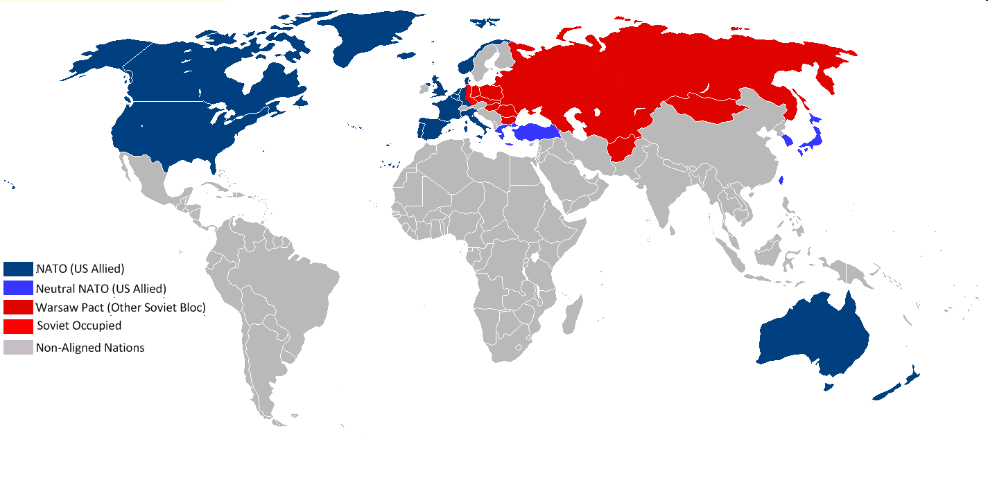
Article 5 of the NATO treaty states that the Parties agree that an armed attack against one or more of them in Europe or North America shall be considered an attack against them all and consequently they agree that, if such an armed attack occurs, each of them, in exercise of the right of individual or collective self-defense recognized by Article 51 of the Charter of the United Nations, will assist the Party or Parties so attacked by taking forthwith, individually and in concert with the other Parties, such action as it deems necessary, including the use of armed force, to restore and maintain the security of the North Atlantic area. Any such armed attack and all measures taken as a result thereof shall immediately be reported to the Security Council. Such measures shall be terminated when the Security Council has taken the measures necessary to restore and maintain international peace and security.
Currently NATO is engaged in political dialogue to aid Ukraine in warding off Russian expansion across their borders. NATO believes that a sovereign, independent and stable Ukraine, firmly committed to democracy and the rule of law, is key to Euro-Atlantic security. The formal basis for NATO-Ukraine relations is the 1997 Charter on a Distinctive Partnership, which established the NATO-Ukraine Commission (NUC), and the Declaration to Complement the Charter signed in 2009. Over time, NATO and Ukraine have reinforced political dialogue and practical cooperation through Ukraine’s Annual National Programme. In the wake of the Russia-Ukraine crisis, they have been intensifying this cooperation.
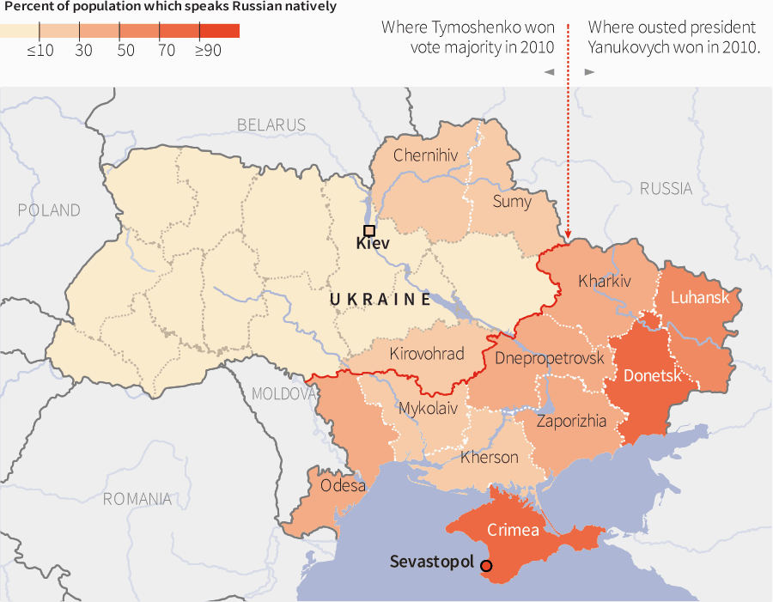
There has been a long history of conflict and political struggle between Russia and Ukraine. Many Russians consider Ukraine an essential part of the Russian ‘motherland’ however most Ukrainians feel they are ethnically and politically independent from Russia. From the time of Russia’s founding Kievan Rus the original federation of Slavic states that the Russian empire was founded on included Ukraine. In the 1850’s Russia fought a war with the Ottomans and their western allies and suffered significant losses, this war was fought over the Crimean peninsula, Ukraine joined Russia's Bolshevik government in 1922 along with Belarus and Transcaucasus in order to form the foundation of the Soviet Union, due in part to soviet influence and Stalin's policy of Russification the eastern edge of Ukraine is predominantly Russian speaking; according to RFERL, Luhansk Oblast is 68.8%, Donetsk Oblast is 74.4%, Crimea is 76.6%and Sevastopol is 90.6%. Russia also has significant economic investment is Ukraine, Russia alone accounts for 7% of total foreign investment in Ukraine. The Ukraine Russia border forms the second largest immigration corridor in the world and many Ukrainians are employed in Russia. Matthew Rojansky, director of the Kennan Institute at the Wilson Center describes the special relationship between Russia and Ukraine, "Their relationship is like the U.S.-U.K. special relationship." Crimea also borders the Black Sea which has tremendous oil reservoirs. Ukraine is also referred to as Eastern Europe’s bread basket (even after the Chernobyl incident) meaning it is rich in natural resources and arable and fertile land.
Questions to Consider
- How can the international community avoid another cold war like escalation?
- What are appropriate actions for Russia to take? And for the west to take?
- Should the international community recognize the Eastern Ukraine rebel elections that have been held and a division of Ukraine into multi-states?
- What role should NATO play in this conflict?
- What role should Russia play in this conflict?
- How can we avoid similar tensions from arising again?

Sources
ABC News Online Australia, Ukrainian Conflict in Maps, http://www.abc.net.au/news/interactives/ukraine-conflict-in-maps/

CIA World Factbook, https://www.cia.gov/library/publications/the-world-factbook/geos/up.html

http://www.slate.com/blogs/the_world_/2014/10/29/elections_in_donetsk_and_luhansk_the_slow_motion_dismemberment_of_ukraine.html

Los Angeles Times, “No progress in talks over Russian gas supplies to Ukraine”, http://www.latimes.com/world/europe/la-fg-ukraine-russia-europe-gas-talks-20141029-story.html

North Atlantic Treaty Organization, “NATO’s relations with Ukraine” , http://www.nato.int/cps/en/natohq/topics_37750.htm

Ukrainian Presidential website, http://www.president.gov.ua/en/

US News and World Report: “Report: Russia Invades Ukraine, Prompts Emergency U.N. Meeting”,
http://www.usnews.com/news/articles/2014/08/28/un-security-council-to-meet-following-reports-of-russian-invasion-into-ukraine

United Nations Security Council Briefing, Conflict Prevention, http://www.un.org/press/en/2014/sc11528.doc.htm

