2014 October

^{23rd}

08
Fall

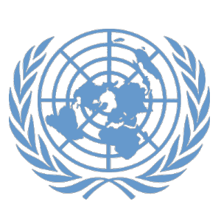

Denver Center for International Studies and South High School

Model United Nations Conference
0

Topic: UN Security Council Reform
Intermediate Future Security Council

Authors: Oscar Buchanan, Adam Salyers
Editor: Dillon Hunter

BACKGROUND GUIDE

Background of the Council
The UN Security council is the only council in the United Nations that has the power to pass resolutions that have actual directive statements in them allowing for action to be done. It has 15 members five of whom are permanent, 10 of whom are elected every two years. The primary objective of the Security Council is to maintain international peace and security. All member states have one vote, there are often observers that do sit in and debate openly in the security council but do not have a vote. The 5 permanent members that are in the council have exclusive veto power, meaning each of these 5 individual states can veto a resolution that comes onto the floor without the consensus of the group. The Security Council generally takes the lead in determining issues that may threaten its main objective; it calls upon parties to settle disputes by peaceful means. The Security Council also recommends the General Assembly on the election of a Secretary General, adding new member states, and it works with the General Assembly to elect judges of the international court. The issue of Security Council Reform has not yet been discussed in the Security Council. This means that it is a future issue and topic that members of this meet have the privilege to pioneer. For the UN reform there needs to be a 2/3rds General Assembly support, but the big five still have veto power. So for this meet we have decided to wave the 2/3rds rule and hold it in the Security Council.

Pertinent Information
The five permanent members do have veto power in all resolutions presented to the chair and voted on. There are several different groups of countries that have a significant stance on this issue and have banded together publically to share their opinions. Some of these groups are the G4, The Uniting for Consensus Reform, and the L69, all of these groups and more have shared and vested interests in the security council and its reform. All of the countries included are a part or share similar views of one of the official groups that has voiced its opinions on security council reform. Most of these groups have put forward possible resolutions that would include more permanent members, more elected members, and possible reformations of veto power and the structure of the permanent members power. Other central points that have been put forth by different UN Reform groups have been under-representation of Africa, South America, and Muslim countries, as well as over-representation of Europe, and the bias that those countries get compared to the rest of the world. Above shows two popular solutions to this ongoing UN reform debate that end with a total of 24 total seats on the council, note however that the proposed two year seats are the total number of non-permanent seats, current and newly proposed. Below are two suggestions by the Uniting for Consensus Group Reform, these models have the percentage of members of each regional group that would sit on the Security Council excluding Permanent Members. For example, the Asian Group, excluding China, has 53 countries and would hold five elected seats: 5 ÷ 53 = 9.4%. Likewise, the overall percentage is the total number of elected seats (20) divided by the total number of member states, excluding permanent members (186): 20 ÷ 186 = 10.8%. Also these models present the idea of regional representation, the Group of United Nations Latin American and Caribbean States (GRULAC), would be used to elect member states to main UN bodies. The Western European Other Groups (WEOG) is a regional group within the United Nations, used to elect member states to main UN bodies. However these are not the only proposed reforms, for example the G4 supports each others bids as permanent members of the security council. But in essence different countries form groups to support each other’s opinions on reform in this council and topic.
History of the Issue
UN reform was brought up at its founding conference. The idea of Security Council reform started in 1945 with contention over veto powers. The Security Council was expanded in 1965, one of three times the UN charter was amended. One of the major issues in UN reform is the changing geopolitical realities. The UN was originally formed by 51 founding members, of which a majority were European. However, 142 member states have joined as of 2014. Although UN Reform has been debated since its inception, only 3 times has the charter been amended. The first time was to expand the Security Council from 11 to the current 15-member body in 1965. Also in 1965 the Economic and Social Council was expanded, and then again in 1973. According to the Charter, reform should only be done to improve transparency, equity, efficiency, and capacity. Security Council reform garnered first momentum in the 1990s when countries formed larger groups to push their agendas on UN reform. While this led to more publicity of the issue, a standstill has occurred due to the concrete opinions of the groups, leading to no major progress. 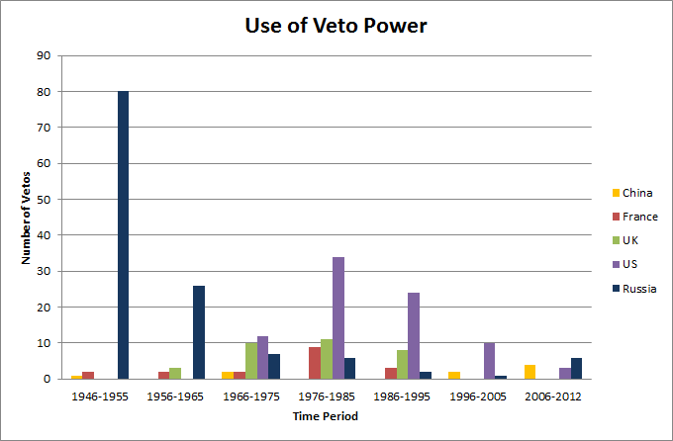

Recent Action
In 2005, the Uniting For Consensus Group sparked action in Security Council reform by changing its opinion and putting forth a new proposal on UN reform. Its proposal is not a rigid idea, it stated, but a platform to open discussion. Member states showed unanimous supported for early reform. The L.69 also have changed their position, although not in a formal proposal. In 2009, the General Assembly pushed forward towards UN reform as countries showed a common interest in improving the working methods and development of the council in terms of efficiency and transparency. Several documents have been published referring to previous resolutions and the ‘five negotiables’ of Security Council reform. Consensus has been reached that any proposal should include all negotiables to provide a comprehensive, rather than piecemeal, approach to reform.
The first of the negotiables is the categories of membership. Currently, there are two categories- the permanent members, with veto, and the non-permanent members elected every two years. There are many varied positions on membership, from staunch opposition to creating new categories of membership to a push for permanent members without veto rights. Also proposed is the creation of a longer term, non-renewable seat (proposals vary from 3-6 year terms), and seats that are elected regionally or by regional groups.
The second negotiable is the question of veto. Many member states have been very active in protesting veto. Proposed solutions include limiting the veto until it can be abolished, as well as giving more developing countries veto rights to mitigate developed countries power over the Security Council. China, Russia, France, the UK and the USA all support retention of veto power. The other issue regarding this negotiable is whether new permanent members will have veto power.
The third negotiable is the question of regional representation. The majority of countries agree that the current Security Council does not reflect the geopolitical realities, and that regions need more representation. The underrepresented groups tend to support each other’s claim to increased representation, and the debate is over how the Security Council should be expanded to allow for representation. Some of the bids are for African, Islamic, and Small Island state representation.
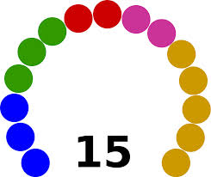
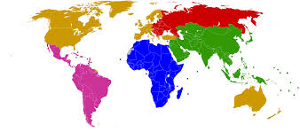
The graphics below show representation of different groups in the 15 seats in the Security Council (note the overrepresentation of Western Europe, North America, and Oceania), and the 193-seat General Assembly. The first graphic is the key to which countries and regions correspond to which colors.
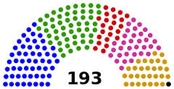

The fourth negotiable is the size of the enlarged Security Council. Recent proposals have gravitated around 24 member states, and the concerns are that a small expansion won’t allow for accurate representation, where a large expansion will affect the fifth negotiable, council transparency and efficiency.
The fifth negotiable is the least contentious, and the main focus is how to improve transparency. Notably, a small group of countries believe that the council is already transparent enough. Some proposals involving working methods include increasing interaction with the General Assembly and requiring the Security Council to write a more analytical annual report.
All five negotiables affect each other, leading to the creation of proposals that address every part of the issue. These proposals were put forward by the major groups involved in the issue, including the Group of Four, the Uniting For Consensus Group, and the L.69.

Questions to Consider
- How should the Security Council reform look in terms of expansion and types of membership?
- How should regional representation be implemented in the council?
- What should be done about the limitation or abolition of veto power, and the inclusion of new permanent members?
- In what ways should the working methods of the council- such as transparency and efficiency- be altered?
- How should Security Council reform be implemented and negotiated in the future?

Sources
Global Policy Forum. Global Policy Forum, 2014. https://www.globalpolicy.org/security-council/security-council-reform.html . November 2014

Global Policy Forum. Global Policy Forum, 2014. https://www.globalpolicy.org/component/content/article/200/41204.html . November 2014

Africa Focus, Africa Focus Group, 2005. http://www.africafocus.org/docs05/un0504.php . November 2014

MOFA Japan, The Ministry of Foreign Affairs, Japan, 2014. http://www.mofa.go.jp/policy/q_a/faq5.html . November 2014

Africa Portal, Global Policy Forum, 1995. http://dspace.africaportal.org/jspui/bitstream/123456789/18535/1/Security%20Council%20Reform.pdf?1 . November 2014

Legal UN, AudioVisual Library of International Law, 1950. http://legal.un.org/avl/ha/ufp/ufp.html . November 2014

UN Reform, Center for UN Reform Education, 2005. http://www.centerforunreform.org/sites/default/files/Special%20Paper%20No.%204.pdf . November 2014

‘We have only ourselves to blame’ . GA/11313, 2012. http://www.un.org/press/en/2012/ga11313.doc.htm . November 2014
44th Plenary Meeting of the General Assembly A/64/PV.44 United Nations General Assembly, 2009. http://daccess-dds-ny.un.org/doc/UNDOC/GEN/N09/606/19/PDF/N0960619.pdf?OpenElement . November 2014

