2014 October

^{23rd}

08
Fall

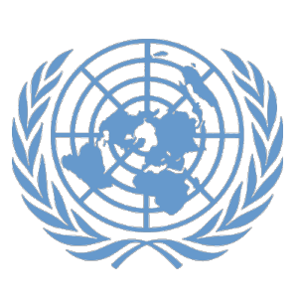

Denver Center for International Studies and South High School

Model United Nations Conference

Advanced GA Council: United Nations Environmental Programme:
Authors: Alex Imhof
Editor: Dillon Hunter

Topic:
Outcomes of Newfound Oil, Specifically Due to the Melting of the Icecaps

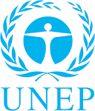
Topic: Possible Outcomes of Newfound Oil, Specifically Due to the Melting of the Icecaps
Background of the Council
UNEP, established in 1972, is the voice for the environment within the United Nations system. UNEP acts as a catalyst, advocate, educator and facilitator to promote the wise use and sustainable development of the global environment. The Regional Seas Action Plan was created to ensure a regional approach to protection of the sea environments. The Arctic Council was established in 1996 and is a distinctive regional form of co-operation between governments and indigenous peoples in the Arctic region addressing all three of the main pillars of sustainable development; the environmental, social and economic. The scientific work and policy guidance of the Arctic Council is carried out in several expert working groups focusing on such issues as monitoring, assessing and preventing pollution in the Arctic, climate change, biodiversity conservation and sustainable use, in addition to emergency preparedness and prevention. Among these programmes is the Protection of the Arctic Marine Environment (PAME). In a response to climate change and increasing economic activity, the Arctic Council has recognized that existing and emerging activities in the Arctic warrant a more coordinated and integrated strategic approach to address these challenges and agreed in 2002 that a strategic plan for protection of the Arctic marine environment be developed under PAME leadership. One of the aims of this plan is to build on the internationally recognized need to manage human activities within the context of entire ecosystems, applying them to achieve the sustainable development of the Arctic marine environment.
Pertinent Information
As of recent, a large expanse of oil fields has been discovered in the western region of the arctic sea. Because of its enormous quantity and low cost extraction, the discovery may pay a fatal blow to that of the Middle East’s’ economy. While a large part of the region is still covered in ice, the estimation of square miles of untapped oil is growing. The most controversial aspect of this problem is what will become of the oil once it drilled up. Whether it is given to first world countries or countries in the Middle East, the seizing country will end up having an economic monopoly over the oil industry. In past scenarios such as the United States combat with standard oil, a viable option was to separate the monopolization of resources although it is estimated that certain parties will object to this solution.
The polar region's loss of ice cover is happening at a rate of 46,100 square kilometers per year since 1981, with summer sea ice loss accelerating over the past decade in terms of ice coverage and thickness. Winter ice extent is also at historically low levels, with 2014 marking the fourth-lowest February ice extent in the satellite record, 910,000 kilometers below the 1981 to 2010 average, according to the U.S. National Snow and Ice Data Center. Completely ice-free summers could come by mid-century by some estimates. Despite the risks, politicians and business officials frequently cite the melting of sea ice as one of the opportunities offered by human-caused climate change, as offshore resources become accessible and new shipping lanes open. In August 2007, the summer of the lowest ice extent in the Arctic Ocean recorded until that time, a Russian submarine expedition planted a titanium Russian flag at the sea bed of the North Pole. The incident set off speculation about a rush to resources in the remote region and signaled that jurisdiction over the top of the world held great political significance.
While the debate of the oil ensues the ending conflict will be with global warming itself and the way this oil will have on the world both environmentally and economically. From what is already seen, the dispute of the oil could cause tensions between the United States and Russia, as tension between the United States and the Middle East. What the resolution the UN passes on the subject holds the fate of the world economy in its hands, due to the exponential growth of oil prices globally.

History of the Issue
While the majority of oil found within the earth’s sediments has been drilled up within the past century, an oil field such as the one discovered is essentially an economic gold mine. Ever since the dawn of the 20th century, oil prices have increased with less and less abnormalities making the prices lower. One of the notable abnormalities occurred in 2008, although this was a purely cosmetic change to the countries supply and demand ratio. The change was made to correct what the company OPEC considered a massive oversupply by cutting close to 500,000 units. While this change eventually made the oil company successful, the world economy would suffer. The company planned to reduce their stock by another whopping 2.2 million barrels. Another notable drop in oil production occurred in the United States with the separation of a corporation known as standard oil. While also having little or no connection at all to the situation at hand, these oil frequencies could be useful to the council as historical examples of how the world economy would fair if the prices in oil should skyrocket in proportion.

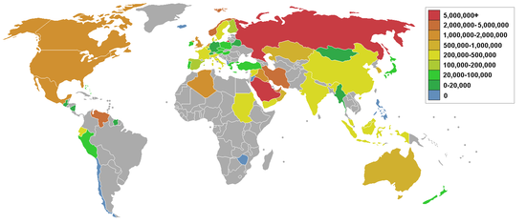
Below: Daily Oil Production by Country

The most perhaps surprising fact about the history of this topic is the fact that until now, there hasn’t been any ratio of cost vs. oil that is sustainable and can compete with prices of the Middle East. It is estimated that the supply of oil found at the North Pole could rival that of the Middle East. It is estimated that the world has 53.3 years to find a sustainable substitution for oil once oil reserves run dry. This estimation is favored by some countries that are researching ways to stop global warming and creating ways to have sustainable energy. These newfound oil fields could have tragic effects on countries governments who have planned to succeed economically based on these estimates, causing economic turnover and leaving business’ out in the dust. Currently a relatively small part of world funds lies in the research of clean energy, and in the case of this economic turnover could leave millions jobless as well as contributing to rising CO2 levels in our atmosphere.
Ownership of the North Pole territory under international law is not assumed by any countries. The UN Convention on the Law of the Seas does allow a country to make a claim extending their territorial possessions into the continental shelf.

Questions to Consider
- How will the discovery of Artic oil affect tensions between Russia and the United States?
- How would the extraction of the oil in the Artic affect the economic situation in the middle east?
- What will environmental organizations do to stop the global turn back to oil?
- What will become of the oil fields and who has the most claim to them?
- Should the UNEP extend the oil drilling ban far into the future?
- What would the consequences of an oil-spill in the Artic be?

Sources
Bloomberg, “Who Owns the North Pole?”, http://www.bloomberg.com/news/2014-04-04/who-owns-the-north-pole-debate-heats-up-as-climate-change-transforms-arctic.html

The Economist, “Cheaper Oil Both symptom and balm”, http://www.economist.com/news/finance-and-economics/21625819-oil-price-tumbling-good-or-bad-news-world-economy-both
Oilprice.com, :Oil Prices: Where are we Headed”, http://oilprice.com/Energy/Crude-Oil/World-Oil-Production-at-3312014Where-are-We-Headed.html
Reuters, “Arctic needs protection from resource rush as ice melts: U.N. body”, http://www.reuters.com/article/2013/02/18/us-unep-arctic-idUSBRE91H0A820130218
United States Energy Information, http://www.eia.gov/countries/index.cfm?view=production
United Nations Environmental Program Regional Seas, “Introduction to the Artic”, http://www.unep.ch/regionalseas/regions/p_arc/arcint.htm
United Nations Environmental Programme: “Planet in Peril, Melting ice Caps”, http://apps.unep.org/publications/pmtdocuments/-Planet%20in%20Peril_%20Atlas%20of%20Current%20Threats%20to%20People%20and%20the%20Environment-2006667.pdf
Worldcrunch, “Mining the North Pole”, http://www.worldcrunch.com/tech-science/mining-the-north-pole-oil-companies-taking-on-the-arctic/total-arctic-environment-greenpeace-oil/c4s10028/#.VFamXjTF_A0

